

|  |  |
| --- | --- |
| **Title of the Report:** | Programming C |
| **Course Name and Code:** | Problem Solving (QHO305) |
| **Student Name:** | Ana Paula Barbosa Tinelli |
| **Student ID:** | 20054375 |
| **Lecture Name:** | Piotr Bednorz |
| **Words Count:** | 1044 |

# Table of Contents

List of Figures 4

List of Tables 7

Introduction 8

1 Task 1: Study Hours Monitor 10

1.1 Basic Study Hours Tracking - Grade 40-49 10

1.2 User Input and Study Goal Check - Grade 50-59 11

1.3 Multi-Week Tracking - Grade 60-69 13

1.4 Dynamic Input and Enhanced Comparison - Grade 70-100 16

2 Task 2: Theme Park Ticketing System 20

2.1 Basic ticket Price Calculation - Grade 40-49 20

2.2 User Input for Tickets - Grade 50-59 23

2.3 Discounts and Additional Services - Grade 60-69 28

2.4 Menu-Driven System - Grade 70-100 32

3 Task 3: Fitness Tracker Loop Challenge 39

3.1 Grade 40-49 39

3.2 Grade 50-59 41

3.3 Grade 60-69 43

3.4 Grade 70-100 48

4 Task 4: Calendar Printer 54

4.1 Grade 40-49 54

4.2 Grade 50-59 57

4.3 Grade 60-69 60

4.4 Grade 70-100 64

5 Task 5: Temperature Logger 70

5.1 Grade 40-49 70

5.2 Grade 50-59 74

5.3 Grade 60-69 78

5.4 Grade 70-100 86

6 Task 6: Playlist Organizer 96

6.1 Grade 40-49 96

6.2 Grade 50-59 98

6.3 Grade 60-69 101

6.4 Grade 70-100 104

7 Task 7: Course Registration System with Functions and Files 110

7.1 Grade 40-49 110

7.2 Grade 50-59 116

7.3 Grade 60-69 122

7.4 Grade 70-100 131

8 Task 8: Personal Learning 146

8.1 Reflective Report 146

9 Appendix 149

10 References 150

# List of Figures

Figure 1: Input Task_1_40-49 9

Figure 2: Output Task_1_40-49 10

Figure 3: Input Task_1_50-59 10

Figure 4: Output Task_ 1_50-59.1 11

Figure 5: Output Task _1_50-59.2 12

Figure 6: Input Task _1_60-69.1 12

Figure 7: Input Task _1_60-69.2 13

Figure 8: Input Task _1_60-69.3 13

Figure 9: Output Task_1_60-69.1 14

Figure 10: Output Task_1_60-69.2 15

Figure 11: Output Task_1_60-69.3 15

Figure 12: Input Task_1_70-100.1 16

Figure 13: Input Task_1_70-100.2 16

Figure 14: Output Task_1_70-100.1 18

Figure 15: Output Task_1_70-100.2 18

Figure 16: Output Task_1_70-100.3 19

Figure 17: Input Task_2_40-49.1 20

Figure 18: Input Task_2_40-49.2 20

Figure 19: Input Task_2_40-49.3 21

Figure 20: Output Task_2_40-49 21

Figure 21: Input Task_2_50-59.1 23

Figure 22: Input Task_2_50-59.2 23

Figure 23: Input Task_2_50-59.3 24

Figure 24: Output Task_2_50-59.1 25

Figure 25: Output Task_2_50-59.2 26

Figure 26: Output Task_2_50-59.3 26

Figure 27: Output Task_2_50-59.4 26

Figure 28: Input Task_2_60-69.1 27

Figure 29: Input Task_2_60-69.2 28

Figure 30: Input Task_2_60-69.3 28

Figure 31: Input Task_2_60-69.4 29

Figure 32: Output Task_2_60-69.1 30

Figure 33: Output Task_2_60-69.2 31

Figure 34: Output Task_2_60-69.3 31

Figure 35: Input Task_2_70-100.1 32

Figure 36: Input Task_2_70-100.2 33

Figure 37: Input Task_2_70-100.3 33

Figure 38: Input Task_2_70-100.4 34

Figure 39: Input Task_2_70-100.5 34

Figure 40: Input Task_2_70-100.6 35

Figure 41: Output Task_2_70-100.1 37

Figure 42: Output Task_2_70-100.2 37

Figure 43: Output Task_2_70-100.3 38

Figure 44: Input Task_3_40-49 39

Figure 45: Output Task_3_40-49 39

Figure 46: Input Task_3_50-59 40

Figure 47: Output Task_3_50-59 42

Figure 48: Input Task_3_60-69.1 43

Figure 49: : Input Task_3_60-69.2 43

Figure 50: Output Task_3_60-69.1 46

Figure 51: Output Task_3_60-69.2 46

Figure 52: Input Task_3_70-100.1 47

Figure 53: Input Task_3_70-100.2 48

Figure 54: Input Task_3_70-100.3 48

Figure 55: Input Task_3_70-100.4 49

Figure 56: Input Task_3_70-100.5 49

Figure 57: Input Task_3_70-100.6 50

Figure 58: Output Task_3_70-100.1 52

Figure 59: : Output Task_3_70-100.2 52

Figure 60: : Output Task_3_70-100.3 53

Figure 61: Input Task_4_40-49.1 54

Figure 62: Input Task_4_40-49.2 54

Figure 63: Output Task_4_40-49.1 55

Figure 64: Output Task_4_40-49.2 56

Figure 65: Input Task_4_50-59.1 56

Figure 66: Input Task_4_50-59.2 57

Figure 67: Output Task_4_50-59 59

Figure 68: Input Task_4_60-69.1 60

Figure 69: Input Task_4_60-69.2 60

Figure 70: Output Task_4_60-69 62

Figure 71: Input Task_4_70-100.1 63

Figure 72: Input Task_4_70-100.2 64

Figure 73: Input Task_4_70-100.3 64

Figure 74: Input Task_4_70-100.4 65

Figure 75: Output Task_4_70-100.1 68

Figure 76: Output Task_4_70-100.2 68

Figure 77: Output Task_4_70-100.3 69

Figure 78: Input Task_5_40-49.1 70

Figure 79: Input Task_5_40-49.2 70

Figure 80: Output Task_5_40-49 72

Figure 81: Input Task_5_50-59.1 73

Figure 82: Input Task_5_50-59.2 74

Figure 83: Output Task_5_50-59.1 75

Figure 84: Output Task_5_50-59.2 76

Figure 85: Input Task_5_60-69.1 77

Figure 86: Input Task_5_60-69.2 78

Figure 87: Input Task_5_60-69.3 78

Figure 88: Input Task_5_60-69.4 79

Figure 89: Input Task_5_60-69.5 79

Figure 90: Input Task_5_60-69.6 80

Figure 91: Output Task_5_60-69.1 82

Figure 92: Output Task_5_60-69.2 82

Figure 93: Output Task_5_60-69.3 83

Figure 94: Output Task_5_60-69.4 83

Figure 95: Input Task_5_70-100.1 84

Figure 96: Input Task_5_70-100.2 85

Figure 97: Input Task_5_70-100.3 85

Figure 98: Input Task_5_70-100.4 86

Figure 99: Input Task_5_70-100.5 86

Figure 100: Input Task_5_70-100.6 87

Figure 101: Output Task_5_70-100.1 90

Figure 102: Output Task_5_70-100.2 91

Figure 103: Output Task_5_70-100.3 92

Figure 104: Output Task_5_70-100.4 93

Figure 105: Output Task_5_70-100.5 93

Figure 106: Input Task_6_40-49 95

Figure 107: Output Task_6_40-49 95

Figure 108: Input Task_6_50-59_1 96

Figure 109: Input Task_6_50-59_2 97

Figure 110: Output Task_6_50-59 98

Figure 111: Input Task_6_60-69_1 99

Figure 112: Input Task_6_60-69_2 100

Figure 113: Output Task_6_60-69 102

Figure 114: Input Task_6_70-100_1 103

Figure 115: Input Task_6_70-100_2 104

Figure 116: Output Task_6_70-100.1 107

Figure 117: Output Task_6_70-100.2 107

Figure 118: Input Task_7_40-49.1 109

Figure 119: Input Task_7_40-49.2 110

Figure 120: Input Task_7_40-49.3 110

Figure 121: Input Task_7_40-49.4 111

Figure 122: Output Task_7_40-49 114

Figure 123: Input Task_7_50-59.1 115

Figure 124: Input Task_7_50-59.2 116

Figure 125: Input Task_7_50-59.3 117

Figure 126: Input Task_7_50-59.4 118

Figure 127: Input Task_7_50-59.5 119

Figure 128: Output Task_7_50-59.1 120

Figure 129: Output Task_7_50-59.2 121

Figure 130: Input Task_7_60-69.1 122

Figure 131: Input Task_7_60-69.2 123

Figure 132: Input Task_7_60-69.3 124

Figure 133: Input Task_7_60-69.4 125

Figure 134: Input Task_7_60-69.5 126

Figure 135: Input Task_7_60-69.6 126

Figure 136: Output Task_7_60-69.1 129

Figure 137: Output Task_7_60-69.2 129

Figure 138: Output Task_7_60-69.3 130

Figure 139: Input Task_7_70-100.1 131

Figure 140: Input Task_7_70-100.2 132

Figure 141: Input Task_7_70-100.3 133

Figure 142: Input Task_7_70-100.4 134

Figure 143: Input Task_7_70-100.5 135

Figure 144: Input Task_7_70-100.6 136

Figure 145: Input Task_7_70-100.7 137

Figure 146: Input Task_7_70-100.8 137

Figure 147: Output Task_7_70-100.1 140

Figure 148: Output Task_7_70-100.2 140

Figure 149: Output Task_7_70-100.3 141

Figure 150: Output Task_7_70-100.4 141

Figure 151: Output Task_7_70-100.5 142

Figure 152: Output Task_7_70-100.6 142

Figure 153: Output Task_7_70-100.7 143

Figure 154: Output Task_7_70-100.8 143

Figure 155: Output Task_7_70-100.9 143

# List of Tables

Table 1: Code Explanation_Task_1_50-59 13

Table 2: Code Explanation_Task_1_60-69 16

Table 3: Code Explanation_Task_1_70-100 19

Table 5: Ticket values_Task_2_50-59 24

Table 6: Code Explanation Task_2_50-59 27

Table 7: Code Explanation Task_2_60-69 32

Table 8: Code Explanation Task_2_70-100 38

Table 9: Code Explanation Task_3_50-59 43

Table 10: Code Explanation Task_3_60-69 47

Table 11: Code Explanation Task_3_70-100 53

Table 12: Code Explanation Task_4_40-49 57

Table 13: Code Explanation Task_4_50-59 60

Table 14: Code Explanation Task_4_60-69 63

Table 15: Code Explanation Task_4_70-100 69

Table 16: Code Explanation Task_5_40-49 73

Table 17: Code Explanation Task_5_50-59 77

Table 18: Code Explanation Task_5_60-69 83

Table 19: Code Explanation Task_5_70-100 91

Table 20: Code Explanation Task_6_50-59 100

Table 21: Code Explanation Task_6_60-69 103

Table 22: Code Explanation Task_6_70-100 108

Table 23: Code Explanation Task_7_40-49 115

Table 24: Code Explanation Task_7_50-59 121

Table 25: Code Explanation Task_7_60-69 129

Table 26: Code Explanation Task_7_70-100 140

# Introduction

This report was developed as part of the Problem Solving module, with a focus on programming in the C language. The main objective of the assessment is to apply fundamental programming concepts to progressively more complex problems, practising not only coding but also logical reasoning and structured problem-solving. The work is organised into seven main tasks, each based on a practical scenario. Within each task, there are four subtasks that gradually increase in difficulty, ranging from simple exercises to more advanced applications. This progressive design allowed knowledge to be built up step by step, while also providing challenges to further extend skills. The foundation for developing this assessment came from both online and in-person classes, which introduced the essential concepts of C. However, completing the tasks required a significant amount of independent study, including practising with code, researching external resources, and testing different approaches. The final task, Task 8, is a personal reflection and includes an overview of progress from the beginning of this work to its conclusion.

The purpose of the list below is to facilitate the process of checking by providing links to the code for each assignment in the online compiler. They are also presented with corresponding topic task and code’s screenshots, and Visual Studio Code .c codes are zipped on appendix.

|  |  |
| --- | --- |
| TASK | Link to Online Compiler |
| Task 1_ 40-49 | <https://www.programiz.com/online-compiler/0GwFwDP6gNpQo> |
| Task 1_ 50-59 | <https://www.programiz.com/online-compiler/2MSzgmRlSnXtv> |
| Task 1_ 60-69 | <https://www.programiz.com/online-compiler/3GwFbFeTvND4x> |
| Task 1_ 70-100 | <https://www.programiz.com/online-compiler/4Cgt0YQP6pGhj> |
|  |  |
| Task 2_ 40-49 | <https://www.programiz.com/online-compiler/7ud644QNhHVe1> |
| Task 2_ 50-59 | <https://www.programiz.com/online-compiler/7Rc2sfcbAClZZ> |
| Task 2_ 60-69 | <https://www.programiz.com/online-compiler/0DncmPKF909o2> |
| Task 2_ 70-100 | <https://www.programiz.com/online-compiler/07DMofCF8O5l0> |
|  |  |
| Task 3_ 40-49 | <https://www.programiz.com/online-compiler/7lKj3eMbKXeav> |
| Task 3_ 50-59 | <https://www.programiz.com/online-compiler/6ENI8UqCrktPJ> |
| Task 3_ 60-69 | <https://www.programiz.com/online-compiler/0Uzuib0uOZn3f> |
| Task 3_ 70-100 | <https://www.programiz.com/online-compiler/8udoVTg6jHwfB> |
|  |  |
| Task 4_ 40-49 | <https://www.programiz.com/online-compiler/67DRs2Jv5OcXe> |
| Task 4_ 50-59 | <https://www.programiz.com/online-compiler/5moyOhIPXzD1Q> |
| Task 4_ 60-69 | <https://www.programiz.com/online-compiler/52khKrSdsfx88> |
| Task 4_ 70-100 | <https://www.programiz.com/online-compiler/7dIN97gF4htY1> |
|  |  |
| Task 5_ 40-49 | <https://www.programiz.com/online-compiler/1AF43EQwfsZJh> |
| Task 5_ 50-59 | <https://www.programiz.com/online-compiler/9CgmdeCe0pPVA> |
| Task 5_ 60-69 | <https://www.programiz.com/online-compiler/7O0Y2Xq7pK7Hh> |
| Task 5_ 70-100 | <https://www.programiz.com/online-compiler/4moh9C812zf1w> |
|  |  |
| Task 6_ 40-49 | <https://www.programiz.com/online-compiler/5DnSIsFsb0zfP> |
| Task 6_ 50-59 | <https://www.programiz.com/online-compiler/4YHdBDsbYtVhs> |
| Task 6_ 60-69 | <https://www.programiz.com/online-compiler/4ENwCbnHokvKY> |
| Task 6_ 70-100 | <https://www.programiz.com/online-compiler/4ysF7bYcYd4hR> |
|  |  |
| Task 7_ 40-49 | <https://www.programiz.com/online-compiler/83eYgwswAJkot> |
| Task 7_ 50-59 | <https://www.programiz.com/online-compiler/5O0nSU2VdKvxq> |
| Task 7_ 60-69 | https://www.programiz.com/online-compiler/2jCcddszxvHTI |
| Task 7_ 70-100 | <https://www.programiz.com/online-compiler/2YHdbmMSztjO8> |

# Task 1: Study Hours Monitor

## Basic Study Hours Tracking - Grade 40-49

This task requires creating a basic program that tracks study hours for three fixed subjects: Maths, Programming, and Networking. The values for each subject are assigned directly in the code, and the program calculates and displays the total weekly study hours by summing the values of all subjects.

Below is the link to check the code in programiz:

<https://www.programiz.com/online-compiler/0GwFwDP6gNpQo>

Input:

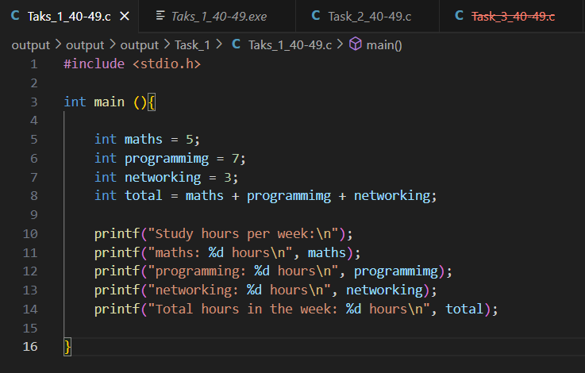

Figure 1: Input Task_1_40-49

**Code Explanation:** The program starts by declaring three variables representing the number of hours studied for Maths, Programming, and Networking. Each variable is assigned a fixed value within the code. Then, the program calculates the total study by adding the three values together. Finally, it prints the total number of study hours for the week.

Output:

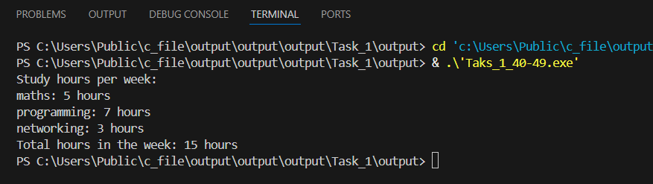

Figure 2: Output Task_1_40-49

## User Input and Study Goal Check - Grade 50-59

This version of the task builds upon the previous one by allowing the user to input the number of study hours for each subject. Additionally, a weekly study goal is introduced. The program compares the total study hours entered by the user with the predefined goal and prints whether the goal was met or if more study time is needed. Below is the link to check the code in programiz:

<https://www.programiz.com/online-compiler/2MSzgmRlSnXtv>

Input:

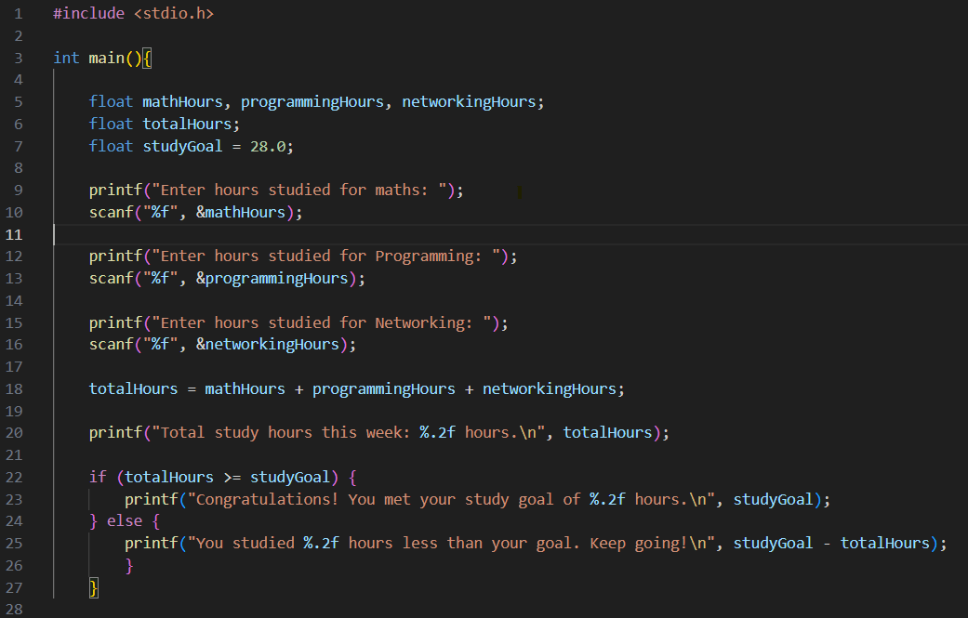

Figure 3: Input Task_1_50-59

**Code Explanation:** In this program the user is asked to enter how many hours were studied for maths, programming, and networking. The program then adds these values together to calculate the total hours for the week. It also compares the result with a fixed goal of 28 hours. If the goal is reached, a congratulations message is shown, otherwise it displays how many hours are still missing. By doing this exercise I could practice reading input with scanf, adding variables together, and using if statements to make decisions in the code.

The table below contains the Code Explanation:



Table 1: Code Explanation_Task_1_50-59

Output:

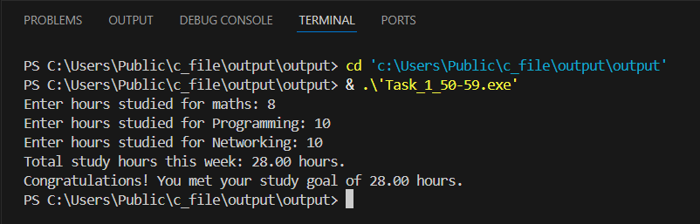

Figure 4: Output Task_ 1_50-59.1

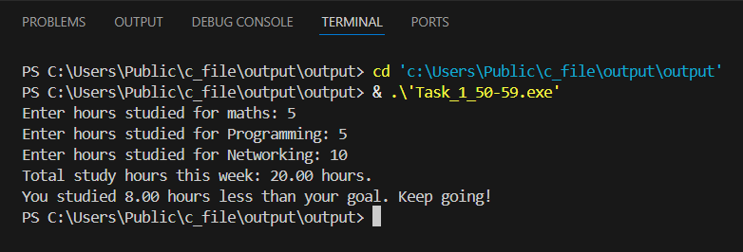

Figure 5: Output Task _1_50-59.2

## Multi-Week Tracking - Grade 60-69

In this version, the program lets the user enter study hours for two weeks. It calculates the total study time for each week and checks if the user has met the weekly goal. Then, it campares both weeks and shows if the user studied more, less, or the same in the second week.

Below is the link to check the code in programiz:

<https://www.programiz.com/online-compiler/3GwFbFeTvND4x>

Input:

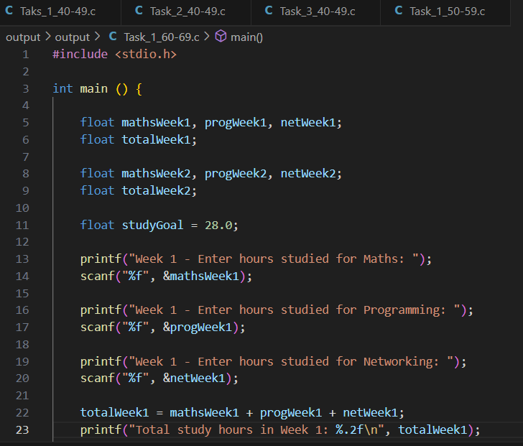

Figure 6: Input Task _1_60-69.1

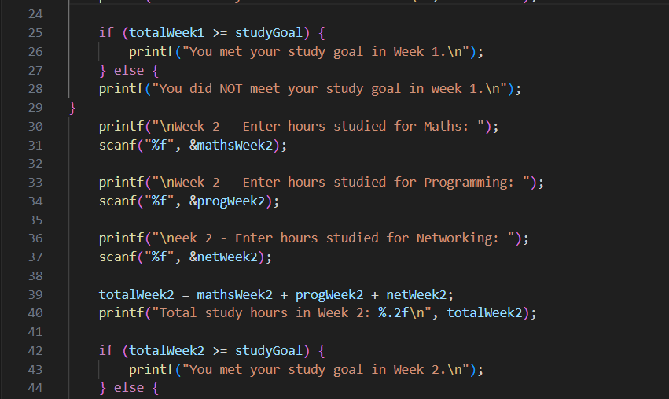

Figure 7: Input Task _1_60-69.2

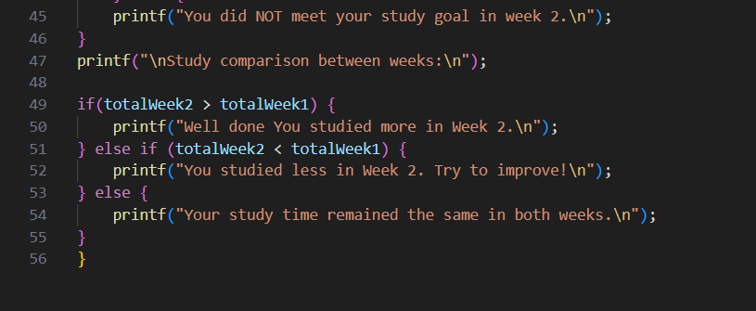

Figure 8: Input Task _1_60-69.3

**Code Explanation**: This program collects the study hours for maths, programming, and networking across two weeks. After entering the values for each subject, it calculates the total study hours for Week 1 and Week 2 and checks if the study goal of 28 hours was reached in each week. At the end, the program compares the totals from both weeks and prints whether there was an improvement, a decrease, or if the study time stayed the same. By practicing with this code I could work with input, calculations, multiple if conditions, and also learn how to compare results between different sets of data.

The table below contains the Code Explanation:



Table 2: Code Explanation_Task_1_60-69

Output:

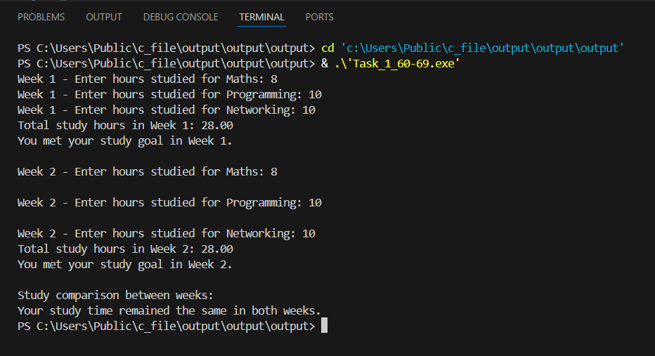

Figure 9: Output Task_1_60-69.1

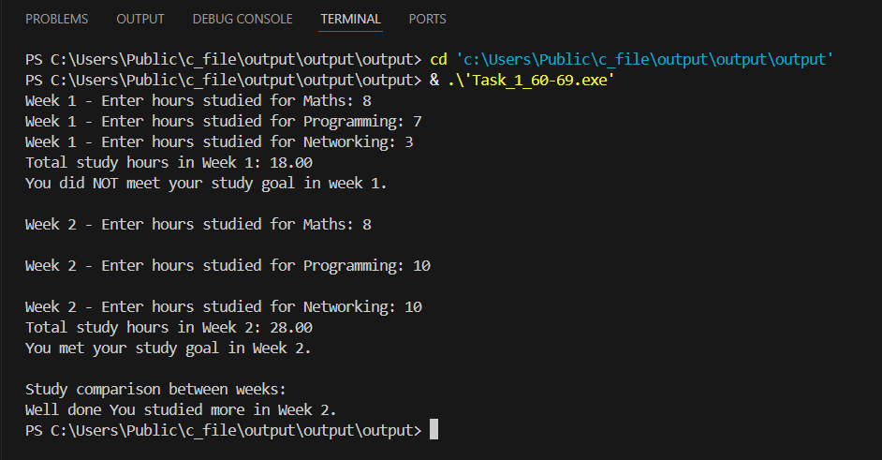

Figure 10: Output Task_1_60-69.2

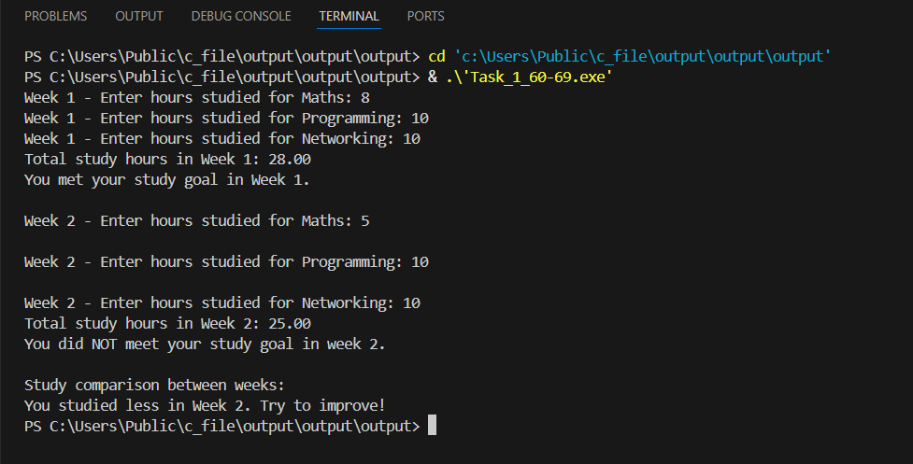

Figure 11: Output Task_1_60-69.3

## Dynamic Input and Enhanced Comparison - Grade 70-100

This task enhances the previous version by adding flexibility and detailed camparasions. Instead of using fixed subjects, the user can now enter any number of subjects they want to track, along with custom subject names. The program collects study hours for each subject over two weeks. Then it displays a breakdwn of the hours per subject and compares the performance between the two weeks, highlighting if the study time increased, decreased, or stayed the same.

Below is the link to check the code in programiz:

<https://www.programiz.com/online-compiler/4Cgt0YQP6pGhj>

Input:

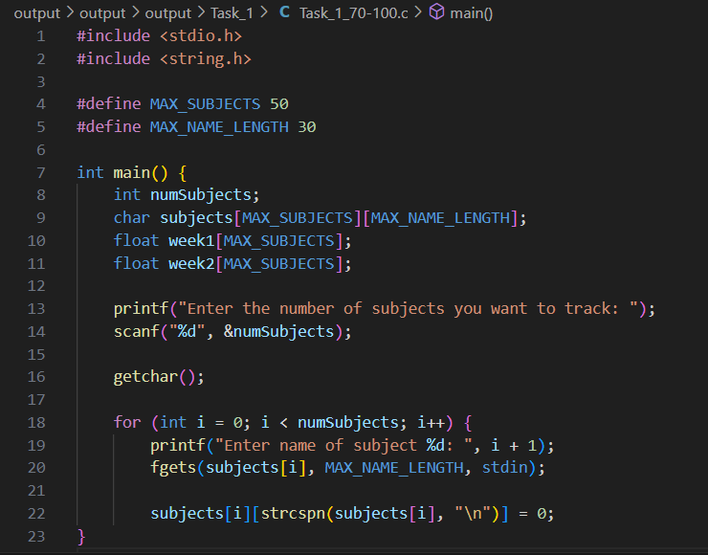

Figure 12: Input Task_1_70-100.1

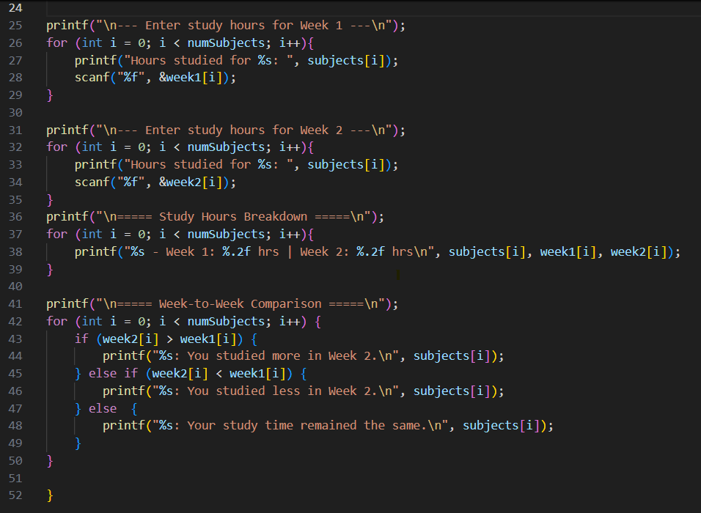

Figure 13: Input Task_1_70-100.2

**Code Explanation:** This program is designed to track study hours for multiple subjects across two weeks. First, it asks how many subjects will be monitored and then allows the user to type the name of each subject. After that, it collects the number of hours studied for each subject in Week 1 and then in Week 2. The subjects and their study hours are stored in arrays so that the program can handle more than one subject at the same time in an organized way.

In the second part, the program prints a breakdown that shows the study hours for every subject in both weeks. It then compares the values, subject by subject, and tells whether the student studied more, less, or the same amount in Week 2 compared to Week 1. By doing this task, I could practice with arrays of strings, loops, input handling with fgets, and conditional statements to compare the data. It gave me a better idea of how to build a program that works with larger and more flexible datasets, not just fixed variables.

The table below contains the Code Explanation:



Table 3: Code Explanation_Task_1_70-100

Output:

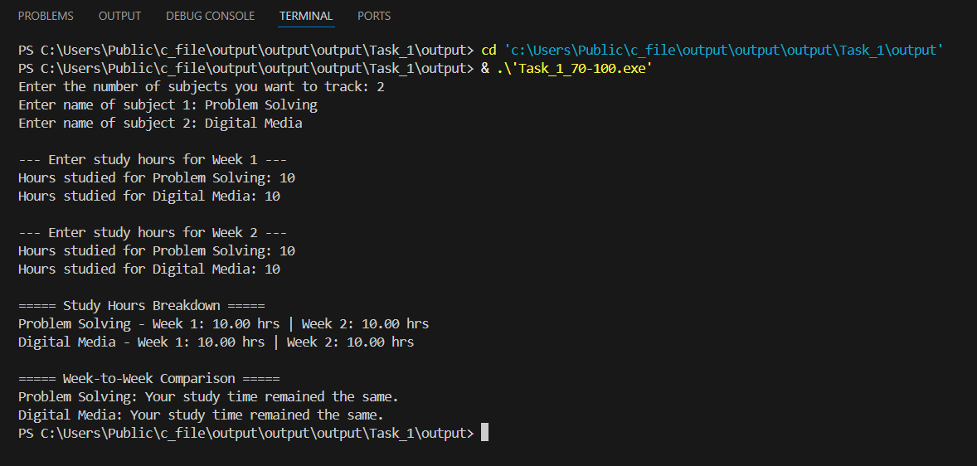

Figure 14: Output Task_1_70-100.1

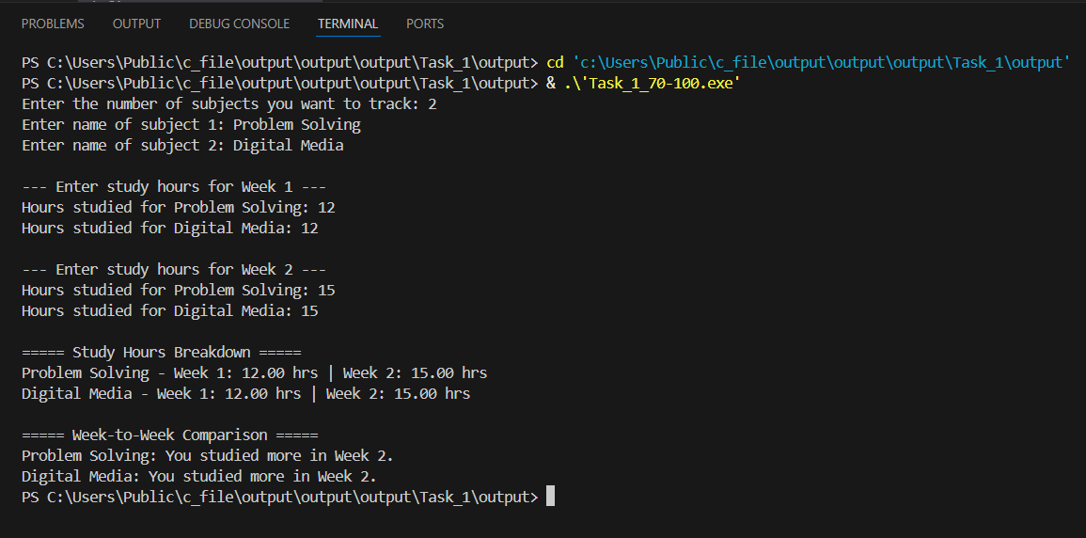

Figure 15: Output Task_1_70-100.2

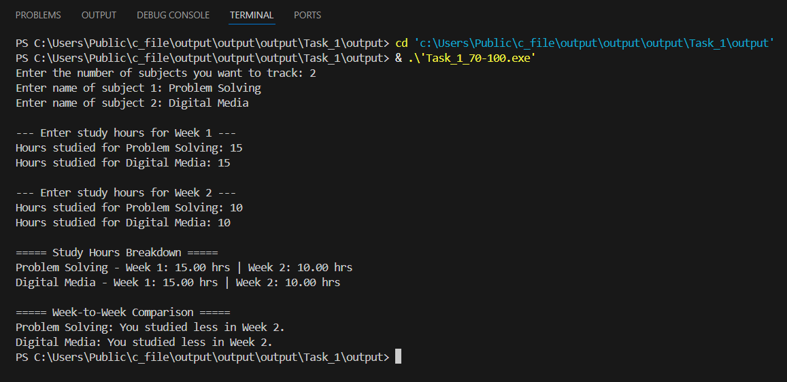

Figure 16: Output Task_1_70-100.3

# Task 2: Theme Park Ticketing System

## Basic ticket Price Calculation - Grade 40-49

This task introduces the basic logic of a theme ticketing system. The program uses predefined values for both the ride type and the ticket type, allowing it to calculate and display the corresponding ticket price without any user input. The goal is to demonstrate the use of variables, switch statements, and conditional logic to perform simple decision-making based on fixed values.

Below is the link to check the code in programiz:

<https://www.programiz.com/online-compiler/7ud644QNhHVe1>

Input:

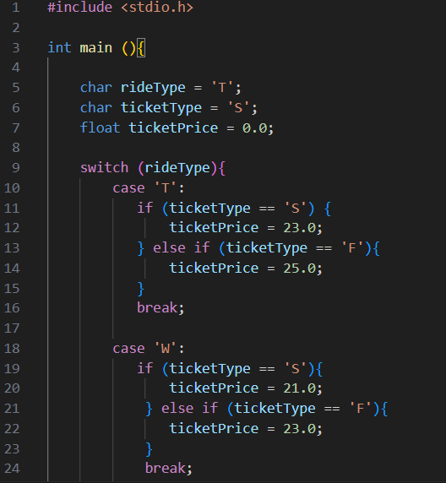

Figure 17: Input Task_2_40-49.1

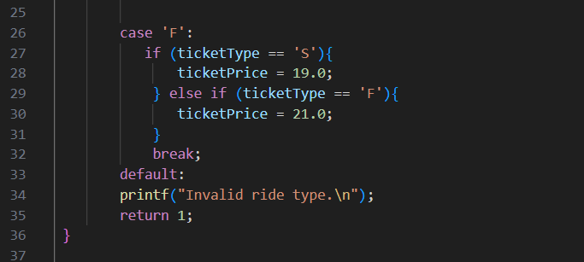

Figure 18: Input Task_2_40-49.2

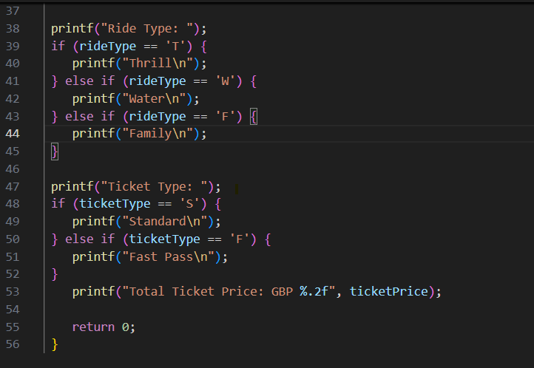

Figure 19: Input Task_2_40-49.3

**Code Explanation:** The code begins by declaring three variables: rideType, ticketType, and ticketPrice. The values of rideType and ticketType are set manually using fixed characters. A switch statement is used to check the selected ride type (T, W, or F), and within each case, an if-else block checks the ticket type (S or F) to assign the correct ticket price. After determining the price, the program prints the ride type, ticket type, and the total ticket price using printf.

Output:

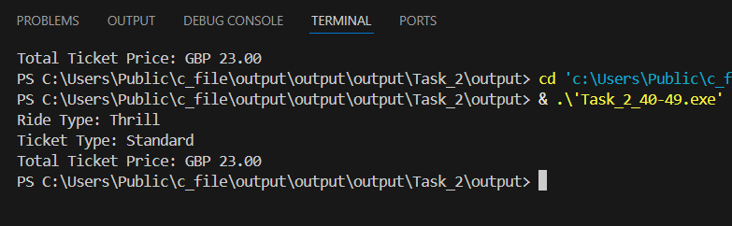

Figure 20: Output Task_2_40-49

## User Input for Tickets - Grade 50-59

This task enhances the ticketing system by introducing user input. Instead of using fixed values, the program now prompts yhe user to select the ride type (T, W, or F), the ticket type (S or F), and the number of tickets they wish to purchase. Based on the input, the program calculates the price of a single ticket using a switch statement and then multiplies it by the quantity to determine the total cost. All chosen options and the final cost are displayed in a clear format. The step introduces interactivity and basic arithmetic operations, reflecting more realistic use of input and output functions.

Below is the link to check the code in programiz:

<https://www.programiz.com/online-compiler/7Rc2sfcbAClZZ>

Ticket values were used as shown in the table below:



Table 5: Ticket values_Task_2_50-59

Input:

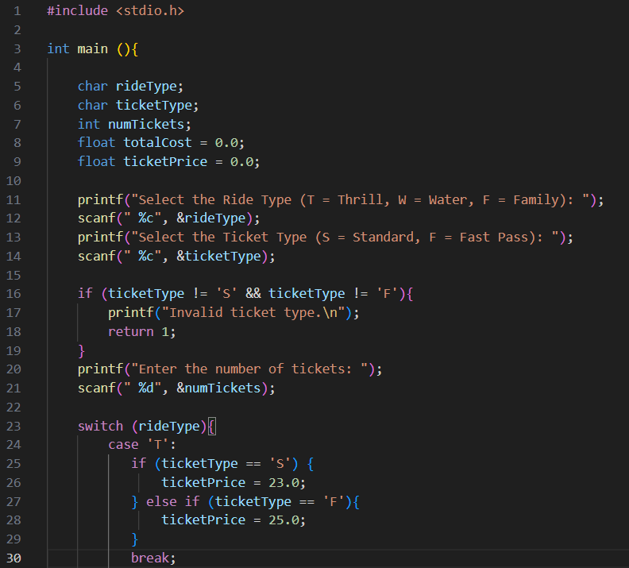

Figure 21: Input Task_2_50-59.1

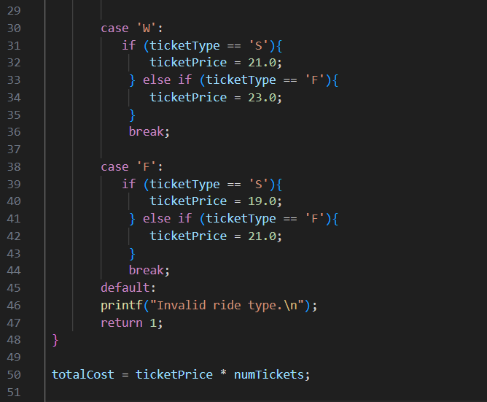

Figure 22: Input Task_2_50-59.2

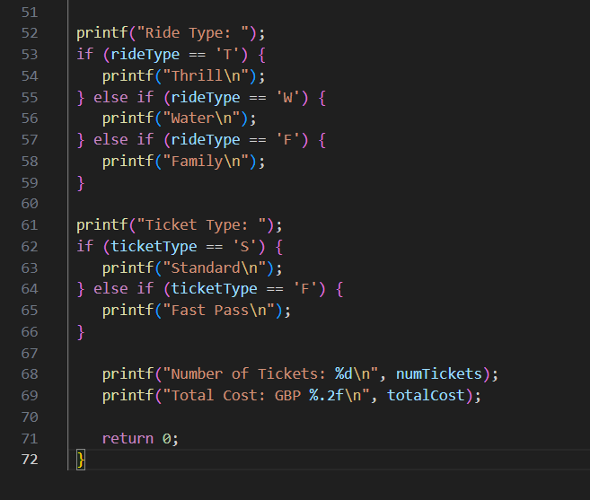

Figure 23: Input Task_2_50-59.3

**Code Explanation:** This program simulates a ticket booking system for different types of rides. The user is asked to choose a ride type (Thrill, Water, or Family), then select the ticket type (Standard or Fast Pass), and finally enter how many tickets they want to buy. Using conditional checks and a switch statement, the program decides the price of a ticket depending on the options chosen. It then multiplies the ticket price by the number of tickets to calculate the total cost. At the end, it prints a summary showing the ride type, ticket type, number of tickets, and the total price. By working on this code I practiced input validation, using switch cases, and calculating results based on user choices.

The table below contains the Code Explanation:



Table 6: Code Explanation Task_2_50-59

Output:

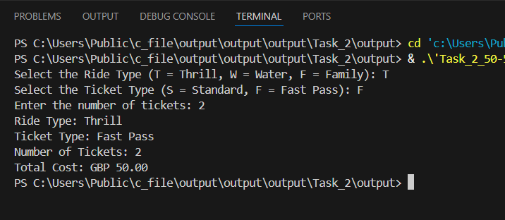

Figure 24: Output Task_2_50-59.1

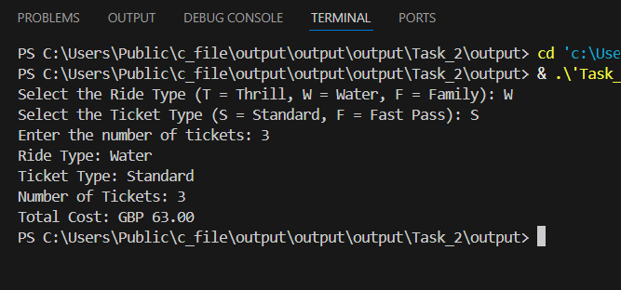

Figure 25: Output Task_2_50-59.2

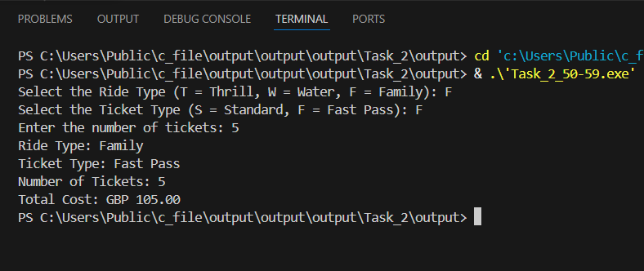

Figure 26: Output Task_2_50-59.3

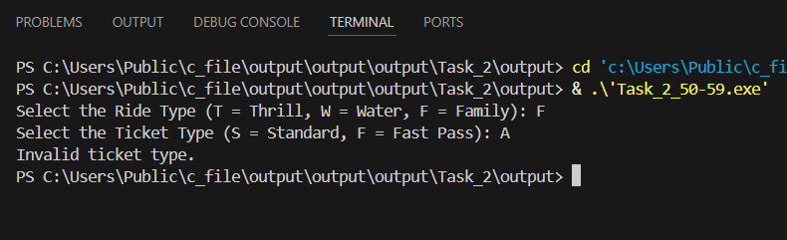

Figure 27: Output Task_2_50-59.4

## Discounts and Additional Services - Grade 60-69

This task improves the program by adding a 15% discount when buying more than 5 tickets and giving the user the option to include a meal package costing GBP 6.50 per ticket. The program calculates and shoes the total before discounts, the discount amount, the meal cost (if selected), and the final total cost.

Below is the link to check the code in programiz:

<https://www.programiz.com/online-compiler/0DncmPKF909o2>

Input:

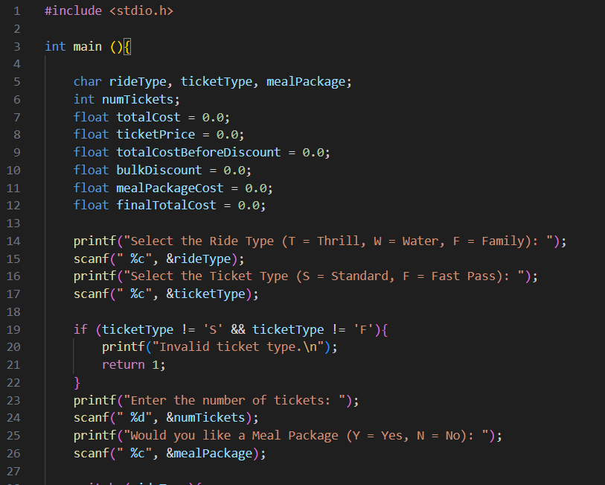

Figure 28: Input Task_2_60-69.1

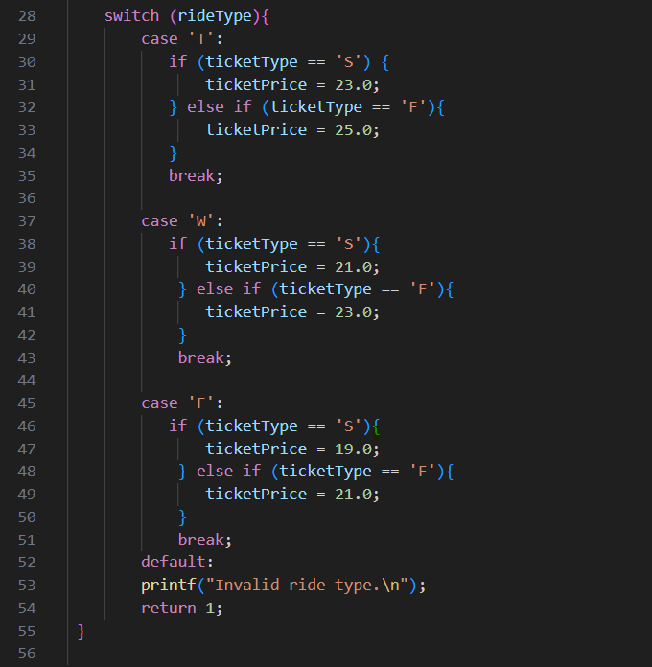

Figure 29: Input Task_2_60-69.2

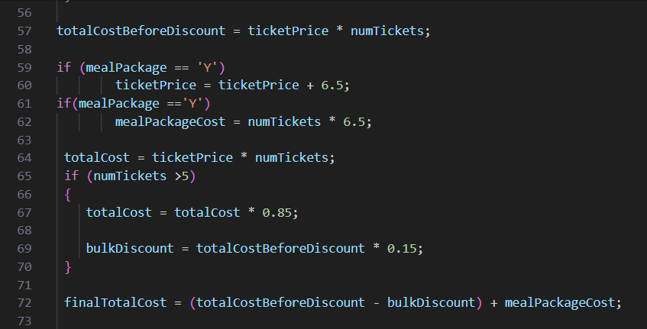

Figure 30: Input Task_2_60-69.3

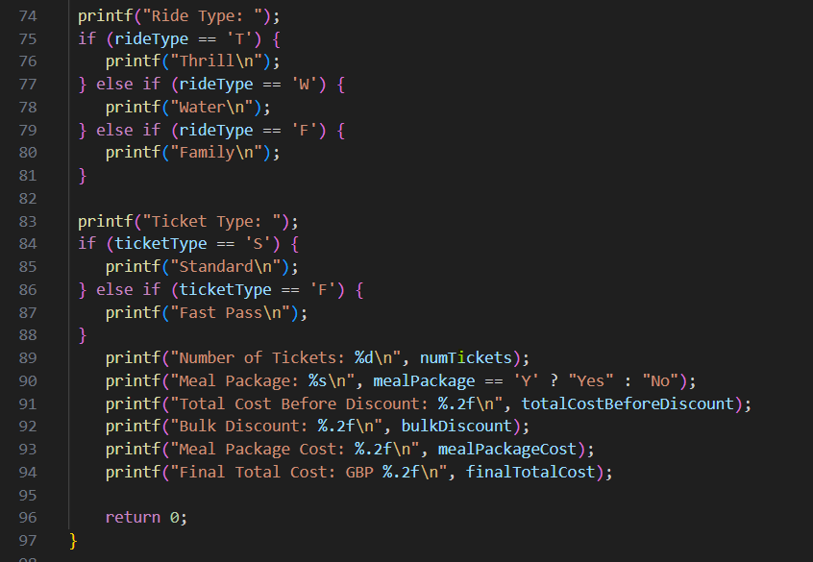

Figure 31: Input Task_2_60-69.4

**Code Explanation:** This program is an extended ticket booking system where the user selects a ride type, ticket type, number of tickets, and whether to include a meal package. The program first decides the ticket price based on the ride and ticket type, and then calculates the cost of the tickets. It also checks if the user added a meal package, and in that case it adds an extra cost of 6.5 per ticket.

Another feature is the bulk discount: if more than five tickets are bought, the total ticket price is reduced by 15%. At the end, the program prints a summary that includes the ride type, ticket type, number of tickets, if the meal package was chosen, the total cost before discount, the discount amount, the meal package cost, and the final total cost. By writing this program I practiced combining conditions, using arithmetic operations for discounts, and managing more detailed outputs to make the program feel closer to a real-world application.

The table below contains the Code Explanation:



Table 7: Code Explanation Task_2_60-69

Output:

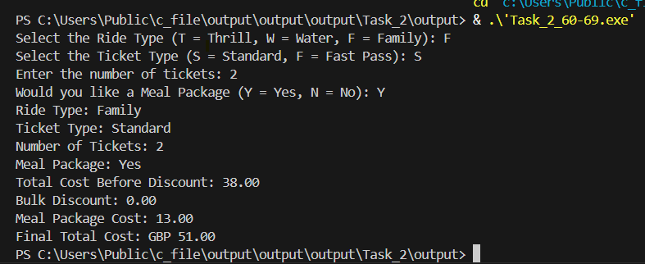

Figure 32: Output Task_2_60-69.1

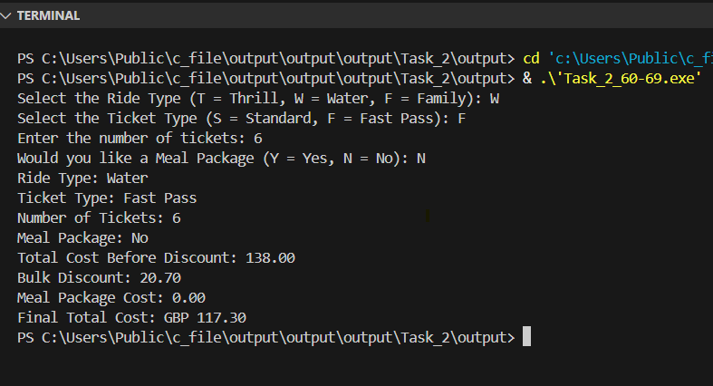

Figure 33: Output Task_2_60-69.2

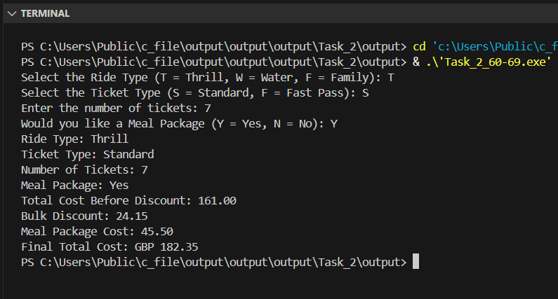

Figure 34: Output Task_2_60-69.3

## Menu-Driven System - Grade 70-100

This task requires the creation of a complete menu-driven ticketing system for theme park. The program should display a menu three options: Book Tickets, View Ticket Prices, or Exit the Program. Using a switch statement, the user selects an option and can interact with the menu repeatedly until they choose to exit. When booking tickets, the program must collect and validate user inputs for ride type, ticket type, and number of tickets, ensuring the ticket quantity is greater than zero. If selected, an optional meal package is added to the total cost. The program should also apply a 15% bulk discount for bookings of more than 5 tickets. Finally, the program should display a full booking summary including all inputs, applied discounts, extra service costs, and the final total cost. The sytem combines conditional logic, loops, input validation, and user interaction to simulate a real-world ticket booking experience.

Below is the link to check the code in programiz:

<https://www.programiz.com/online-compiler/07DMofCF8O5l0>

Input:

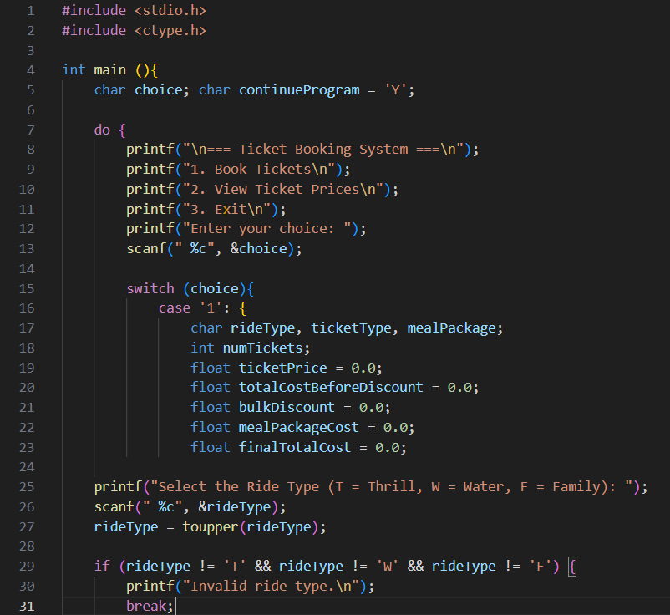

Figure 35: Input Task_2_70-100.1

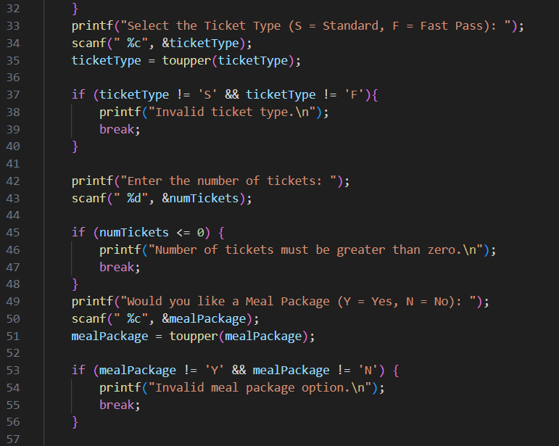

Figure 36: Input Task_2_70-100.2

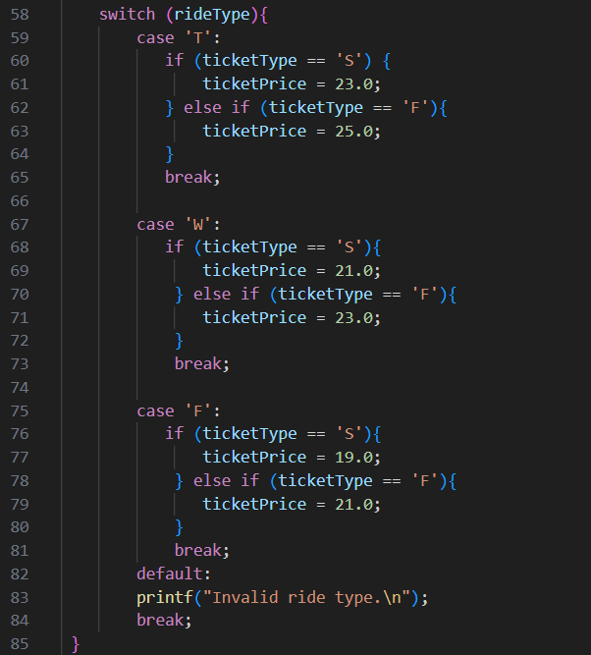

Figure 37: Input Task_2_70-100.3

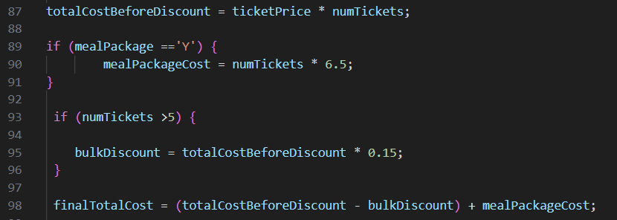

Figure 38: Input Task_2_70-100.4

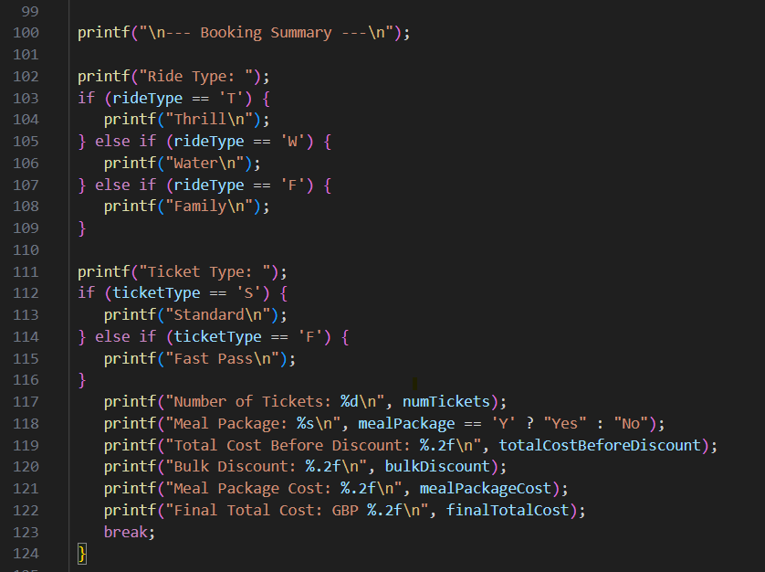

Figure 39: Input Task_2_70-100.5

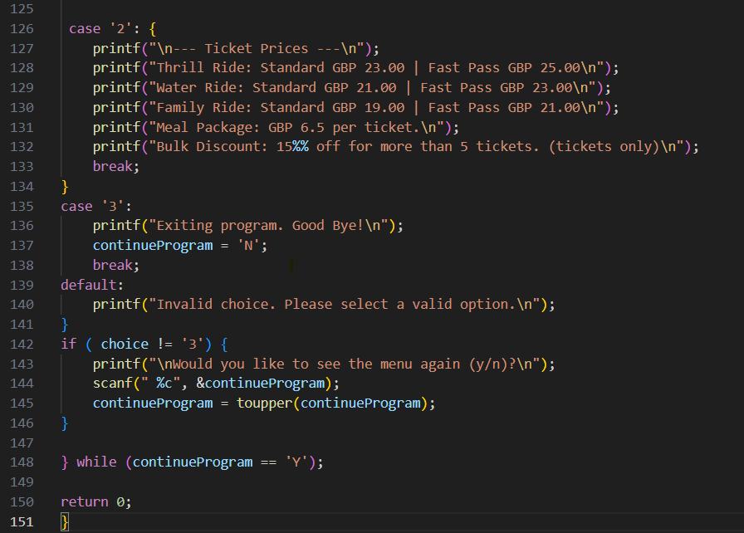

Figure 40: Input Task_2_70-100.6

**Code Explanation:** This version of the ticket booking system introduces a menu with three options: booking tickets, viewing ticket prices, or exiting the program. The menu runs inside a loop, so the user can choose an option and then return to the main menu until they decide to exit. When booking tickets, the program asks for the ride type, ticket type, number of tickets, and whether the meal package should be included. It validates each input to make sure only valid choices are accepted. Based on these inputs, it calculates the total cost, applies a bulk discount if more than five tickets are purchased, and adds the meal package cost if selected. A detailed booking summary is then displayed. In addition to booking, the user can also select the option to view ticket prices, which shows all the costs for each ride type and ticket type, as well as the meal package and bulk discount information. The program keeps running until the exit option is chosen. By developing this code I could practice using loops, switch cases with multiple options, input validation, and combining all the earlier features into a more complete system that feels closer to a real application.

The table below contains the Code Explanation:



Table 8: Code Explanation Task_2_70-100

Output:

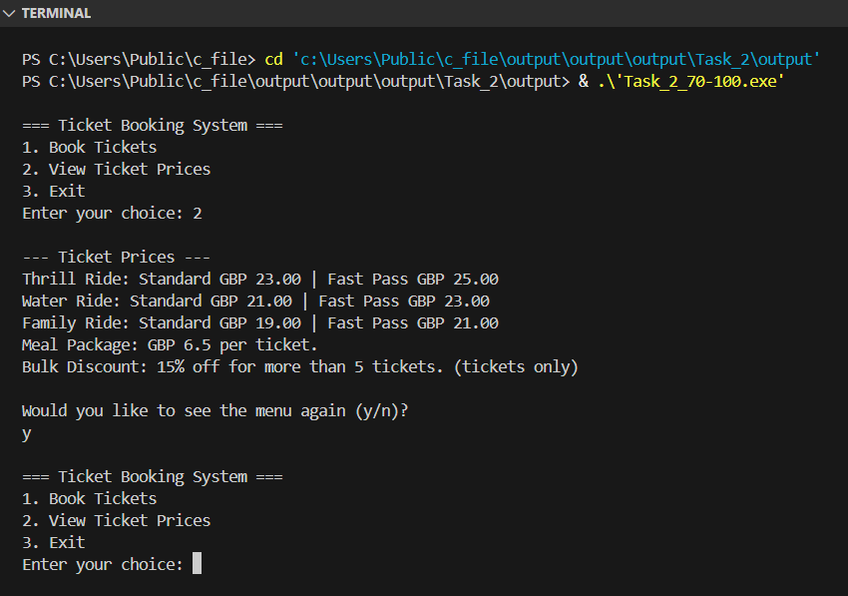

Figure 41: Output Task_2_70-100.1

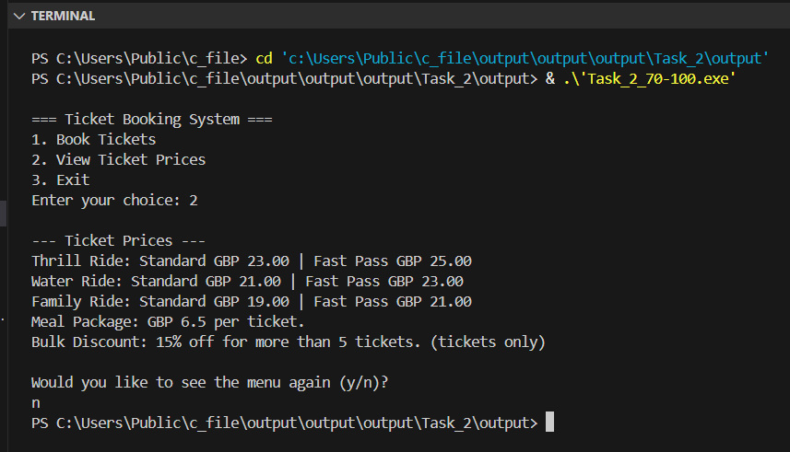

Figure 42: Output Task_2_70-100.2

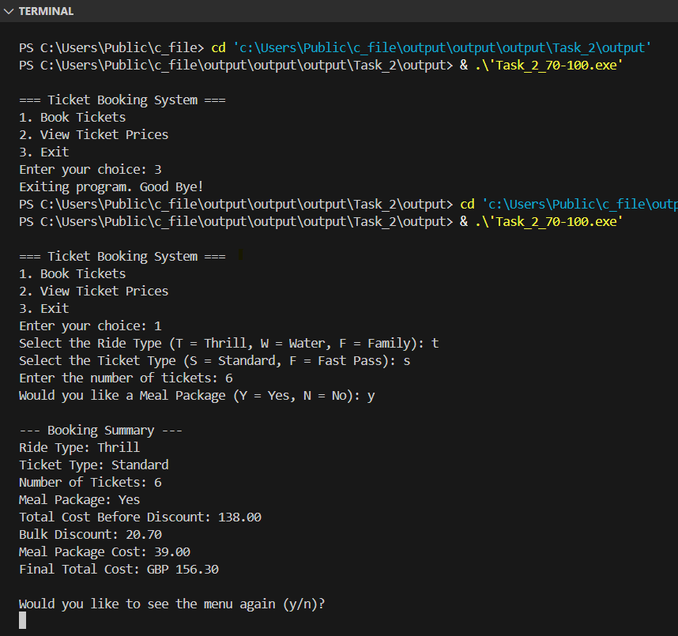

Figure 43: Output Task_2_70-100.3

# Task 3: Fitness Tracker Loop Challenge

## Grade 40-49

This task involves creating a basic fitness tracker program. The user is asked to enter the number of steps taken in one day. The program then calculates the calories burned using a fixed conversion rate (between 0.04 and 0.06) and displays the results. This introduces basic input handling, arithmetic calculation, and output display.

Below is the link to check the code in programiz:

<https://www.programiz.com/online-compiler/7lKj3eMbKXeav>

Input:

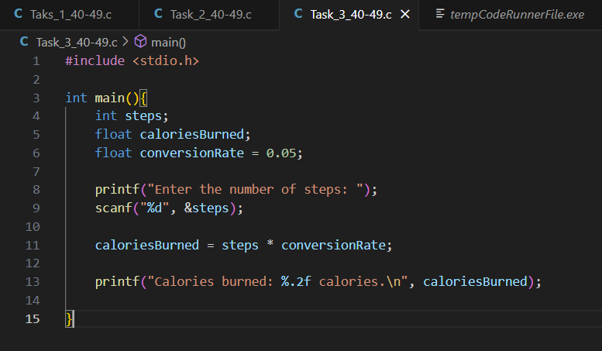

Figure 44: Input Task_3_40-49

**Code Explanation:** The program is designed to convert the number of steps taken in a day into calories burned. It begins by declaring three variables: steps, and conversionRate, which is set to a fixed value of 0.05. The user is prompted to enter the number of steps using printf, and the input is read with scanf. The program then calculates the calories burned by multiplying the steps by conversion rate.

Output:

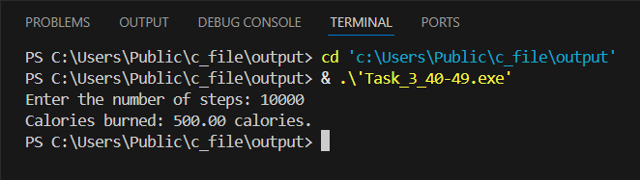

Figure 45: Output Task_3_40-49

## Grade 50-59

This Task requires modifying the previous step-counting program to allow the user to input step for multiple days. The program should use a loop to repeatedly ask the user for the number of steps walked each day, calculate the calories burned, and display the result. After each entry, the user should be asked if they want to enter data for another day. The loop continues based on the user’s response. When the user decides to stop, the program should display the total numbers of days tracked and the total calories burned over all days. This allows the user to keep track of their daily walking activity and the total calories burned.

Below is the link to check the code in programiz:

<https://www.programiz.com/online-compiler/6ENI8UqCrktPJ>

Input:

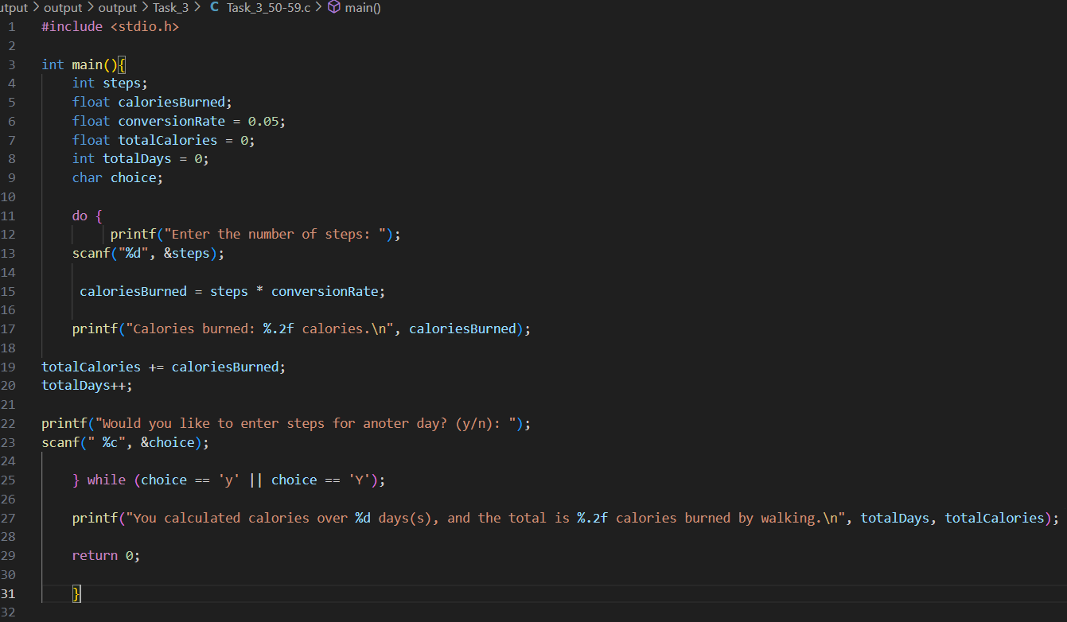

Figure 46: Input Task_3_50-59

**Code Explanation:** This programme calculates how many calories are burned by walking, based on the number of steps entered by the user. For each day, the user types the steps, and the programme multiplies this by a fixed conversion rate to find the calories burned. The process repeats inside a loop, where the user can choose to enter data for more days. At the end, the programme shows the total number of days recorded and the total calories burned. By working on this task I could practise using loops, user input, variables that accumulate values, and simple arithmetic in C.

The table below contains the Code Explanation:



Table 9: Code Explanation Task_3_50-59

Output:

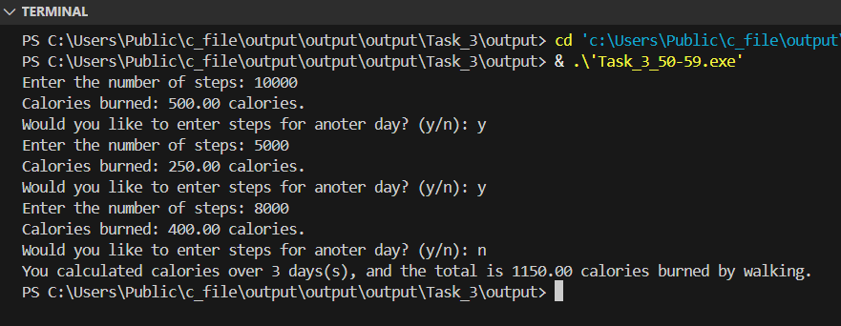

Figure 47: Output Task_3_50-59

## Grade 60-69

This task requires adding a menu system that allows the user to choose what kind of activity to track: steps, calories, or walking distance. Based on the user’s choose, the program should perform the correct calculation using conditional logic. For example, if the user selects steps, it calculates burned from steps. If they choose distance, the program convert kilometres to steps and calories (assuming 1 step = 0.0008km). The user should be able to return to the menu to add more entries or exit the program. When the user decides to quit, the program must display a full summary of all entries, including the total calories burned.

Below is the link to check the code in programiz:

<https://www.programiz.com/online-compiler/0Uzuib0uOZn3f>

Input:

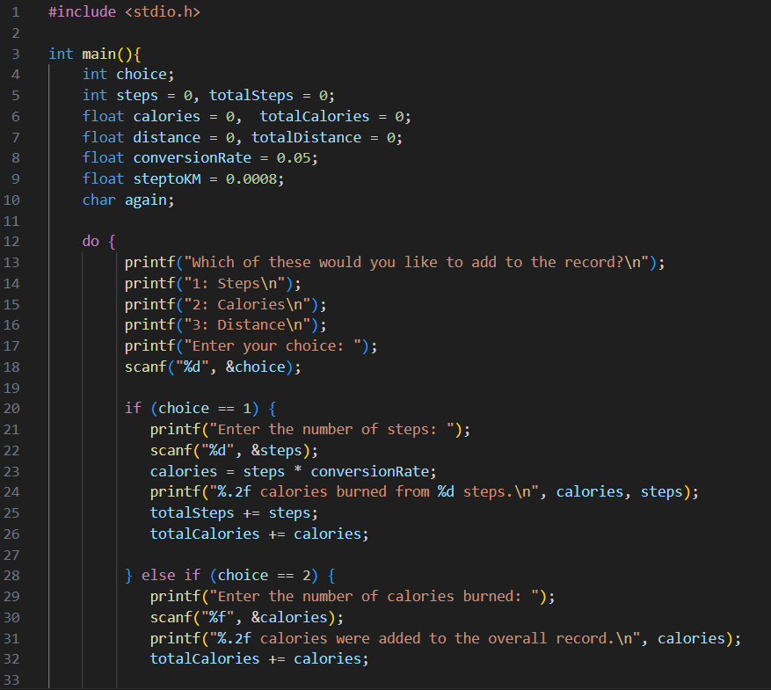

Figure 48: Input Task_3_60-69.1

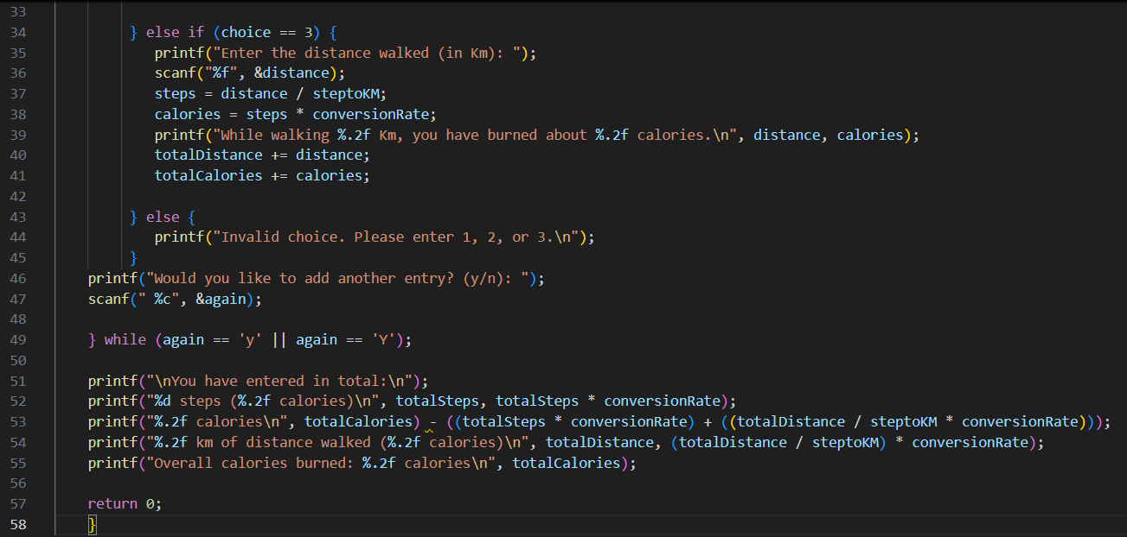

Figure 49: : Input Task_3_60-69.2

**Code Explanation:** This programme works as a small fitness tracker where the user can choose to record steps, calories, or distance. Depending on the choice, the programme asks for the value, performs the necessary calculations, and updates the totals. For example, if steps are entered, it converts them to calories; if distance is entered in kilometres, it calculates the equivalent steps and calories. It also checks for invalid input and asks the user again if the choice is not correct.

At the end, the programme prints a summary with the total number of steps, calories, and distance walked, together with the overall calories burned. The process runs inside a loop so that multiple entries can be added until the user decides to stop. By building this task I could practise using conditional statements, loops, accumulators for totals, and formulas to convert between steps, distance, and calories.

The table below contains the Code Explanation:



Table 10: Code Explanation Task_3_60-69

Output:

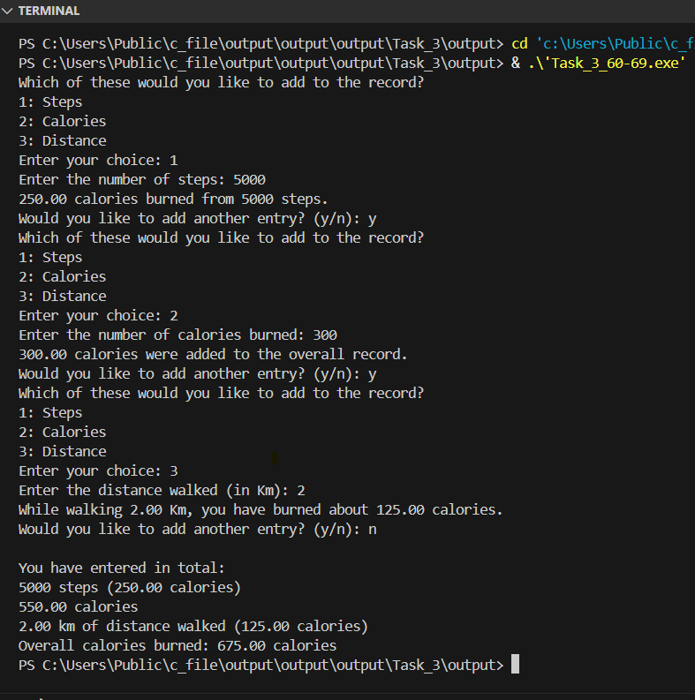

Figure 50: Output Task_3_60-69.1

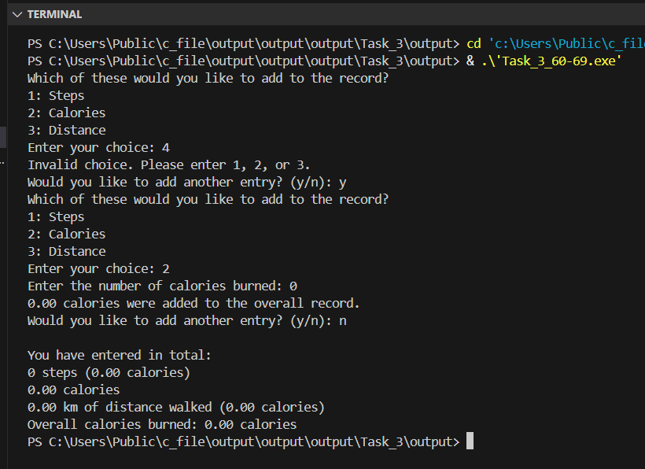

Figure 51: Output Task_3_60-69.2

## Grade 70-100

In this final stage of the fitness tracker task, the program must become more advanced and interactive. The user should first be allowed to set a daily calorie goal at the start of the program. Then, as they log their physical activities, the program should calculate calories burned and display progress toward that goal as a percentage.

Additionally, when entering steps or distance, the user must choose an intensity level (Low, Medium, or High), which will affect the calorie conversion rate.

The program should include strong input validation. This means checking that all numbers entered are positive and that menu selections are valid. If the user enters anything incorrect, the program should not crash, it should ask again until the input is correct. Below is the link to check the code in programiz:

<https://www.programiz.com/online-compiler/8udoVTg6jHwfB>

Input :

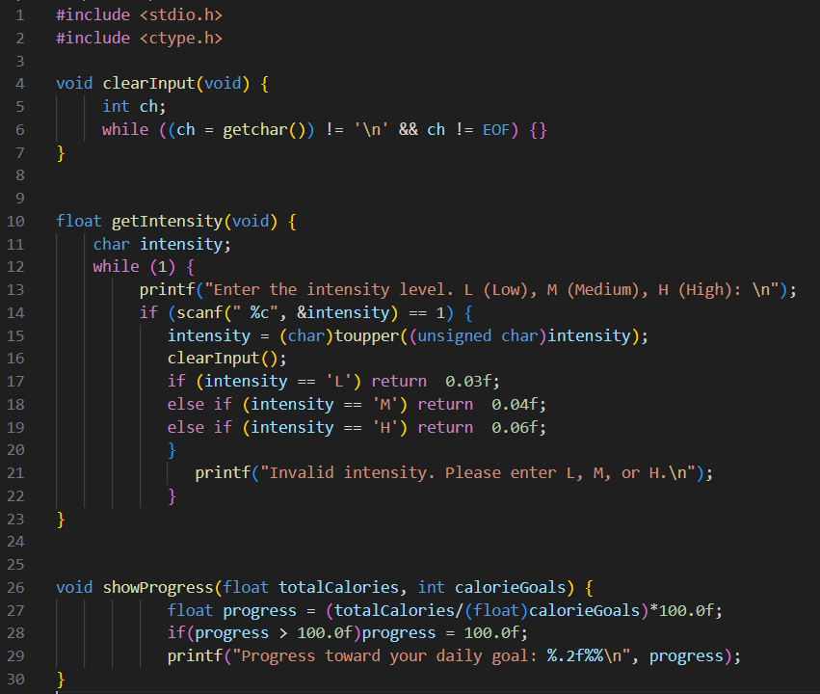

Figure 52: Input Task_3_70-100.1

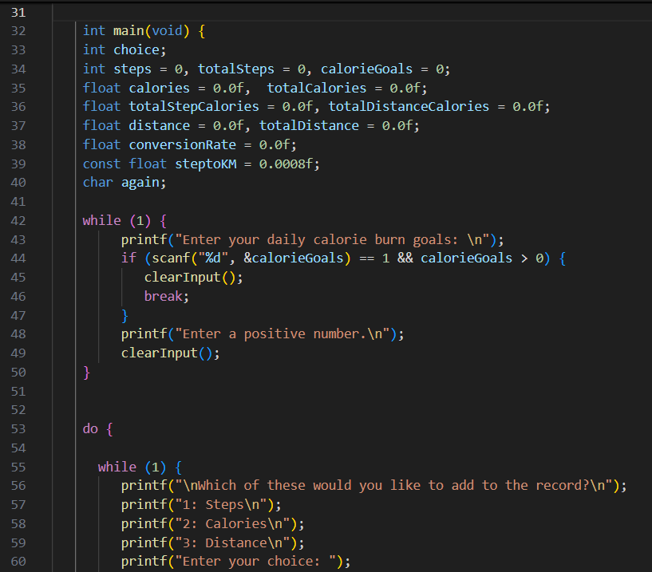

Figure 53: Input Task_3_70-100.2

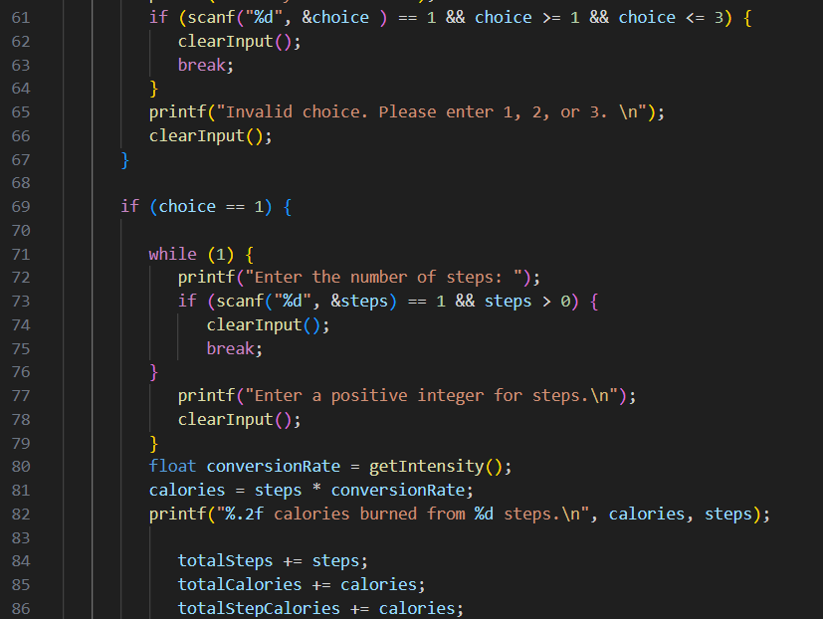

Figure 54: Input Task_3_70-100.3

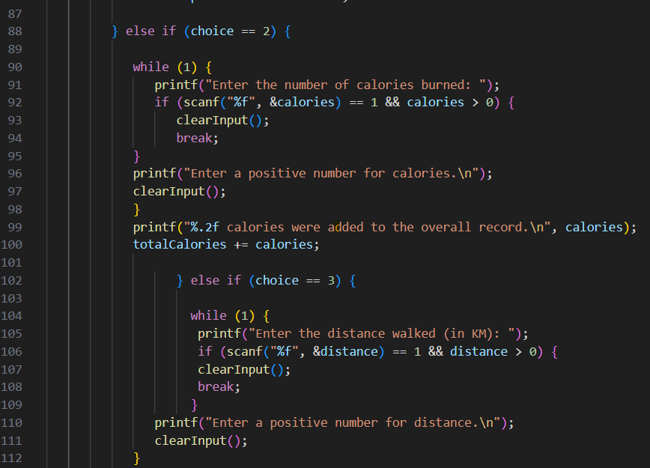

Figure 55: Input Task_3_70-100.4

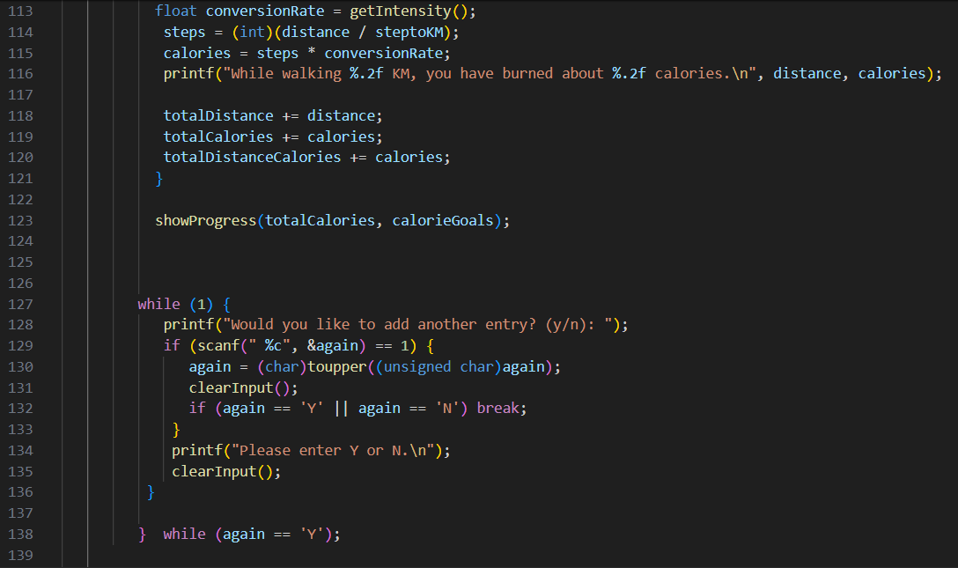

Figure 56: Input Task_3_70-100.5

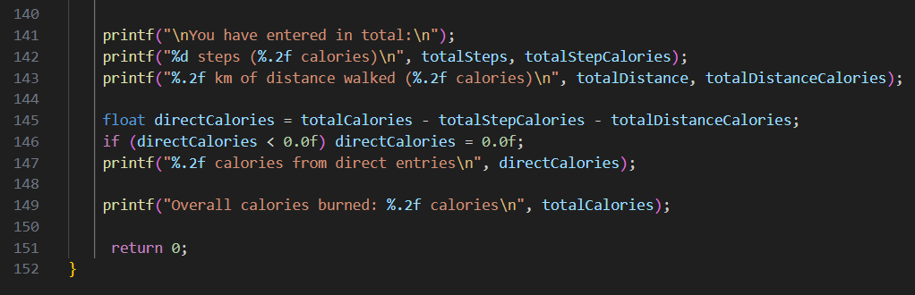

Figure 57: Input Task_3_70-100.6

**Code Explanation:** This programme is an improved version of the fitness tracker. At the start, the user sets a daily calorie burn goal, and then chooses between adding steps, calories, or distance. Each input is validated so that only positive numbers are accepted. The validation works by placing each scanf inside a loop that repeats until a valid value is entered. For menu choices and yes/no decisions, the programme accepts only specific valid characters 1–3 for the menu, Y/N for continuing, L/M/H for intensity and keeps asking until the input is correct. When steps or distance are entered, the programme also asks for an intensity level (Low, Medium, or High), which changes the conversion rate used to calculate calories burned. All the values are added to running totals so that steps, distance, and calories are tracked separately as well as together. Another feature is the progress check: after each entry, the programme shows how close the user is to reaching their daily goal. At the end, it prints a full summary with steps, distance, direct calorie entries, and the total calories burned. One limitation is that if the user types non-numeric text: e.g., “abc” instead of a number, the validation does not always catch this correctly because scanf leaves invalid characters in the input buffer. This was not addressed, as handling such cases would require more advanced input handling techniques than were necessary for this task. By creating this code I could practise input validation, breaking the programme into functions, using loops and conditions to control the flow, and managing multiple accumulators for different types of data. It also gave me a better sense of how a real fitness tracking application might work.

The table below contains the Code Explanation:



Table 11: Code Explanation Task_3_70-100

Output:

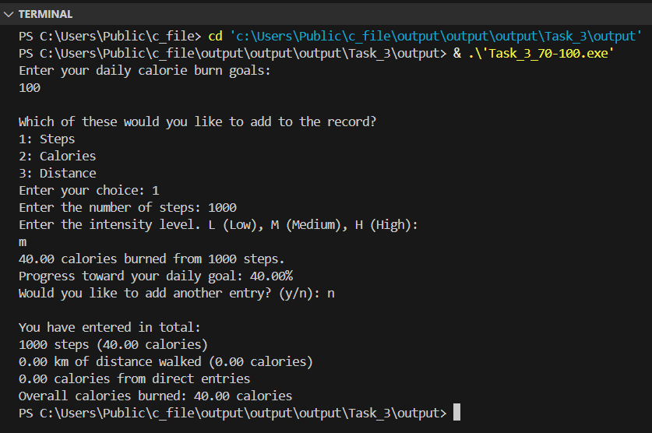

Figure 58: Output Task_3_70-100.1

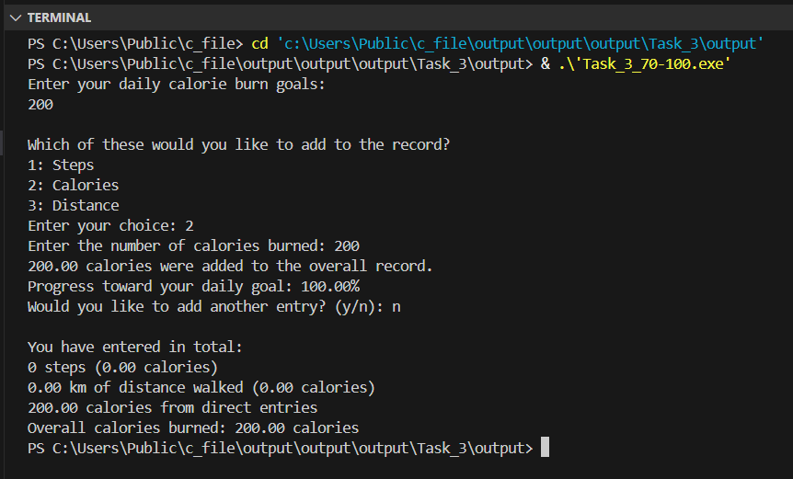

Figure 59: : Output Task_3_70-100.2

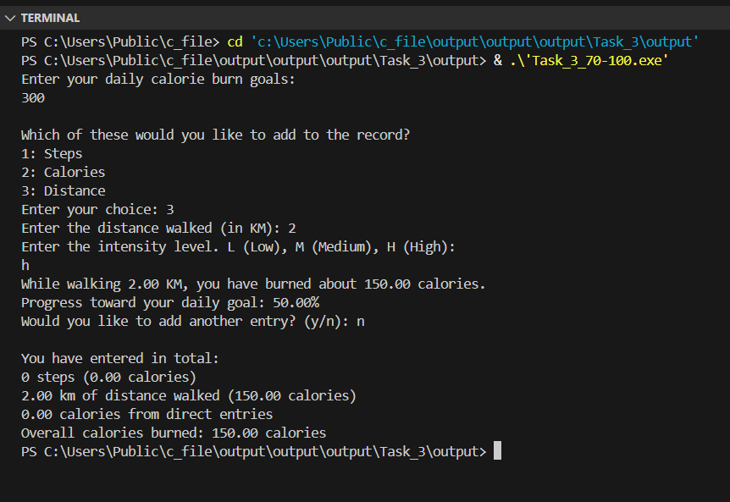

Figure 60: : Output Task_3_70-100.3

# Task 4: Calendar Printer

## Grade 40-49

This task requires creating a basic calendar printing program for any selected month of the year 2025. The program asks the user to enter two inputs: the number of the month (from 1 to 12) and the weekday the month starts on (1 for Monday to 7 for Sunday). Then, using a fixed number of days (such as 30), the program displays a basic calendar layout. The aim is to show understanding of loops, conditionals, and how to format calendar output in C.

Below is the link to check the code in programiz:

<https://www.programiz.com/online-compiler/67DRs2Jv5OcXe>

Input:

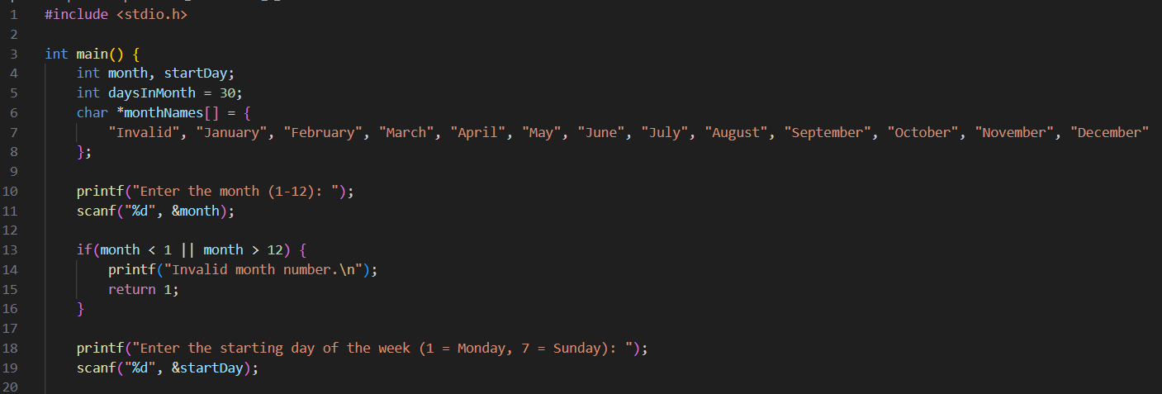

Figure 61: Input Task_4_40-49.1

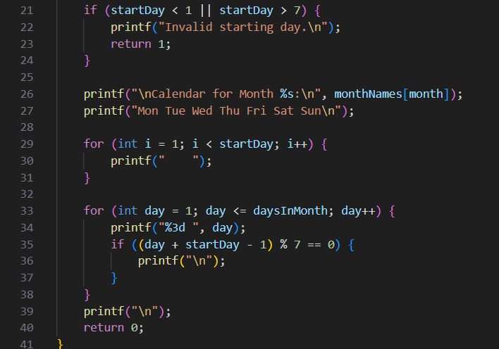

Figure 62: Input Task_4_40-49.2

The table below contains the Code Explanation:



Table 12: Code Explanation Task_4_40-49

Output:

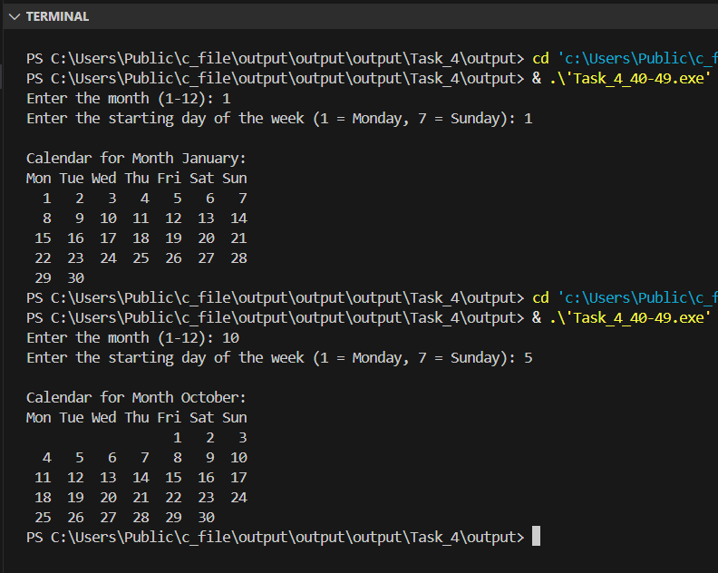

Figure 63: Output Task_4_40-49.1

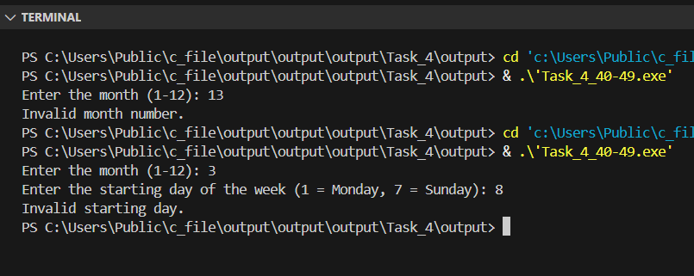

Figure 64: Output Task_4_40-49.2

## Grade 50-59

This task requires creating a calendar program that uses the correct number of days for select mont in 2025. The program should include a logical structure. Such as an array, to store the number of days in each month. It must print the full calendar layout for the selected month, based on user input. Additionally, the program should count how many Saturdays and Sundays appear in that month and display the totals. Basic input validation must be included to ensure that the month number and weekday values are valid. Below is the link to check the code in programiz:

<https://www.programiz.com/online-compiler/5moyOhIPXzD1Q>

Input:

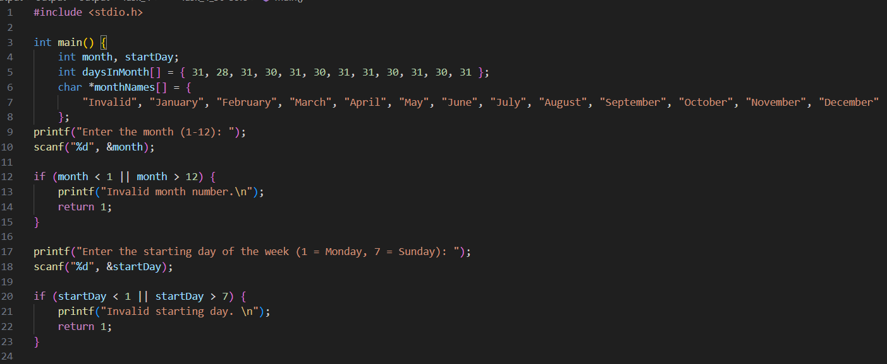

Figure 65: Input Task_4_50-59.1

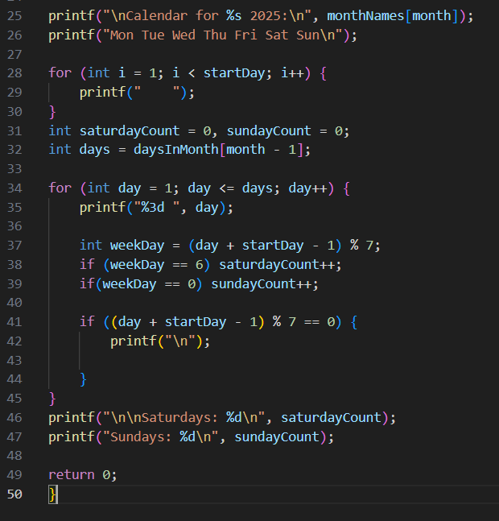

Figure 66: Input Task_4_50-59.2

**Code Explanation**: This programme asks the user for the number of a month and the day of the week it begins, then generates an organised calendar for that month in 2025. In addition to displaying the days correctly aligned, it also counts how many Saturdays and Sundays are in the month, which helped me to practise using arrays, loops, and conditions to format the output.

The table below contains the Code Explanation:



Table 13: Code Explanation Task_4_50-59

Output:

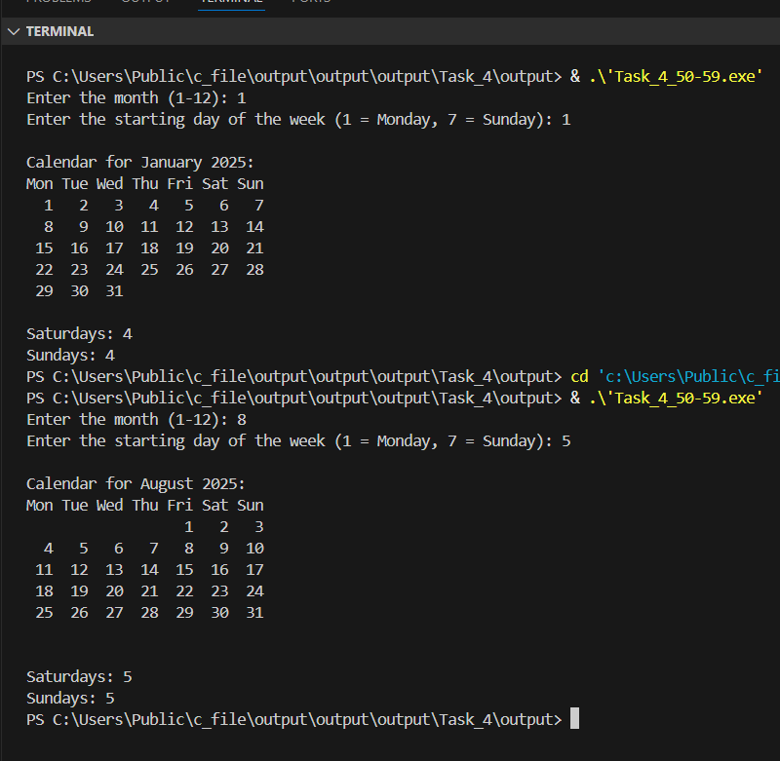

Figure 67: Output Task_4_50-59

## Grade 60-69

This task requires improving the previous calendar program by automatically calculating the starting weekday of a selected month in the year 2025. Instead of asking the user which day the month begins on, the program must use date logic or modular arithmetic to determine it. Since January 1st day of any chosen month based on the number of days passed since the beginning of the year. This enhancement removes user guesswork and makes the calendar output more accurate.

Below is the link to check the code in programiz:

<https://www.programiz.com/online-compiler/52khKrSdsfx88>

Input:

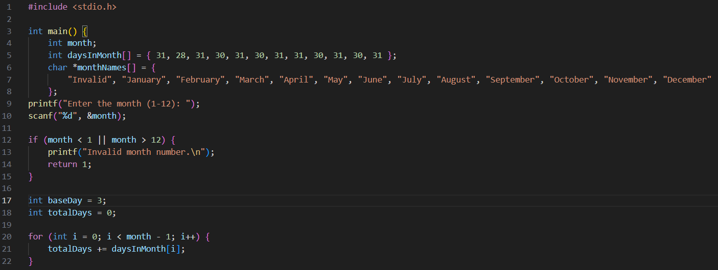

Figure 68: Input Task_4_60-69.1

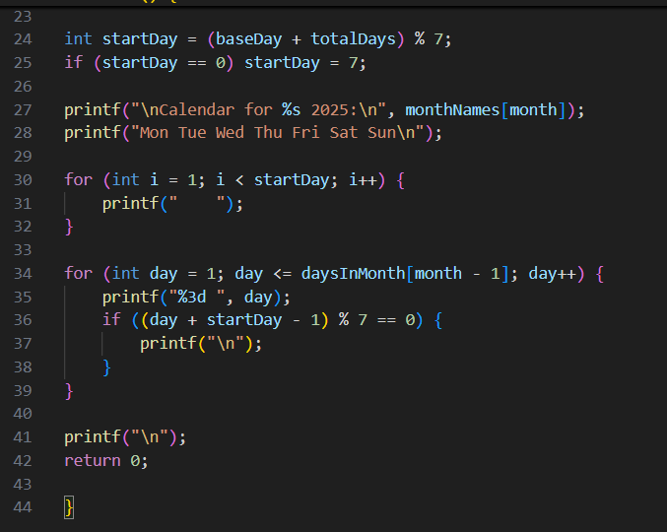

Figure 69: Input Task_4_60-69.2

**Code Explanation:** This programme generates a calendar for any month of the year 2025. The user first enters the month number, and the programme validates the input. Instead of asking for the starting weekday, the programme calculates it automatically using a fixed reference point: 1 January 2025 is set as day 3, which means Wednesday (following the convention 1 = Monday, …, 7 = Sunday). To determine the weekday of the 1st of the chosen month, the programme adds up the number of days in all the months before it and then adds this total to the base day. The modulo operator %7 is used to cycle through the days of the week, with a small adjustment so that 0 corresponds to Sunday.

Once the correct starting day is known, the programme prints the month name, followed by the weekday headers. Empty spaces are inserted before the 1st of the month so that it is aligned under the correct weekday. Each day is then printed in order, and a line break is added whenever the loop reaches a Sunday, which produces a properly formatted calendar grid. By doing this task I learned how arrays, loops, and modular arithmetic can be combined to perform date calculations and generate structured output.

The table below contains the Code Explanation:



Table 14: Code Explanation Task_4_60-69

Output:

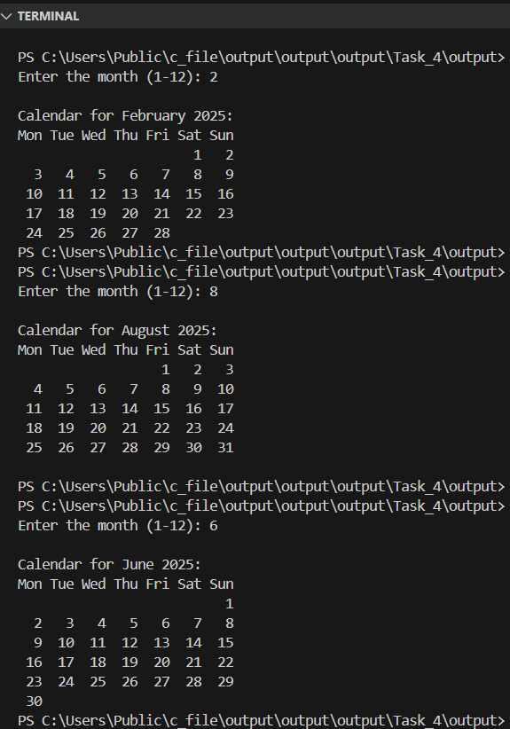

Figure 70: Output Task_4_60-69

## Grade 70-100

This task builds on the previous calendar program by adding interactive features. The user can enter a specific date, which will be highlighted in the printed calendar using special symbols. The program will also offer options to navigate to the previous or next month after displaying the current one. All user inputs must be validated to ensure correctness, and the solution should include a clear explanation of the logic used and any challenges faced during implementation.

Below is the link to check the code in programiz:

<https://www.programiz.com/online-compiler/7dIN97gF4htY1>

Input:

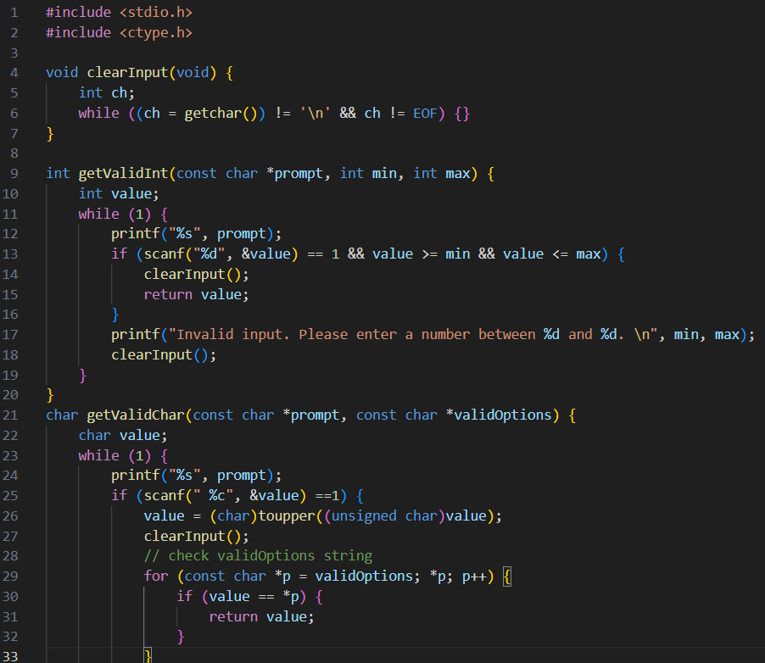

Figure 71: Input Task_4_70-100.1

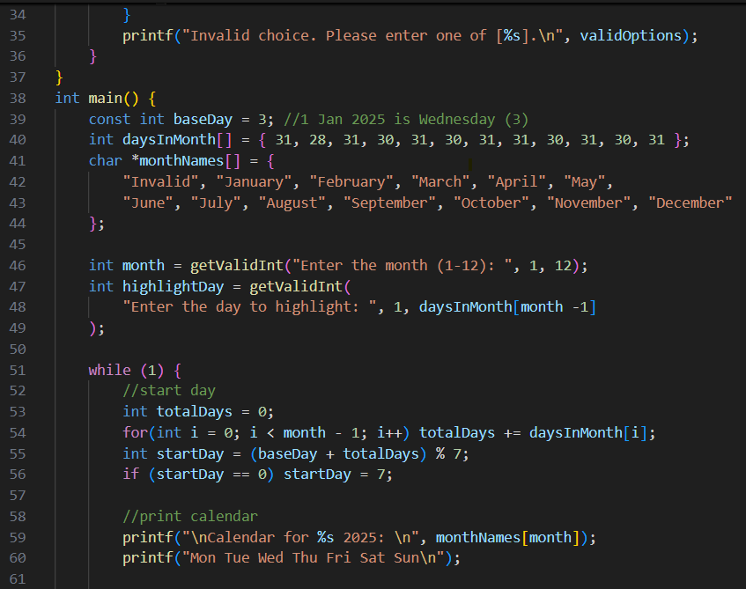

Figure 72: Input Task_4_70-100.2

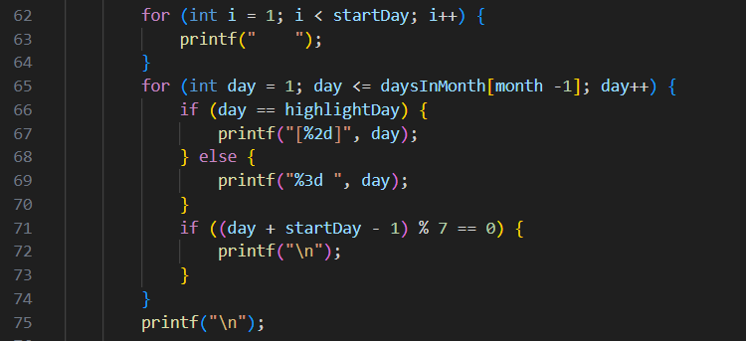

Figure 73: Input Task_4_70-100.3

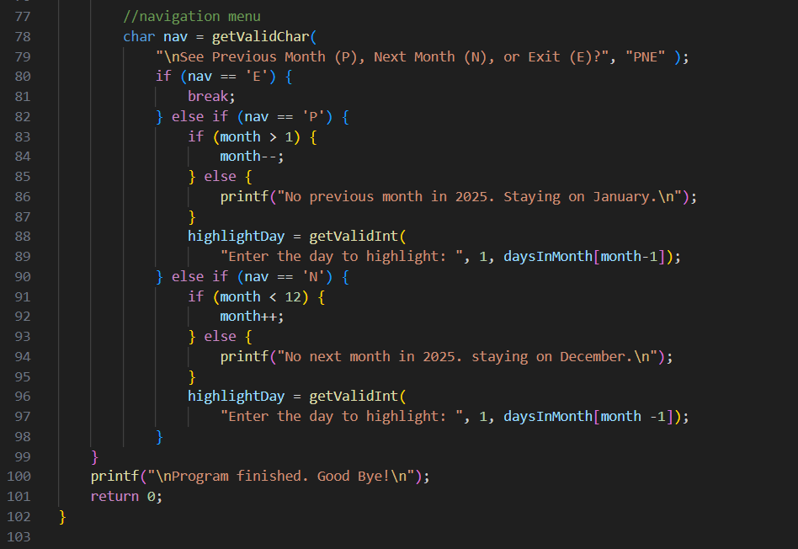

Figure 74: Input Task_4_70-100.4

**Code Explanation:** This programme calculates the starting weekday for any month in 2025 by adding the days of all preceding months to a fixed base day and then applying modular arithmetic. The base day is set to 3, meaning 1 January 2025 is Wednesday under the convention 1 = Monday … 7 = Sunday. After computing startDay = (baseDay + totalDays) % 7, a small adjustment maps 0 to 7 so that Sunday is treated as day 7. With this start day, the programme prints the month name and the weekday headers, inserts the right amount of spacing before day 1, and then prints each date in order, breaking the line whenever a Sunday is reached. A looped navigation menu allows moving to the previous or next month, and the highlighted day is re-validated each time to respect the month’s length.

Input validation is handled by small helper functions. getValidInt keeps prompting until a number within a required range is entered; getValidChar restricts choices (e.g., P/N/E), normalises case with toupper, and only accepts allowed options; clearInput() flushes leftover characters so subsequent reads are reliable. I had two main challenges: first, aligning the weekdays (I solved it by treating Sunday as 7), and second, making sure the highlighted day still kept the calendar aligned (I solved it by printing the day in a special format [%2d]) while non-highlighted days use %3d , both are four characters wide, so columns stay aligned. Finally, I tested the program with different months like February (28 days) and months with 30 and 31 days to make sure it still worked correctly, even at the edges of the year. By completing this task I learned how to combine input validation, modular arithmetic, and careful output formatting to build a user-friendly calendar system. While some earlier extensions, such as explicitly displaying the first weekday of each month or counting weekend days, were not included in this version, this was a deliberate decision to prioritise clarity and functionality over completeness, with awareness that such features could be integrated if required.

The table below contains the Code Explanation:



Table 15: Code Explanation Task_4_70-100

Output:

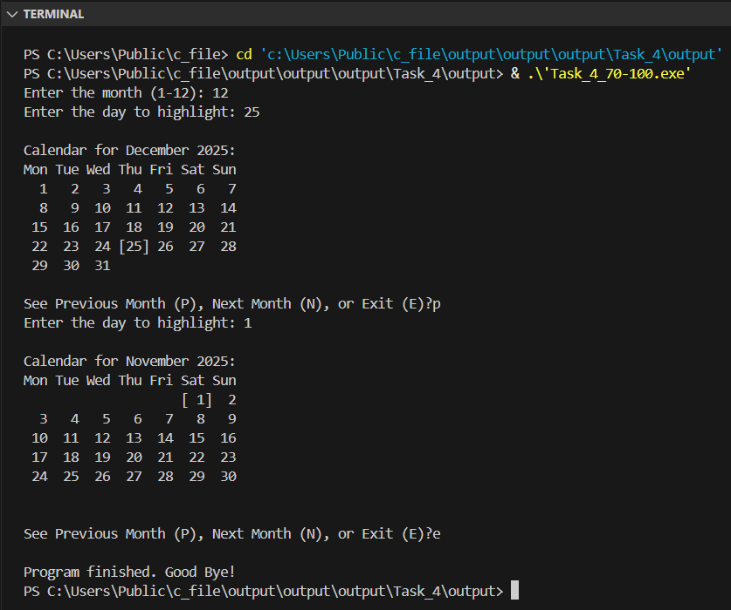

Figure 75: Output Task_4_70-100.1

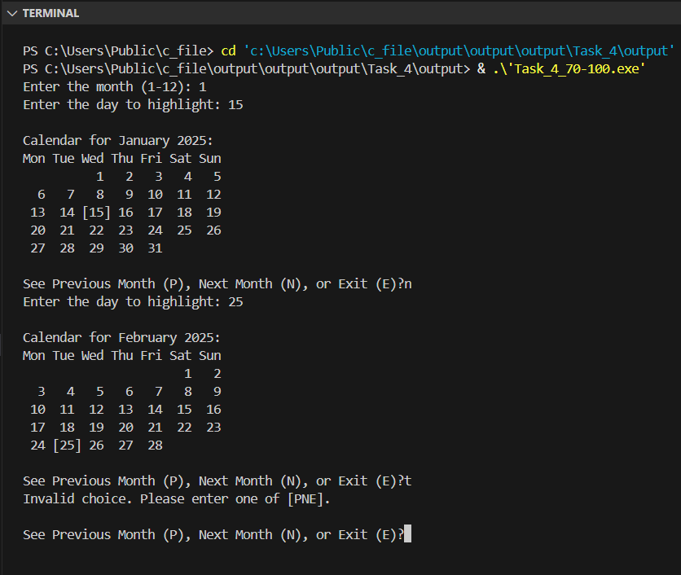

Figure 76: Output Task_4_70-100.2

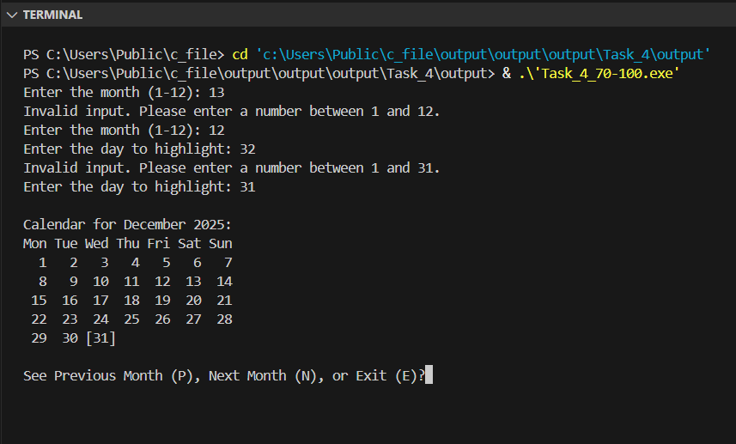

Figure 77: Output Task_4_70-100.3

# Task 5: Temperature Logger

This task involves creating a temperature logging program for up to 30 days. The user first enters the number of days, and the program stores daily temperatures in an array. A menu system then allows the user to perform various analyses, including viewing all readings, calculating the overall average, finding the highest and lowest temperatures, counting days above or below a chosen threshold, computing weekly averages, reversing the order of readings, and exiting the program.

## Grade 40-49

For this stage, the program should let the user choose how many days they want to record temperatures for, then store those readings in an appropriately sized array. Menu options need to be implemented: one to display all stored temperature and another to calculate and display the overall average temperature. The program should demonstrate both features by showing the list of entered temperatures and the calculated average. Below is the link to check the code in programiz:

<https://www.programiz.com/online-compiler/1AF43EQwfsZJh>

Input:

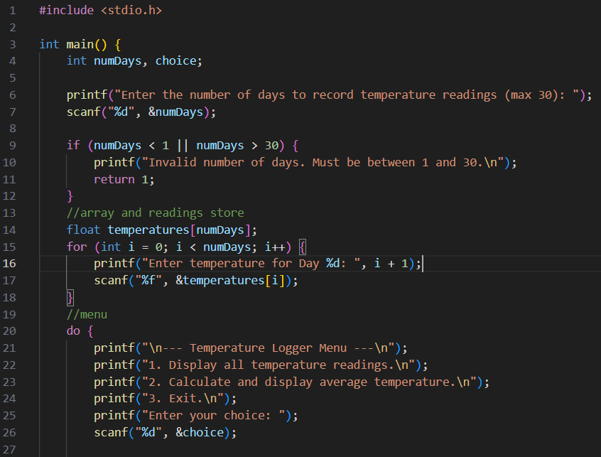

Figure 78: Input Task_5_40-49.1

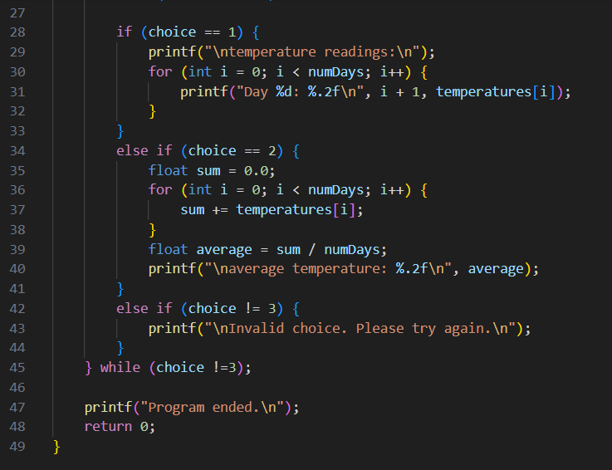

Figure 79: Input Task_5_40-49.2

The table below contains the Code Explanation:



Table 16: Code Explanation Task_5_40-49

Output:

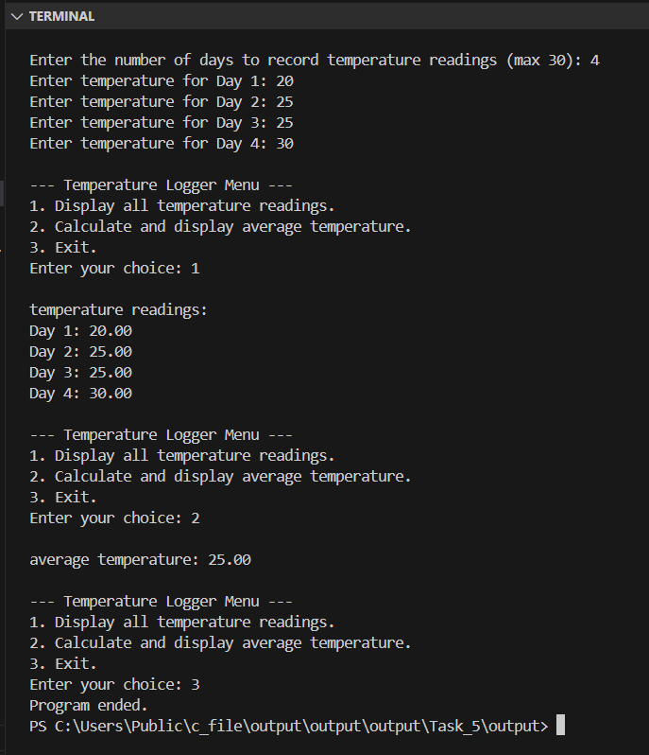

Figure 80: Output Task_5_40-49

## Grade 50-59

This version of the temperature logger builds on the previous task by adding two new menu options and improving program control. Option 3 calculates and displays the highest and lowest recorded temperatures by scanning through the stored values and comparing each one. Option 7, exits the program, ending the loop when selected. The menu runs continuously in a loop until the user chooses to exit, and any invalid menu choices are handled with an error message.

Below is the link to check the code in programiz:

<https://www.programiz.com/online-compiler/9CgmdeCe0pPVA>

Input:

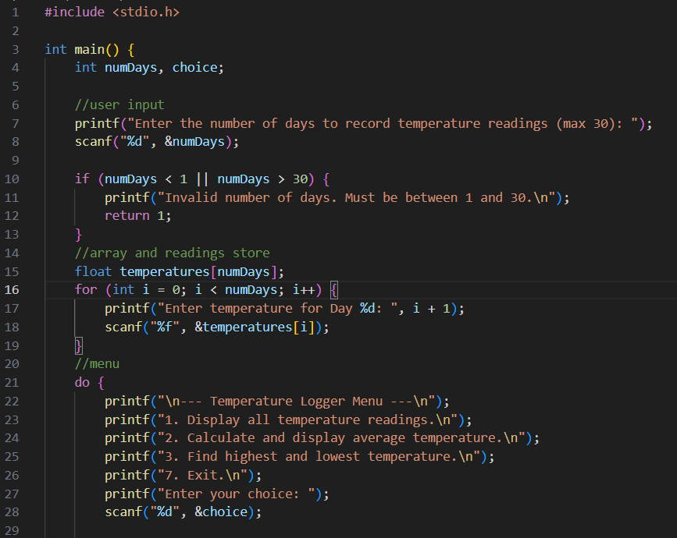

Figure 81: Input Task_5_50-59.1

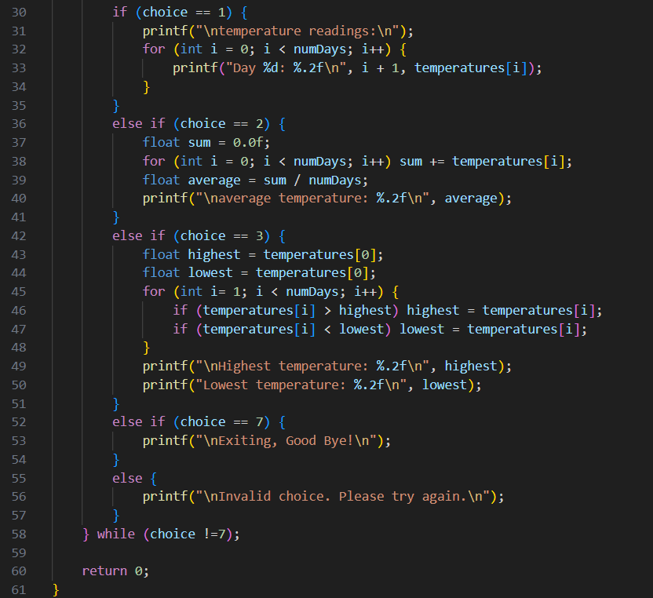

Figure 82: Input Task_5_50-59.2

**Code Explanation:** This programme records temperature readings for up to 30 days and then allows the user to analyse them through a menu. The options include displaying all the readings, calculating the average, and finding the highest and lowest values. A loop keeps showing the menu until the user chooses to exit. By working on this task I learned how to use arrays to store data, apply loops to process values, and create simple menu-driven applications.

The table below contains the Code Explanation:



Table 17: Code Explanation Task_5_50-59

Output:

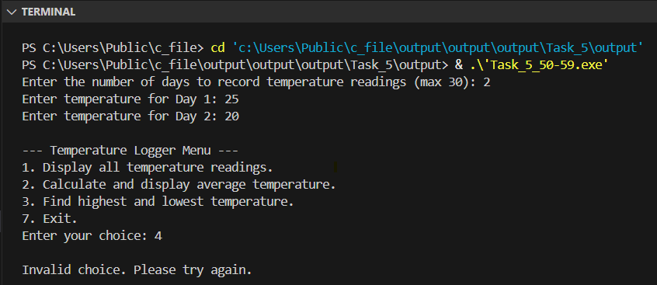

Figure 83: Output Task_5_50-59.1

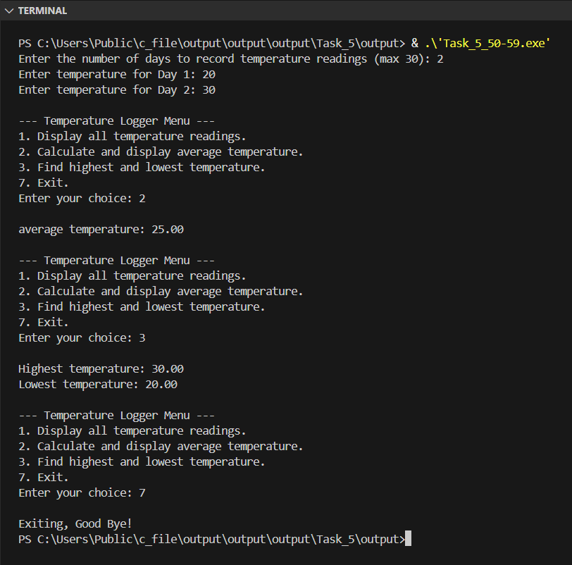

Figure 84: Output Task_5_50-59.2

## Grade 60-69

This stage the temperature logger by using a fixed-size array and applying a sentinel value to mark the end of valid data. It adds menu option 4 to let the user enter a temperature threshold and count how many recorded days are above and below that value. It also adds menu option 5 to calculate and display the average temperature for each week, assuming day 1 starts week 1 and every 7 days form a week. The program must keep all previous functionality, ensure each menu action works correctly, and include clear explanations of how the code operates.

Below is the link to check the code in programiz:

<https://www.programiz.com/online-compiler/7O0Y2Xq7pK7Hh>

Input:

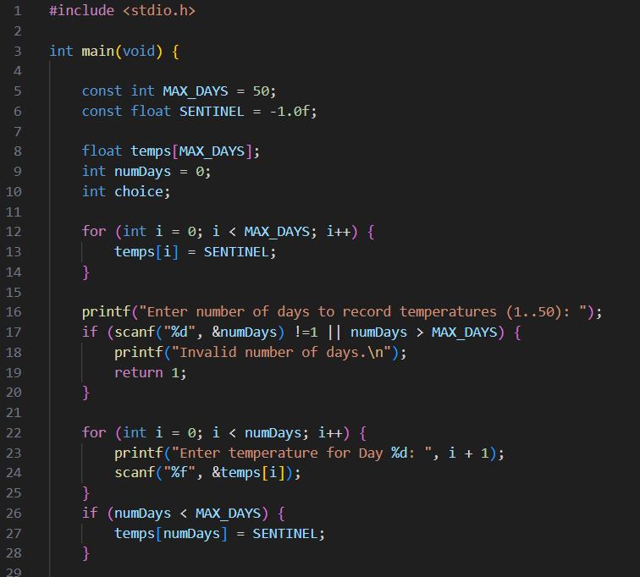

Figure 85: Input Task_5_60-69.1

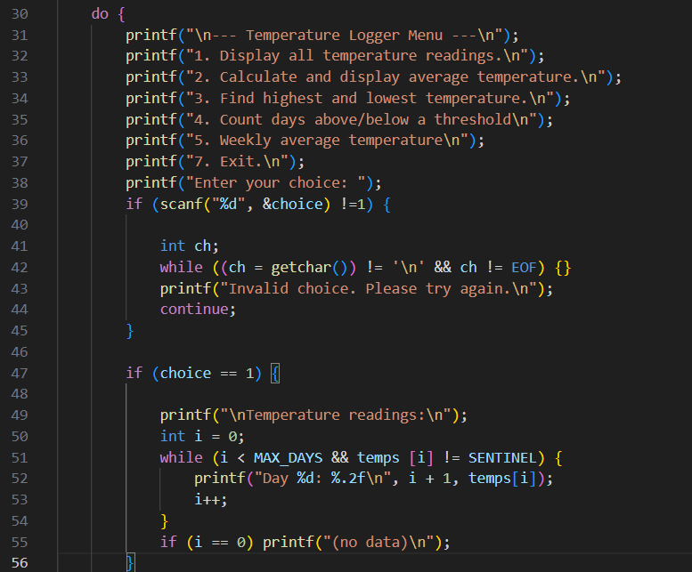

Figure 86: Input Task_5_60-69.2

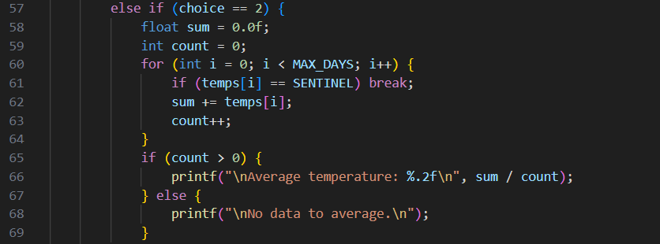

Figure 87: Input Task_5_60-69.3

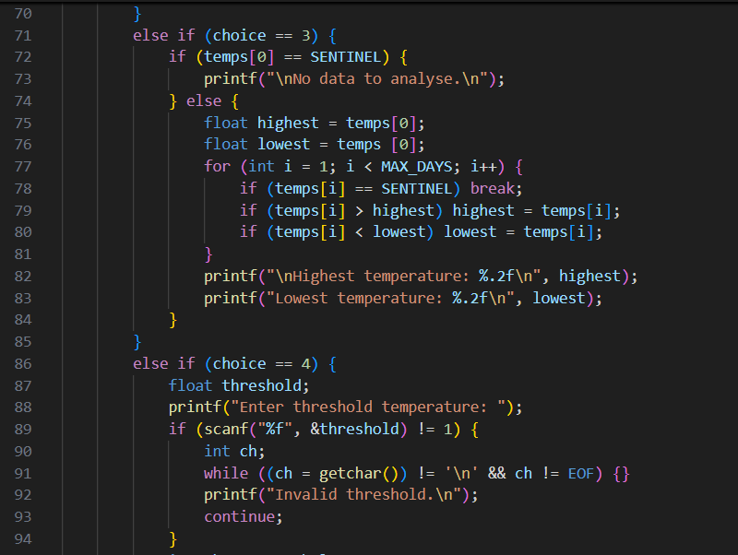

Figure 88: Input Task_5_60-69.4

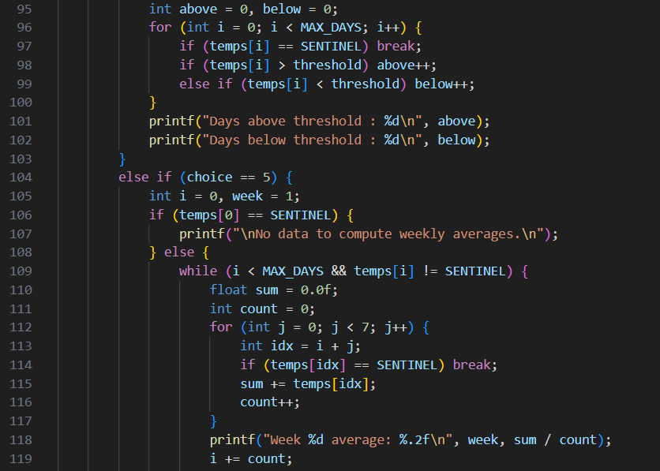

Figure 89: Input Task_5_60-69.5

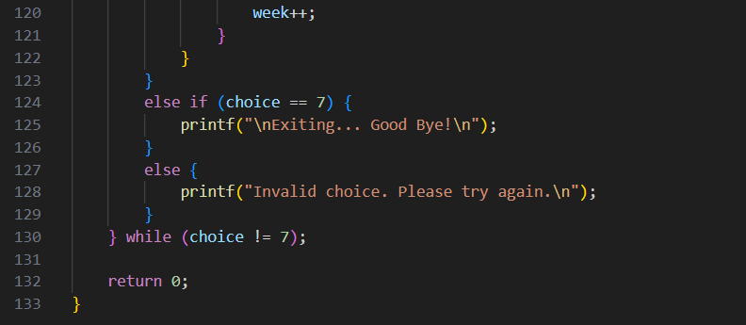

Figure 90: Input Task_5_60-69.6

**Code Explanation**: This program uses a fixed-size array temps[50] and a sentinel value (-1.0f) to mark the end of valid data. At the start, all array elements are set to the sentinel so that empty positions are easy to identify. The user chooses how many days to record, enters the temperatures in order, and the element after the last entry is set to the sentinel. A do…while (choice != 7) loop shows a menu and keeps asking the user until they decide to exit. If the user types an invalid number, the program clears the input and asks again. All calculations stop when the sentinel is found, so the program never reads uninitialised values (W3Schools, 2025; Testbook, 2023). Using the sentinel makes the code easier, because it removes the need to pass the array length to every function and gives a simple way to end loops. The menu allows the user to run different options without restarting the program, and the input checks make sure the values are correct. Negative temperatures are accepted, since they are valid in °C, and the sentinel value -1.0f is only added after the last entry, so it never causes confusion. Because the program uses floating-point numbers, small rounding differences can appear when calculating averages. In the threshold option, the program counts days above and below the limit, but does not count equal values separately.

From this task I learned how to use sentinel values to control arrays, how to design menu loops that keep the program running, and how to combine input checks with data analysis. The sentinel made it easier to go through the array and control the menu without using extra counters. However, in bigger systems this method would be less flexible, and other structures such as linked lists would work better for storing dynamic data.

The table below contains the Code Explanation:



Table 18: Code Explanation Task_5_60-69

Output:

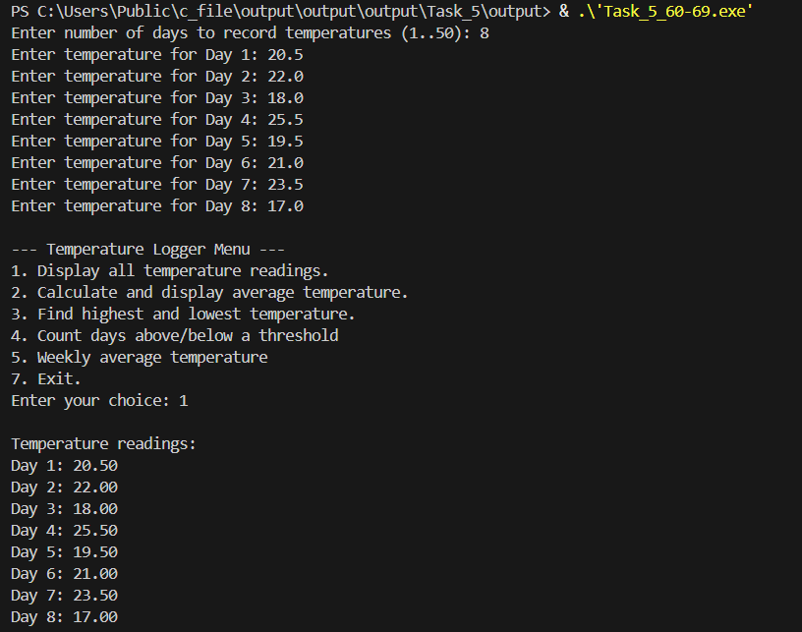

Figure 91: Output Task_5_60-69.1

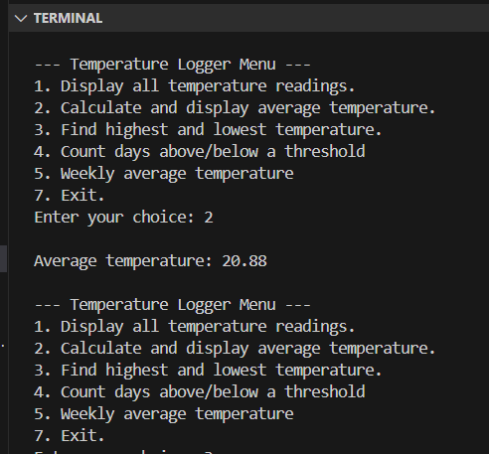

Figure 92: Output Task_5_60-69.2

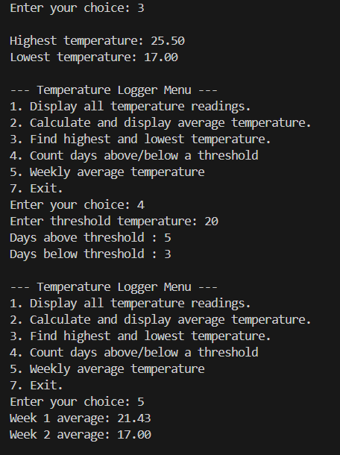

Figure 93: Output Task_5_60-69.3

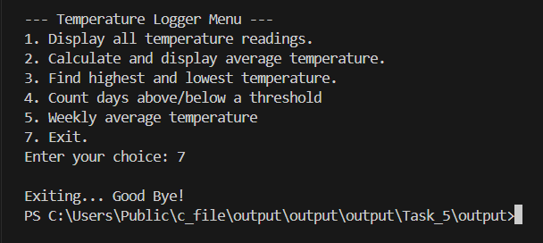

Figure 94: Output Task_5_60-69.4

## Grade 70-100

This task expands the previous temperature logger program by adding a new menu option (Option 6) to reverse the order of temperature readings and display them in a “Today/Yesterday/X days ago” format. It also requires researching and explaining how pointers work and their benefits, particularly for iterating through arrays, reversing data, and finding minimum/maximum values. Finally, part of the program must be rewritten to use pointer arithmetic instead of traditional array indexing, demonstrating how pointers can simplify traversal and manipulation of the temperature data.

Below is the link to check the code in programiz:

<https://www.programiz.com/online-compiler/4moh9C812zf1w>

Input:

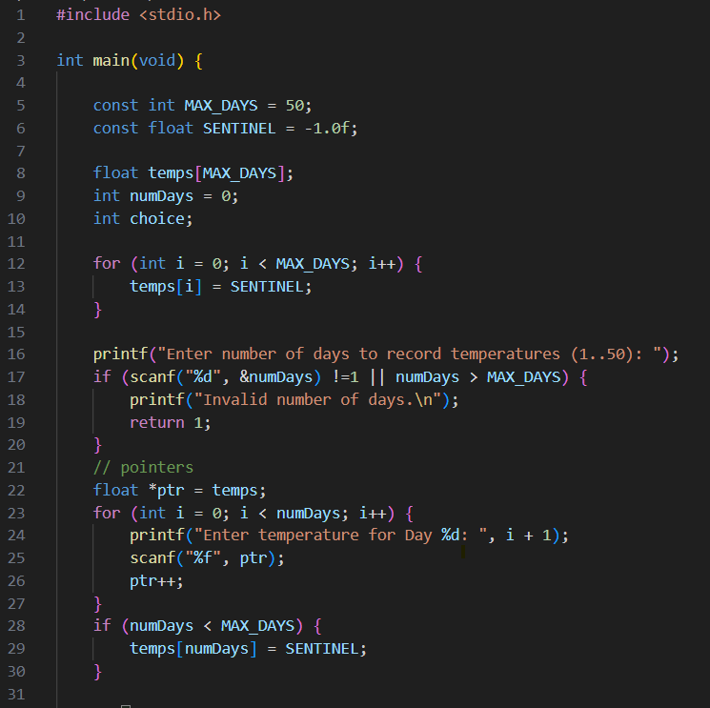

Figure 95: Input Task_5_70-100.1

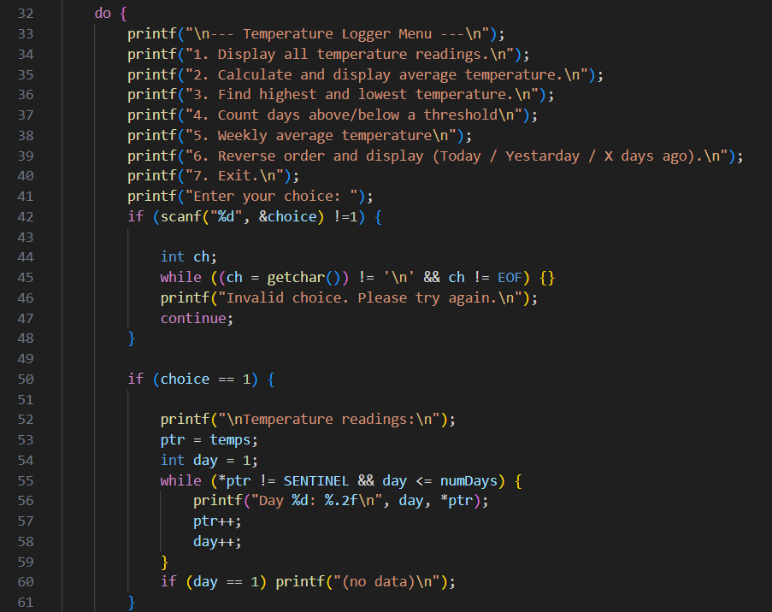

Figure 96: Input Task_5_70-100.2

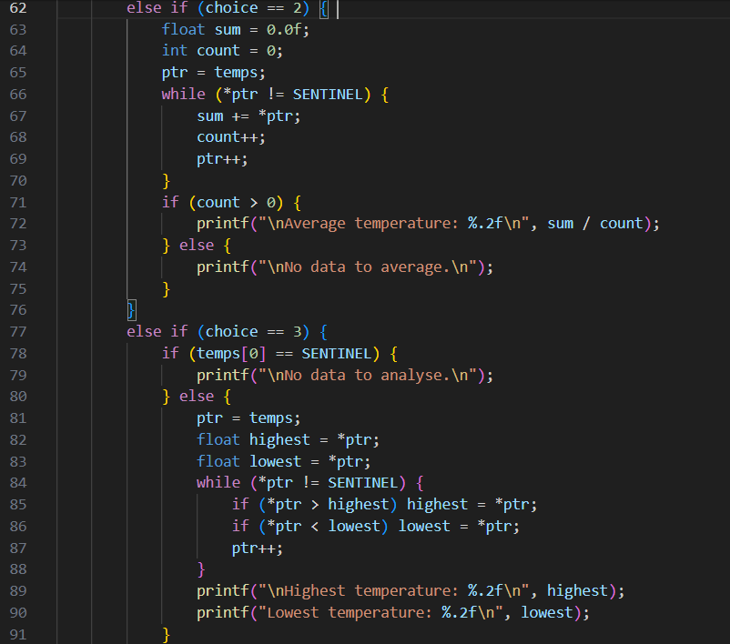

Figure 97: Input Task_5_70-100.3

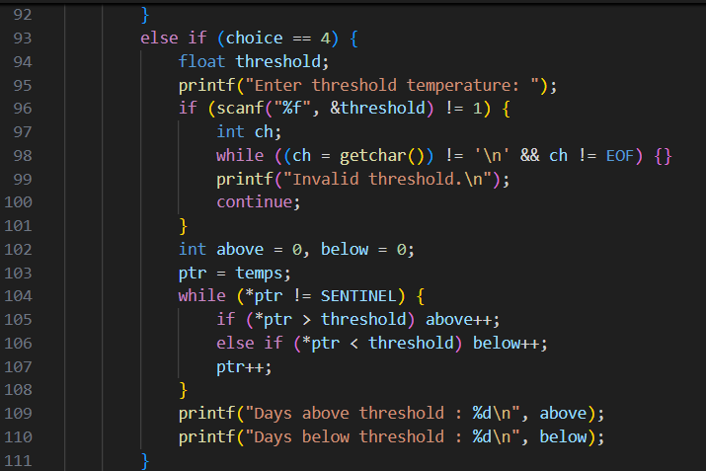

Figure 98: Input Task_5_70-100.4

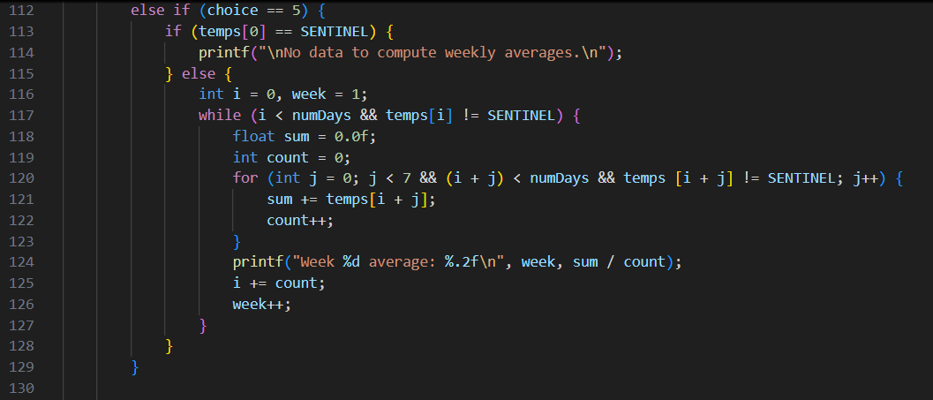

Figure 99: Input Task_5_70-100.5

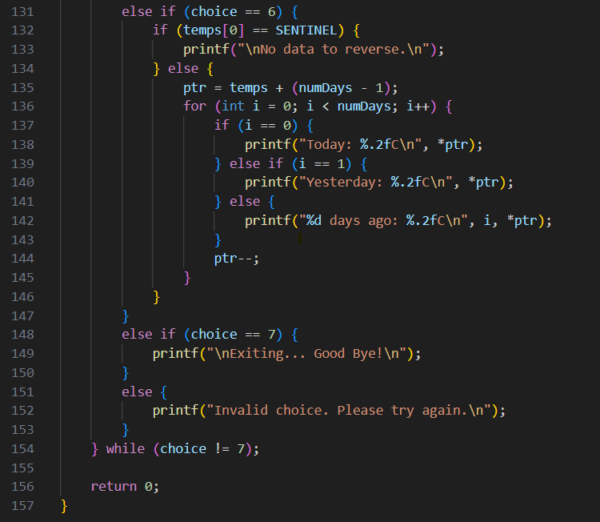

Figure 100: Input Task_5_70-100.6

**Code Explanation**: A pointer in C is a variable that stores a memory address instead of a direct value. By dereferencing with the operator *, the programme can access the value stored at that address. Pointers can also move between elements in memory with pointer arithmetic, for example using ptr++ to go to the next number. This makes them very useful for working with arrays, as they provide a simple way to traverse values without having to rely only on index counters (freeCodeCamp 2020 & GeeksforGeeks 2025.).

In this programme, pointers are used in several ways to make the code easier and more efficient. When entering the temperatures, a pointer moves through the array so each value is stored in order. When analysing the data, loops like while (*ptr != SENTINEL) allow traversal until the end marker without worrying about array indices. I also used pointers to print the temperatures in reverse order. By starting at the last day and moving backwards with ptr--, I could easily print ‘Today’, ‘Yesterday’, and so on without writing complicated index formulas.

Working on this task helped me understand not only how pointers work, but also why they are powerful in practice. I learned that they simplify traversal, make reverse operations easier, and keep the code shorter and clearer. This gave me more confidence with a concept that at first seemed difficult but is very important in C programming.

The table below contains the Code Explanation:



Table 19: Code Explanation Task_5_70-100

Output: TEST 1: full function test with valid data:

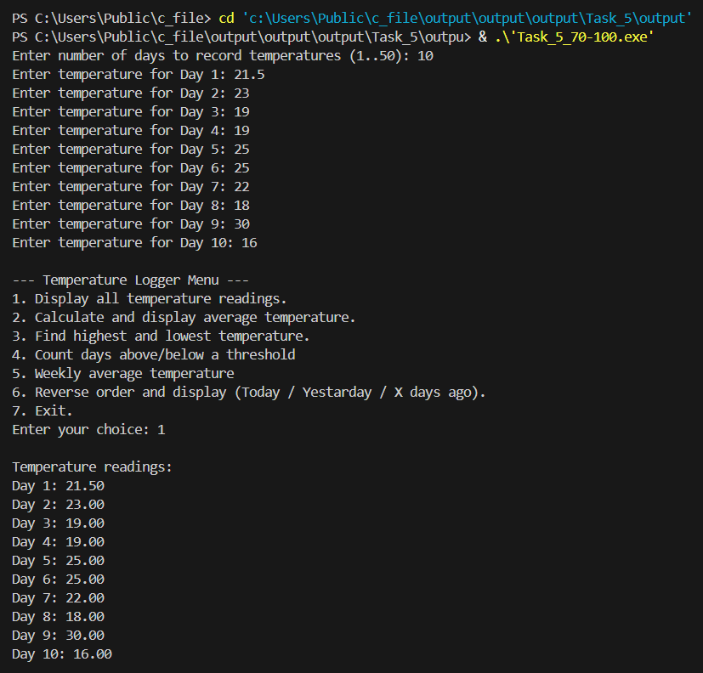

Figure 101: Output Task_5_70-100.1

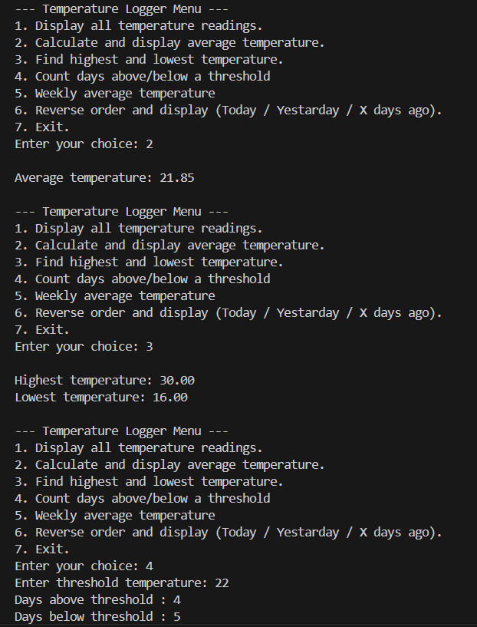

Figure 102: Output Task_5_70-100.2

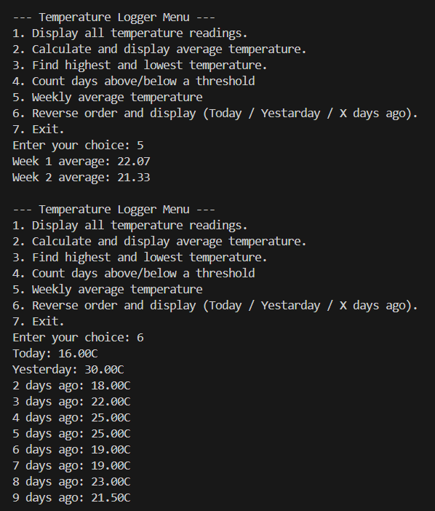

Figure 103: Output Task_5_70-100.3

Output: TEST 2: Validation check.

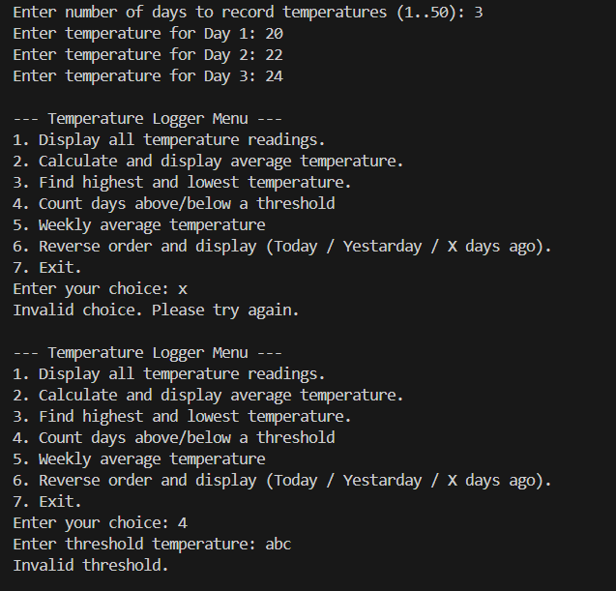

Figure 104: Output Task_5_70-100.4

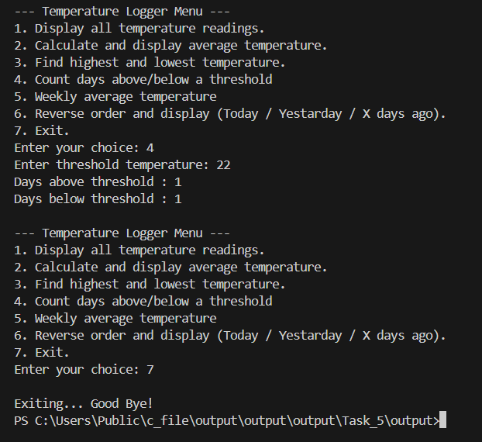

Figure 105: Output Task_5_70-100.5

# Task 6: Playlist Organizer

This task involves working with a playlist stored as an array of strings, where each string represents a song title. The program progressively builds functionality to manage this playlist. It first displays all the songs, then sorts the titles alphabetically for easier organization. Additional features allow the user to add new songs, remove existing ones, update titles, and manage the playlist dynamically. This task provides practice with arrays of strings in C, as well as the use of loops, string operations, and functions to structure the program effectively.

## Grade 40-49

This task involves creating a string array containing 8 song titles in completely random alphabetical order. Using a loop, the program prints the current song title being visited and, at the same time, always prints the very first song in the array (the one stored at index 0). This process repeats for each iteration of the loop until all songs have been displayed. At this stage, no sorting or manipulation of the array is required. The focus is on practicing array traversal and accessing specific elements by index.

Below is the link to check the code in programiz:

<https://www.programiz.com/online-compiler/5DnSIsFsb0zfP>

Input:

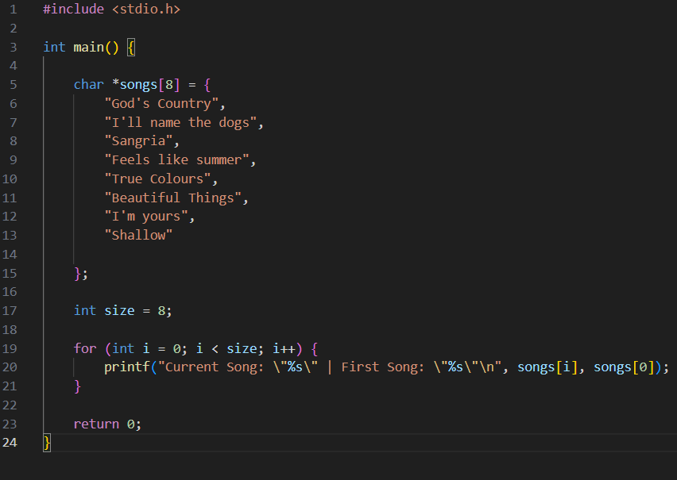

Figure 106: Input Task_6_40-49

**Code Explanation**: This program stores 8 song titles in an array and, using a loop, prints the current song along with the first song in the playlist.

Output:

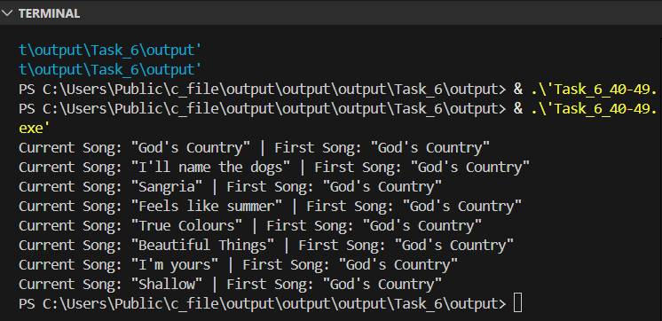

Figure 107: Output Task_6_40-49

## Grade 50-59

In this task, the playlist program is extended to compare each song title in the array with the one stored at index 0. During a single pass through the array, the program identifies the alphabetically first song and swaps it with the element at index 0. No output is printed during the loop itself, but the playlist is displayed before and after the operation to show the effect of the swap. This ensures that, once completed, the very first song in alphabetical order is moved to the front of the playlist.

Below is the link to check the code in programiz:

<https://www.programiz.com/online-compiler/4YHdBDsbYtVhs>

Input:

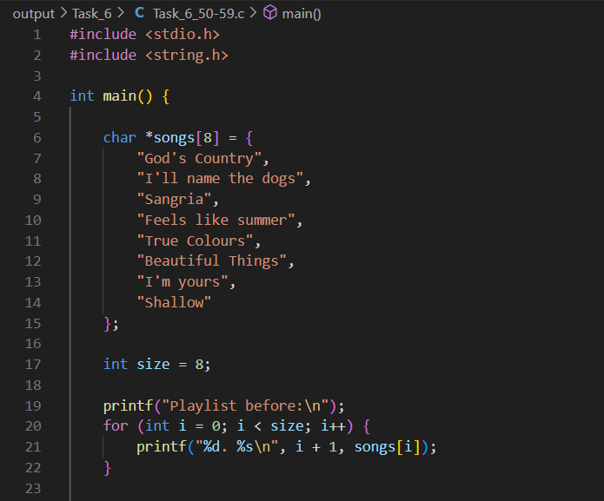

Figure 108: Input Task_6_50-59_1

Input:

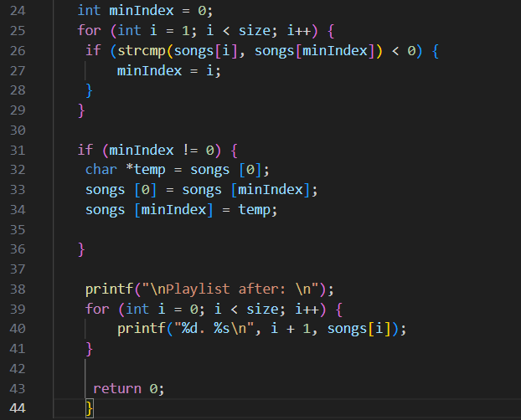

Figure 109: Input Task_6_50-59_2

**Code Explanation:** This programme stores a playlist of eight songs in an array of strings and demonstrates how to bring the alphabetically first song to the front. First, it prints the original playlist. Then it uses a loop with the function strcmp to compare each title with the one currently at the first position, keeping track of the smallest string alphabetically. If a new “first” song is found, it swaps it with the song at index 0. Finally, the programme prints the playlist again, now showing the correct first song at the top. By completing this task I learned how to compare and swap strings in C, and how loops and conditions can be combined to achieve partial sorting.

The table below contains the Code Explanation:



Table 20: Code Explanation Task_6_50-59

Output:

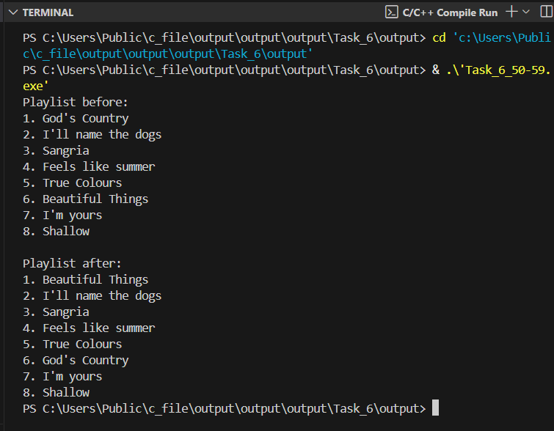

Figure 110: Output Task_6_50-59

## Grade 60-69

In this task, the program must extend the previous functionality by implementing a nested loop to fully sort the playlist in alphabetical order. Using selection sort logic, the program repeatedly identifies the alphabetically smallest song in the unsorted portion of the array and swaps it with the first unsorted element. The playlist is printed once before the sorting process and once after, showing the complete alphabetical ordering of all song titles.

Below is the link to check the code in programiz:

<https://www.programiz.com/online-compiler/4ENwCbnHokvKY>

Input:

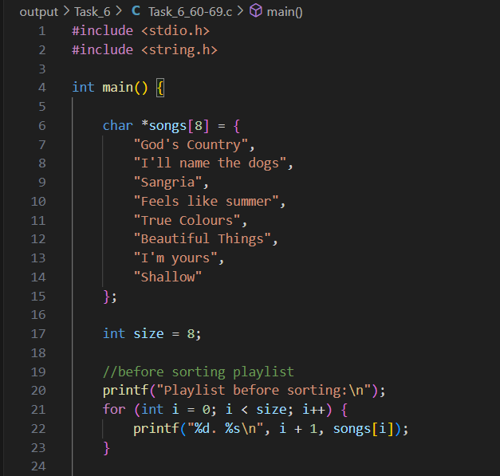

Figure 111: Input Task_6_60-69_1

Input:

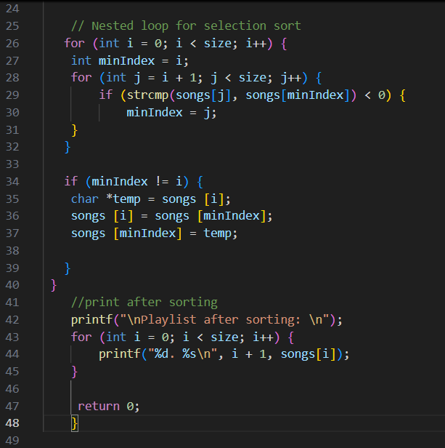

Figure 112: Input Task_6_60-69_2

**Code Explanation:** This programme builds on the earlier playlist task by introducing a full alphabetical sort. It begins by printing the playlist in its original order and then applies a selection sort algorithm using nested loops. For each position in the array, the code searches for the alphabetically smallest song title in the remaining unsorted part of the list. The function strcmp is used to compare strings, and when a smaller value is found, the positions are swapped so that the correct song moves into place.

After all passes of the loop, the playlist is printed again, now fully arranged in alphabetical order. This step-by-step sorting method ensures that by the end, the songs are displayed from the earliest to the latest alphabetically. By completing this task I learned how nested loops can be used to control sorting, how selection sort works in practice, and how swapping with temporary variables helps to reorder string arrays correctly in C.

The table below contains the Code Explanation:



Table 21: Code Explanation Task_6_60-69

Output:

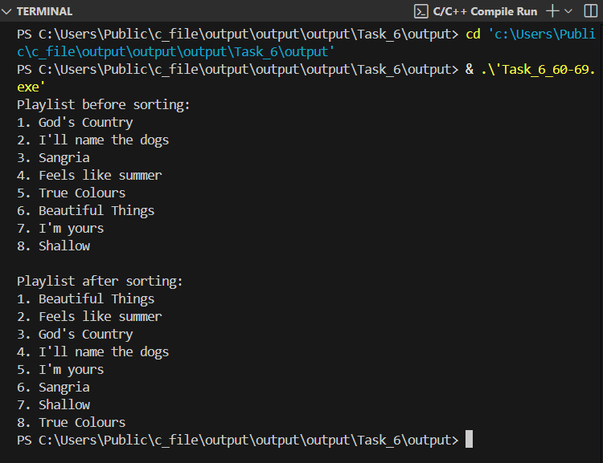

Figure 113: Output Task_6_60-69

## Grade 70-100

In this task, the playlist program is extended with functionality to delete a song entered by the user. When the user provides a title, the program searches the playlist and, if the song is found, removes it and shifts the remaining elements to avoid leaving a gap in the array. If the title is not found, an appropriate message is displayed. Additionally, the sorting logic is updated to use a different algorithm, such as Bubble Sort, to arrange the playlist in alphabetical order.

Below is the link to check the code in programiz:

<https://www.programiz.com/online-compiler/4ysF7bYcYd4hR>

Input:

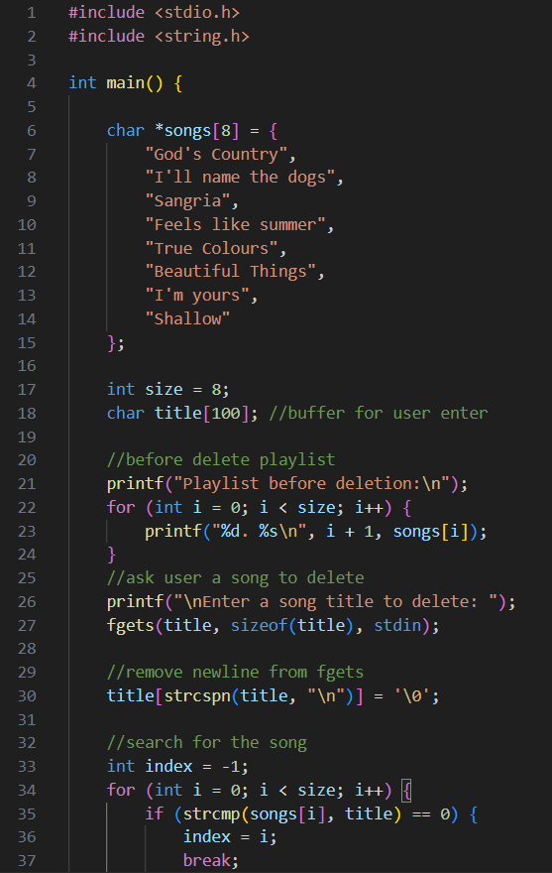

Figure 114: Input Task_6_70-100_1

Input:

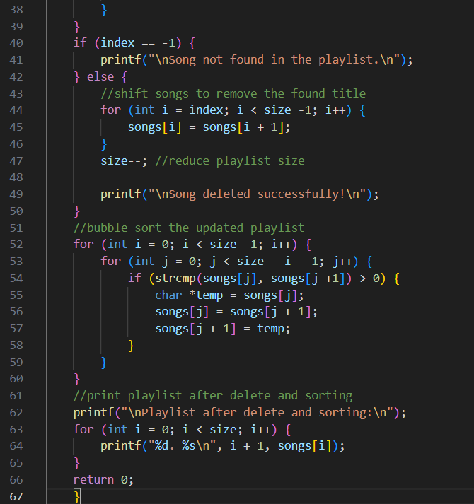

Figure 115: Input Task_6_70-100_2

**Code Explanation:** In the previous step I used the Selection Sort algorithm, and now I changed it to Bubble Sort. Both of them are simple sorting methods that I learned while practising with arrays. The main idea of Selection Sort is to look through the whole list and pick the smallest element each time, then swap it into the right position. Bubble Sort works a bit differently, because it compares pairs of items and keeps swapping them so that the bigger ones move towards the end, like they are bubbling up (GeeksforGeeks 2025. & Ziggit.dev 2024).

In terms of performance, both algorithms are not very efficient for large data because they use many comparisons. Selection Sort always does about the same amount of work no matter if the list is sorted or not. Bubble Sort can sometimes be faster if the list is already close to sorted, because it can stop earlier when no swaps are needed. Another difference I noticed is that Bubble Sort keeps equal items in the same order stable, while Selection Sort might not.

For my playlist of only 8 songs, both methods work fine and I could see the difference in the way they move the songs during sorting. I now understand better how different sorting algorithms can achieve the same result but follow different steps and have different strengths.

Bubble Sort worked fine for my playlist of 8 songs because it is simple. But I learned that it is not good for bigger datasets, where better algorithms like Merge Sort or Quick Sort would work faster. (GeeksforGeeks 2025; Testbook 2025).

The table below contains the Code Explanation:



Table 22: Code Explanation Task_6_70-100

Output:

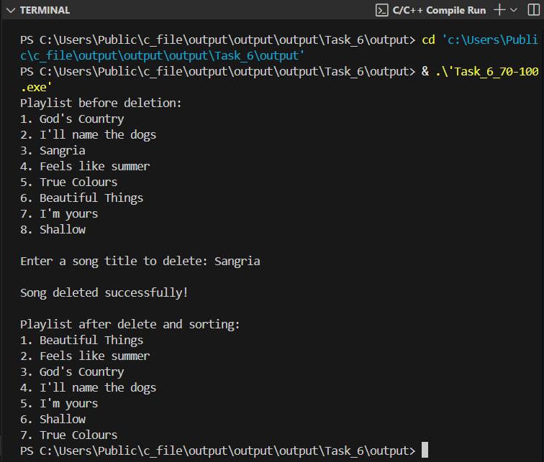

Figure 116: Output Task_6_70-100.1

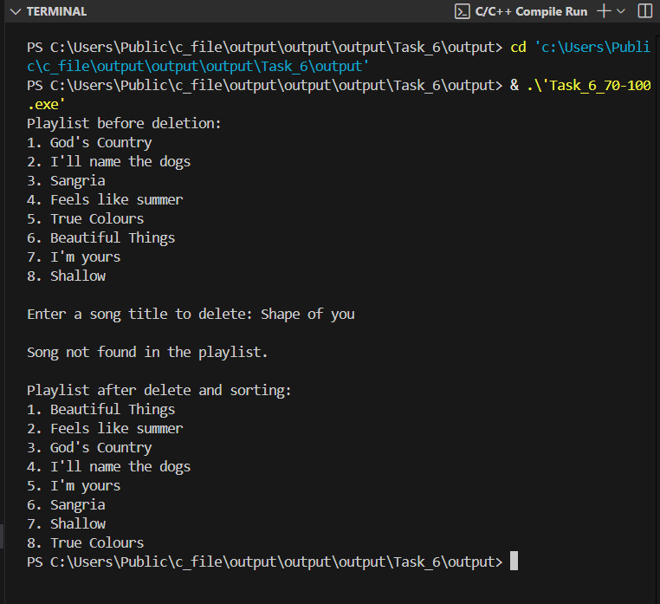

Figure 117: Output Task_6_70-100.2

# Task 7: Course Registration System with Functions and Files

This task focuses on building a Course Registration System that simulates how a school or college might manage its courses. The programme must include functionality to add new courses with details such as course code, ID, and status, display the list of all courses, update existing records, and delete those no longer needed. A key requirement is also to implement file handling so that the data is saved and can be retrieved the next time the programme runs, ensuring persistence. All these features need to be structured into functions, making use of parameters, return values, and variable scope to organise the code effectively.

## Grade 40-49

This stage sets the foundation for the Course Registration System by creating a struct to store course details such as ID, course code, and status. Two functions are introduced: addCourse(), which collects data from the user and appends it to a text file (*regs.txt*), and displayCourses(), which reads and displays all stored courses. At this level, the functions do not use parameters or return values, and all input and output is handled directly inside them. This provides a simple starting point before adding more advanced features in later stages.

Below is the link to check the code in programiz:

<https://www.programiz.com/online-compiler/83eYgwswAJkot>

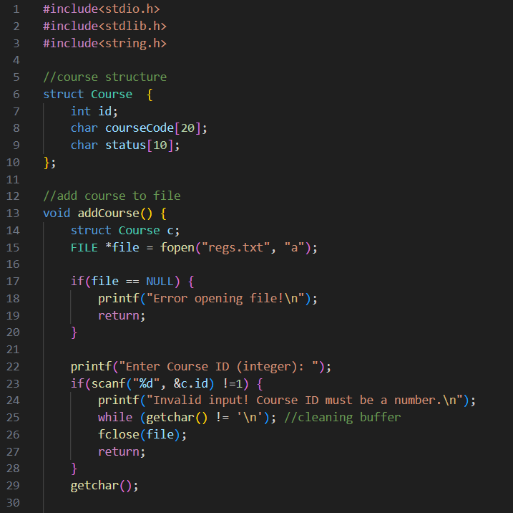

Figure 118: Input Task_7_40-49.1

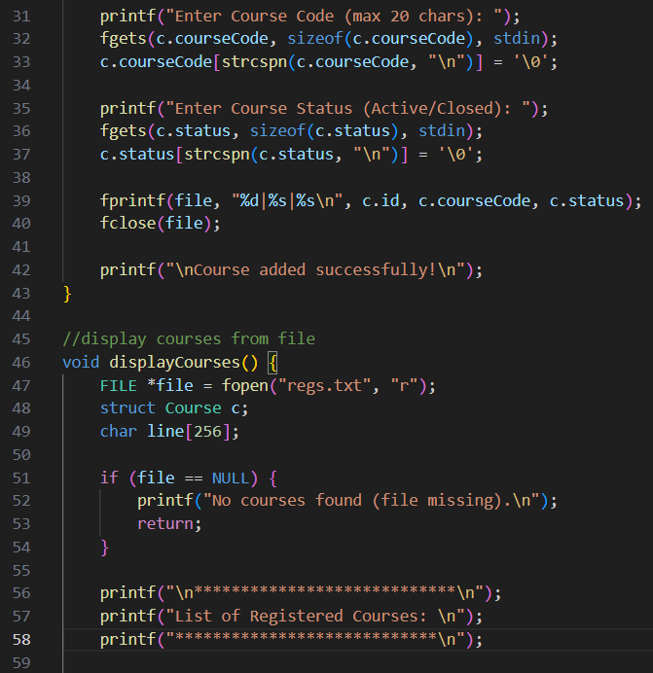

Figure 119: Input Task_7_40-49.2

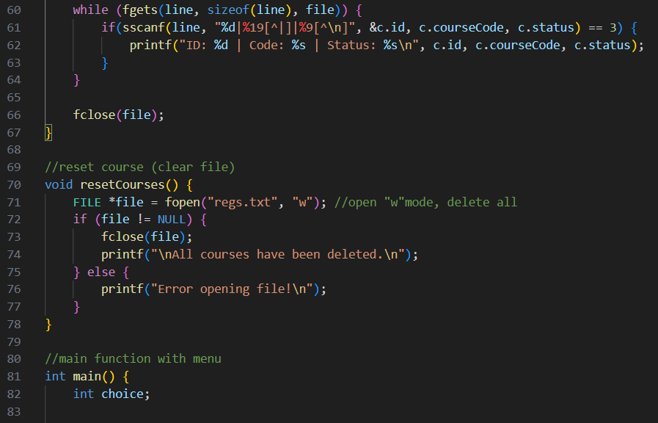

Figure 120: Input Task_7_40-49.3

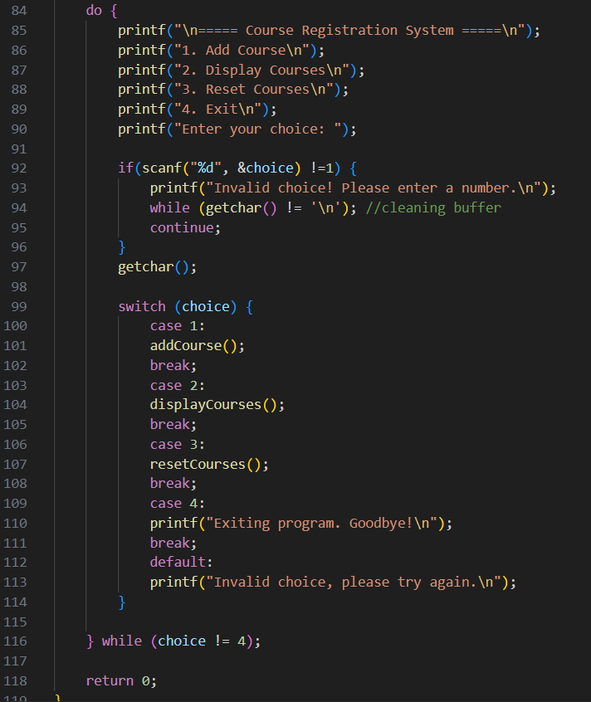

Figure 121: Input Task_7_40-49.4

**Code Explanation:** This program is a simple Course Registration System that stores and displays course information using files. It starts by defining a struct Course that keeps three pieces of data: the course ID, its code, and its status. The addCourse() function asks the user to enter this information, then writes it into a text file called regs.txt. To keep the input neat, it removes the newline character from the inputs before saving. When the user chooses to see the saved courses, the displayCourses() function reads the file line by line and prints each course with a clear, formatted layout.

The system runs through a menu inside the main() function, where the user can choose to add new courses, display all existing ones, reset the file, or exit the program. Each option calls the corresponding function, showing how tasks are separated into smaller reusable blocks.

During testing, I needed to make several adjustments that helped me understand the logic better. First, I improved the reading process so that course names with spaces, such as Problem Solving, could be stored and displayed correctly, instead of being cut after the first word. Second, I added validation to make sure the course ID accepts only numbers, preventing errors when users mistakenly enter text instead of integers. Finally, I created a reset option to clear the list of previously stored courses. This became necessary after many test runs, because old data in the file caused confusion when displaying results.

Through this task I learned how to design a program with functions that work together without parameters or return values, while also practising structures, file handling, input validation, and formatting for readability. It showed me the importance of thinking about usability, ensuring data consistency, and testing code carefully to discover improvements.

The table bellow contains the Code Explanation:



Table 23: Code Explanation Task_7_40-49

Output:

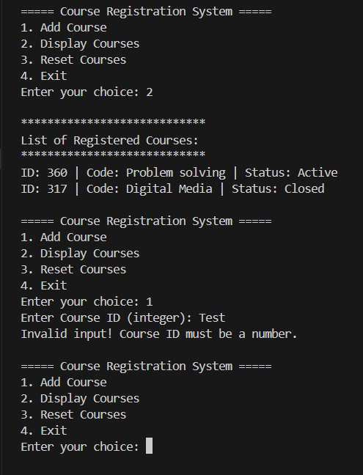

Figure 122: Output Task_7_40-49

## Grade 50-59

In this task the program was improved to use parameters in its functions. The addCourse() function now receives the course details (id, code, and status) directly, and displayCourses() takes a list of courses to show them on the screen. A new function called searchCourses() was added so it is possible to look for a course by its ID and see the full information. Another change was to make sure that when a new course is added, the program checks if the ID already exists, avoiding duplicates. These updates made the system more organised and closer to how a real course registration system would work.

Below is the link to check the code in programiz:

<https://www.programiz.com/online-compiler/5O0nSU2VdKvxq>

Input:

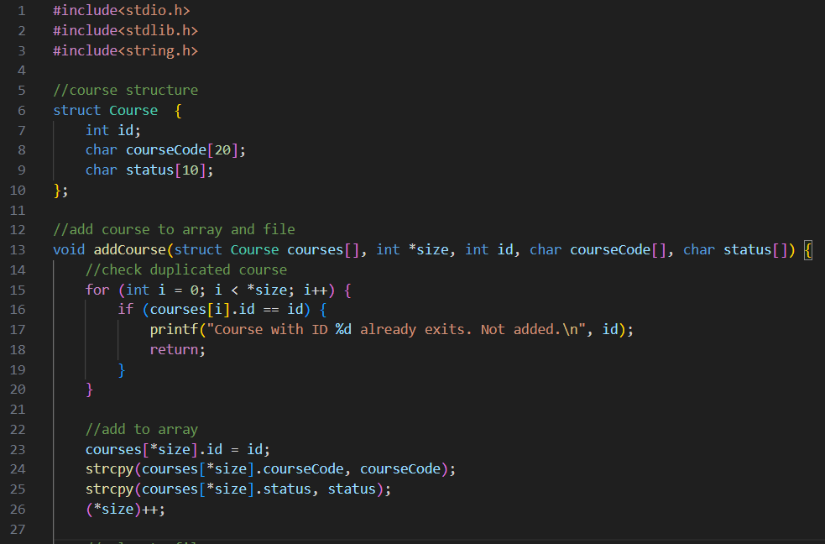

Figure 123: Input Task_7_50-59.1

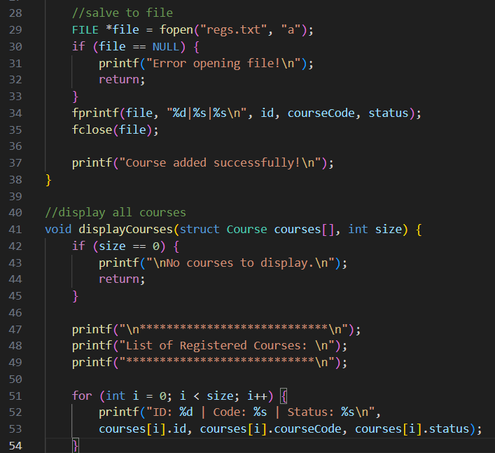

Figure 124: Input Task_7_50-59.2

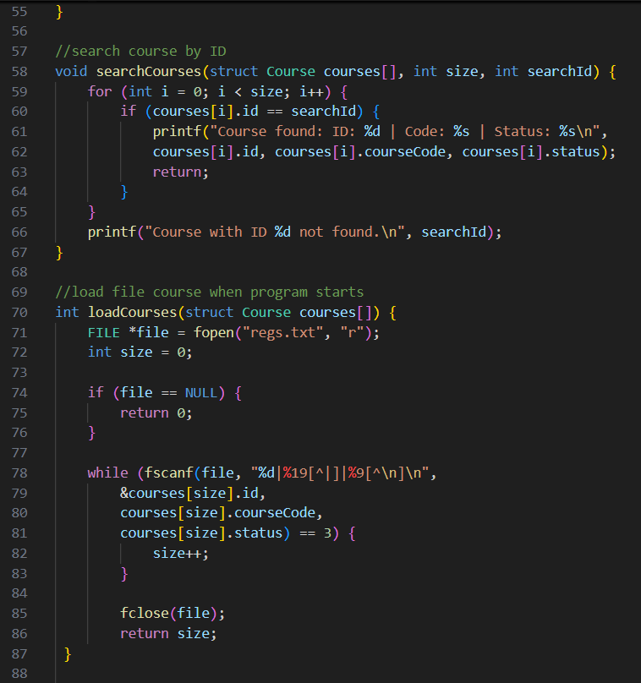

Figure 125: Input Task_7_50-59.3

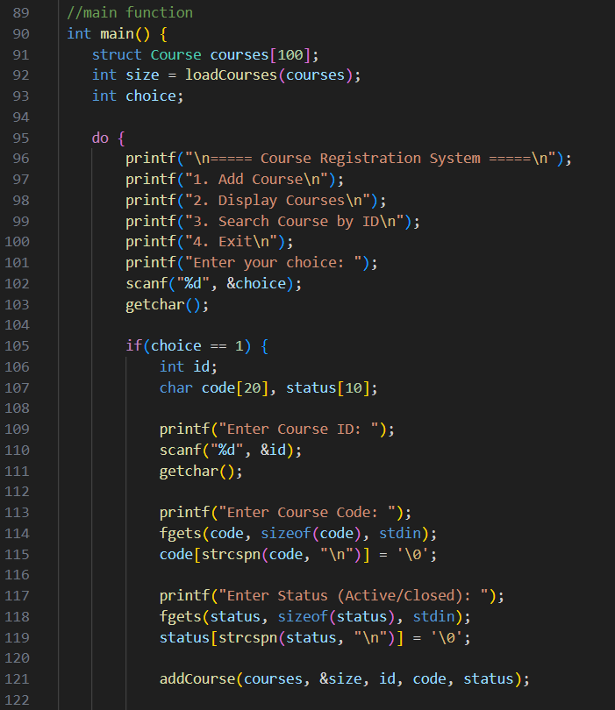

Figure 126: Input Task_7_50-59.4

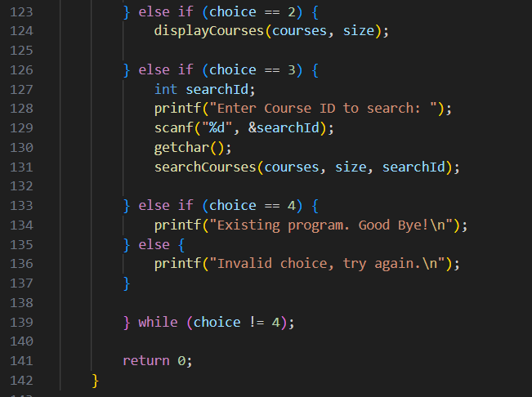

Figure 127: Input Task_7_50-59.5

**Code Explanation:** This program is an updated version of the course registration system, now with more functions and the use of parameters. The addCourse(int id, char courseCode[], char status[]) function is responsible for adding a new course, but before it saves, it checks if another course with the same ID already exists. If the ID is already in the system, the program shows a message and does not add it again, which avoids duplicates.

The displayCourses(struct Course courses[], int size) function receives the list of courses and prints them on the screen, showing their ID, code, and status in a clear way. A new function, searchCourses(struct Course courses[], int size, int id), allows the user to type an ID and see the full details of that specific course. The main function manages the menu, so the user can choose between adding, displaying, or searching for courses.

Through this task I learned how functions can work with parameters to make the program more organised, and also how to add checks like avoiding repeated IDs. It also helped me practise working with arrays of structs and making the program feel more like a real system.

The table below contains the code explanation:



Table 24: Code Explanation Task_7_50-59

Output:

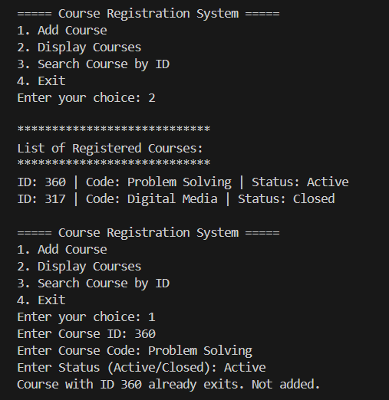

Figure 128: Output Task_7_50-59.1

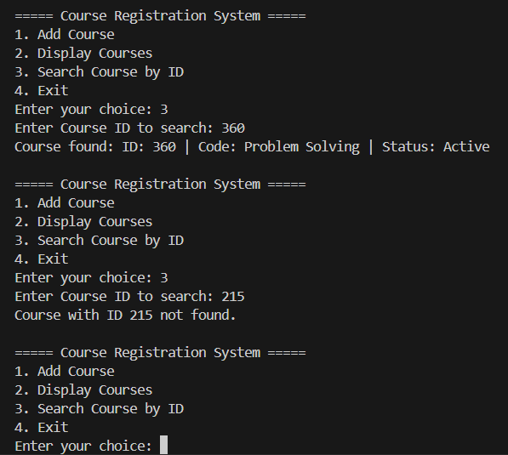

Figure 129: Output Task_7_50-59.2

## Grade 60-69

This task requires improving the course registration system by making functions return values and by adding an update option. The addCourse() function must now return 1 when a course is added or 0 if the ID already exists, and searchCourses() should return the course position or -1 if not found. In the original task description, it was suggested that the function should return 1 when a course is not found, but I chose to use -1 instead. This is a common convention in C programming because valid array indexes are always zero or positive, so returning -1 makes it clear that no course exists at that position and avoids confusion with a real index*.* (Wikipedia 2025). A new updateCourse() function allows changing a course’s code and status using its ID, returning 1 if updated or 0 if not found. File handling must also be corrected so that updates are written to regs.txt and shown properly when courses are displayed.

Below is the link to check the code in programiz:

<https://www.programiz.com/online-compiler/2jCcddszxvHTI>

Input:

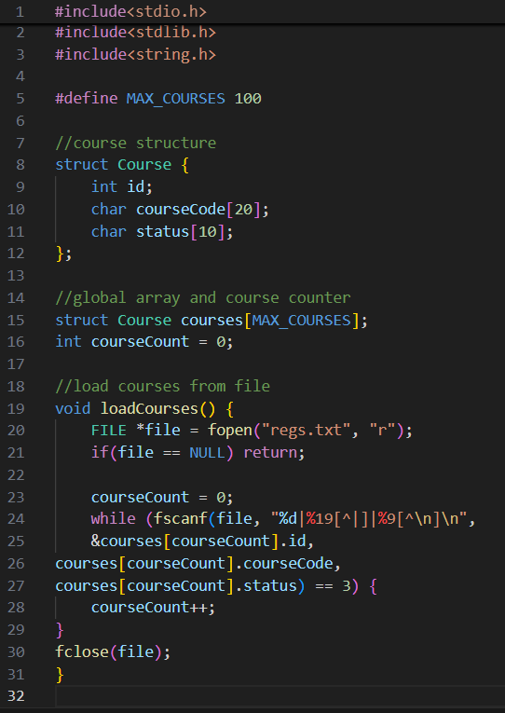

Figure 130: Input Task_7_60-69.1

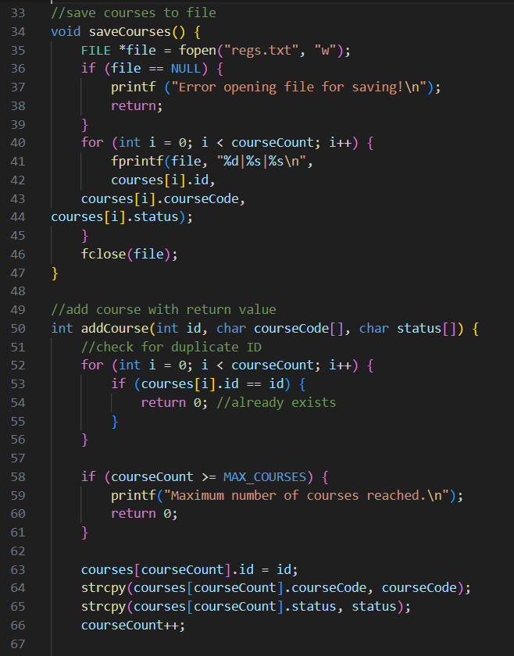

Figure 131: Input Task_7_60-69.2

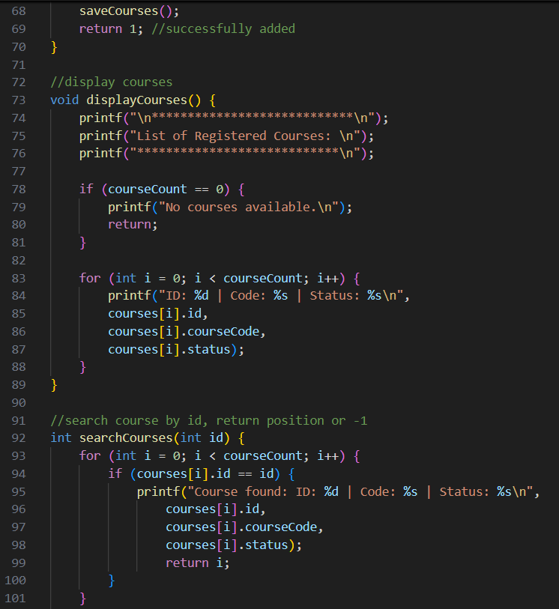

Figure 132: Input Task_7_60-69.3

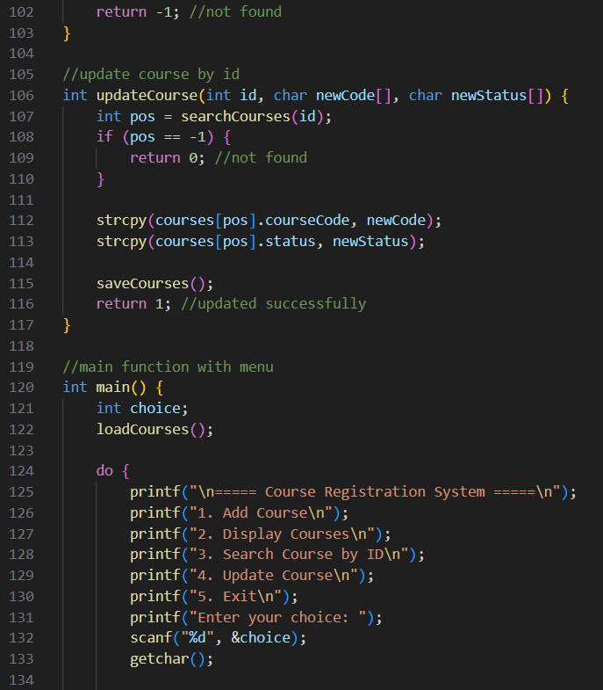

Figure 133: Input Task_7_60-69.4

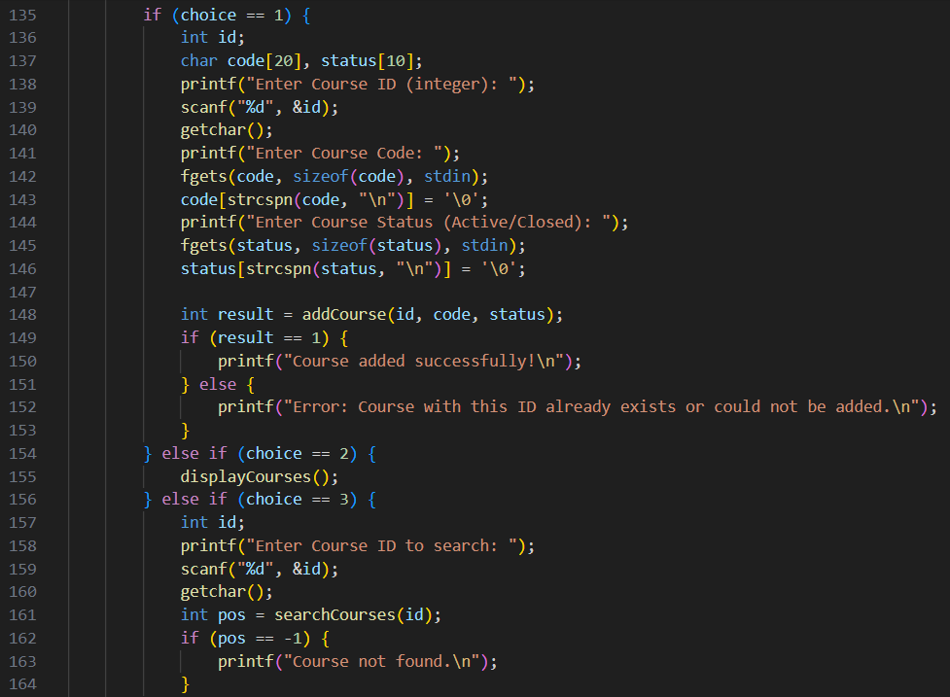

Figure 134: Input Task_7_60-69.5

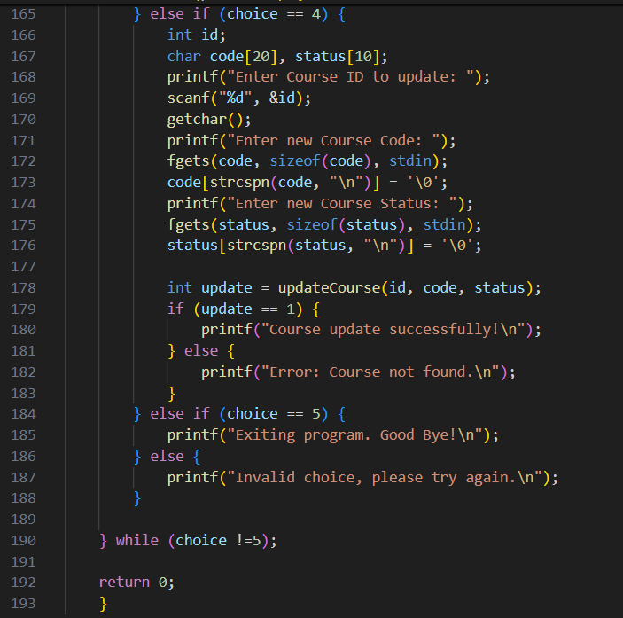

Figure 135: Input Task_7_60-69.6

**Code Explanation:** This code was quite a challenge for me because it’s not just about writing simple functions, but about integrating many different parts of C programming. First, I had to define the struct Course, which organizes the information for each course (id, code, and status). It looks simple, but using a structure together with a global array to store up to 100 courses made me think a lot about how to control the indexes and avoid exceeding the limit.

Another difficult part was file handling. I had to learn how to save and read courses from a text file (regs.txt) using fprintf and fscanf. The tricky part is that the data is saved with separators (id|code|status), and if I got the format wrong, the reading would not work. This forced me to test a lot, especially when course names had spaces. Also, the program needs to check if the file exists or not, which added another layer of reasoning.

The addCourse() function was also challenging. It has to check if a course with the same ID already exists before adding, and return 0 if it’s a duplicate. At first, it was hard to understand how to loop through the array and prevent repetitions, but then I realized it made sense to compare each id before saving. The searchCourses() function also required attention because besides searching, it returns the position found or -1 if nothing is found. This return value was essential to implement the updateCourse() function, which changes the data of an existing course and also updates the file to keep persistence.

Finally, the interactive menu with do…while and the options to add, list, search, and update courses tied everything together. I had to worry about invalid inputs, duplicates, and also the logic to exit the program. Overall, this code made me realize how every detail matters and how important it is to test in different situations.

The table below contains the code explanation, and helped me to better understand the structure of the program and to clearly see how each part contributes to the final code:



Table 25: Code Explanation Task_7_60-69

Output:

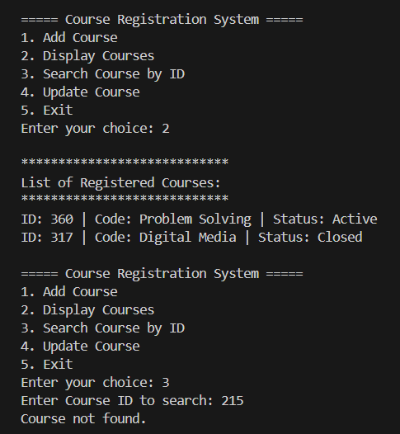

Figure 136: Output Task_7_60-69.1

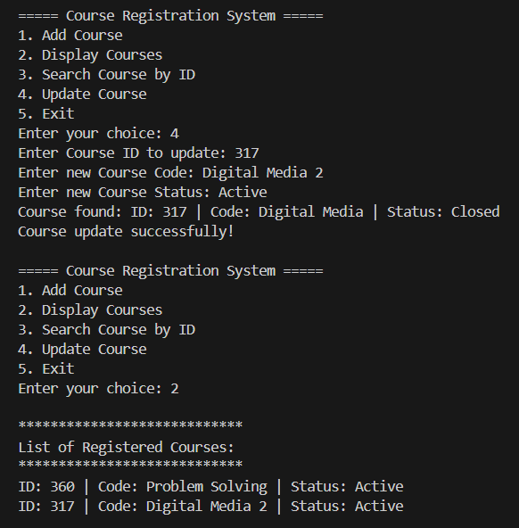

Figure 137: Output Task_7_60-69.2

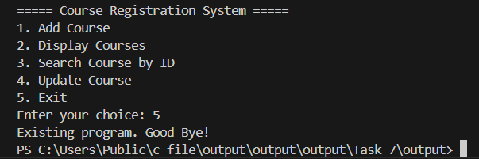

Figure 138: Output Task_7_60-69.3

## Grade 70-100

This task requires improving the Course Registration System by adding advanced file handling. The program must include a deleteCourse() function that removes a course by its ID and rewrites the file with the remaining records. It also introduces file persistence, meaning the system should load data from the file at startup, allow the user to save on demand, and automatically save when exiting. To support this, the task asks us to apply global variables for shared values like the file name, the array of courses, and counters, so they can be used across multiple functions.

Below is the link to check the code in programiz:

<https://www.programiz.com/online-compiler/2YHdbmMSztjO8>

Input:

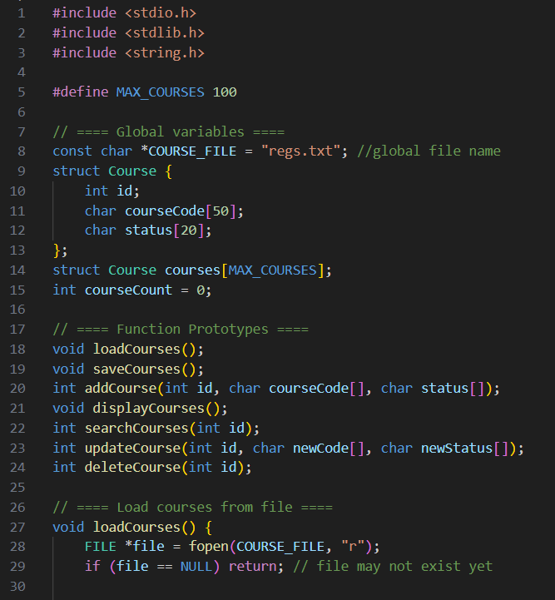

Figure 139: Input Task_7_70-100.1

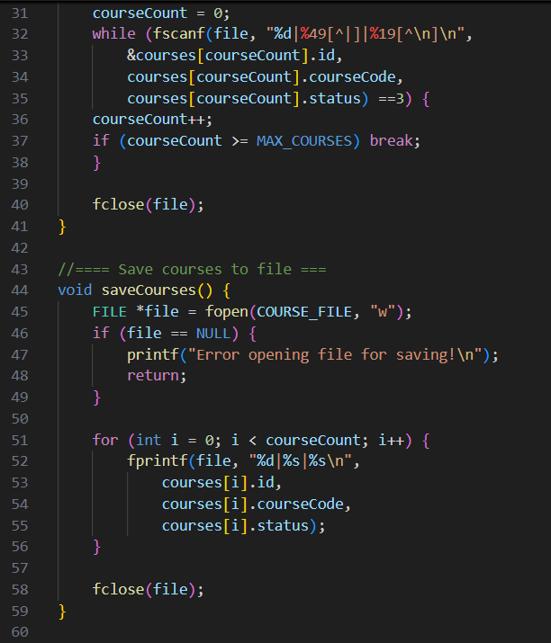

Figure 140: Input Task_7_70-100.2

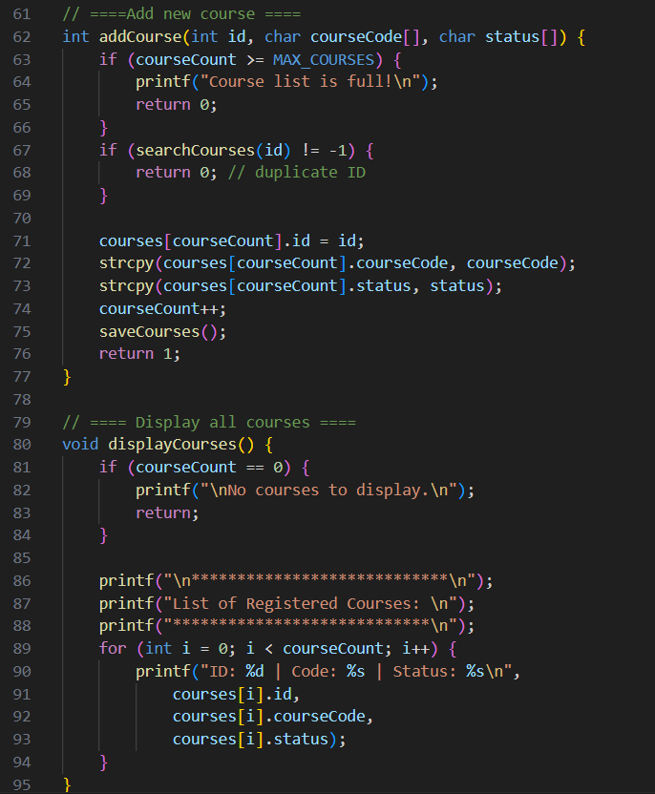

Figure 141: Input Task_7_70-100.3

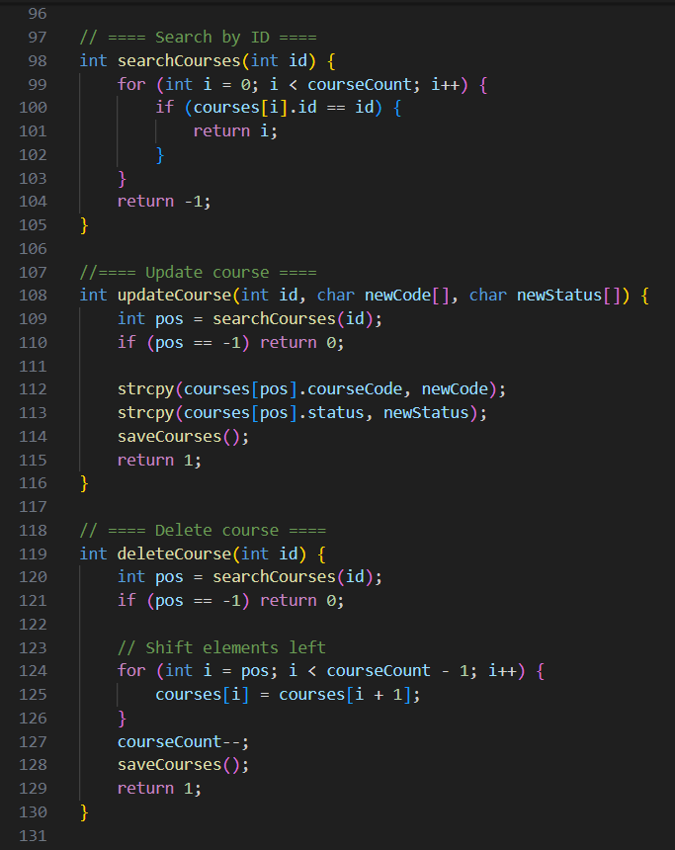

Figure 142: Input Task_7_70-100.4

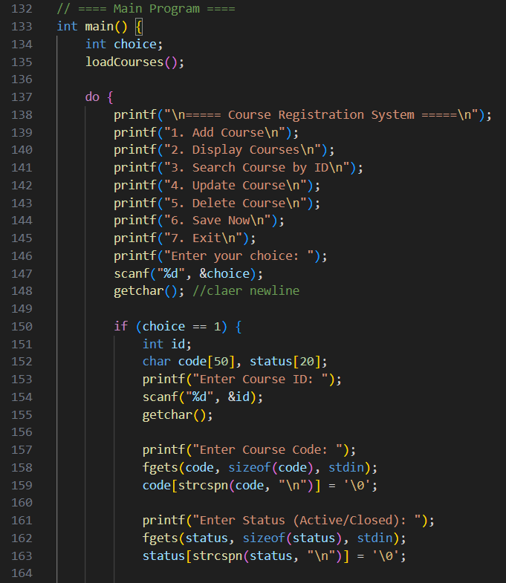

Figure 143: Input Task_7_70-100.5

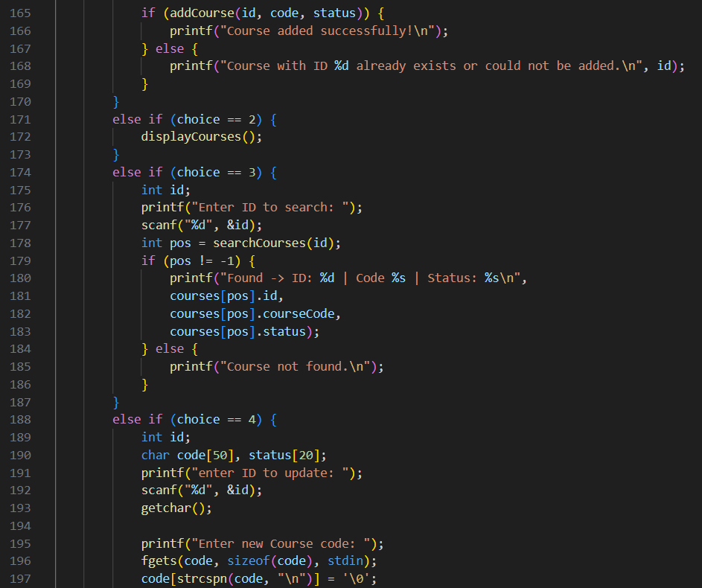

Figure 144: Input Task_7_70-100.6

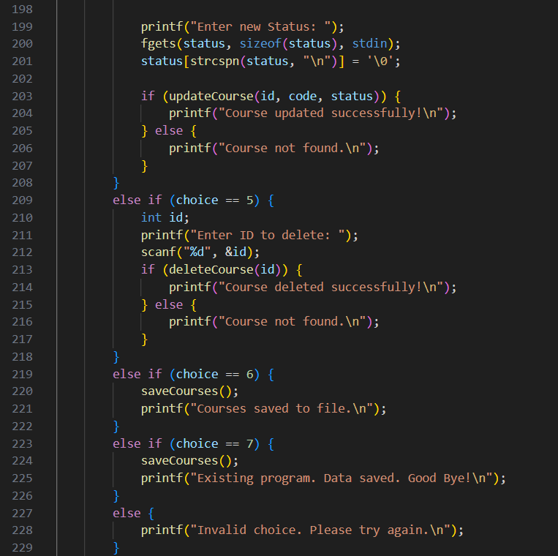

Figure 145: Input Task_7_70-100.7

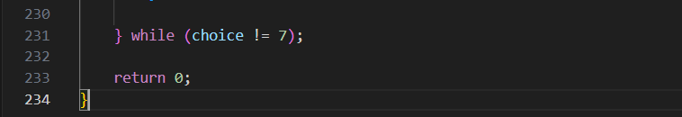

Figure 146: Input Task_7_70-100.8

**Code Explanation:** In this last stage, the Course Registration System became more complete and challenging because it required advanced file handling. The main new feature was the deleteCourse() function, which removes a course by its ID. At first, this was not so simple, because deleting in a file is not like deleting in an array. I had to learn that the program needs to read all the courses, skip the one to be deleted, and then overwrite the file with the updated list. This made me pay more attention to how files work in C, since they don’t shrink automatically.

Another important part was adding file persistence. Now, the program loads the courses from the file when it starts, saves them automatically when exiting, and even allows the user to choose “Save Now.” This made the system feel more like a real application, because the data is always consistent between runs. I also had to practice the use of global variables, like the file name, the array of courses, and the counter. At first, I was not comfortable with globals, but I realized they help in this case because many functions need to access the same data without passing too many parameters.

As part of this task, I also had to study variable scope. A local variable only exists inside the function where it is declared, for example int choice; inside main(). It can’t be accessed by other functions. A global variable, on the other hand, is declared outside all functions and can be shared by the whole program. In my code, the courses[] array and courseCount are global, so that addCourse(), deleteCourse(), updateCourse() and displayCourses() can all access the same data. (Wikipedia 2025). At first, I thought using globals was not very safe, but I understood that in this system they make the code clearer and easier to manage.

The use of global variables simplified state management across functions and reduced parameter passing, which was efficient for this project’s scale. Yet, in professional applications, this practice may compromise modularity and maintainability, suggesting that alternative approaches, such as structured data management, would be more appropriate.

This assignment taught me how to manage file deletions, how to keep data persistent throughout the program's execution, and how global variables interact with local ones when designing a larger program. It was also a good exercise in carefully testing each function, as small errors during deletion or saving could result in data loss or cause the program to behave unexpectedly.

The table below contains the code expanation by structure:



Table 26: Code Explanation Task_7_70-100

Output:

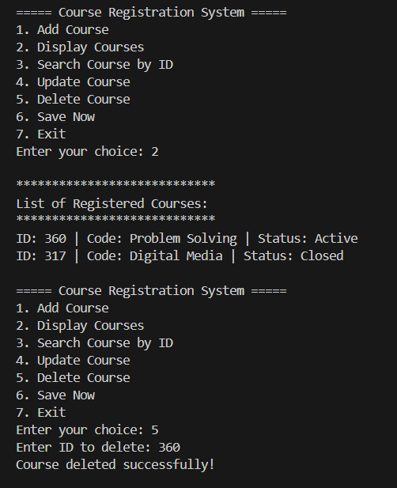

Figure 147: Output Task_7_70-100.1

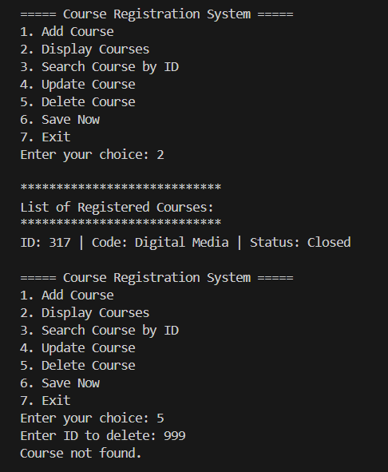

Figure 148: Output Task_7_70-100.2

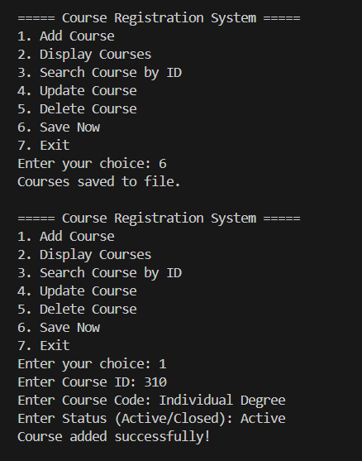

Figure 149: Output Task_7_70-100.3

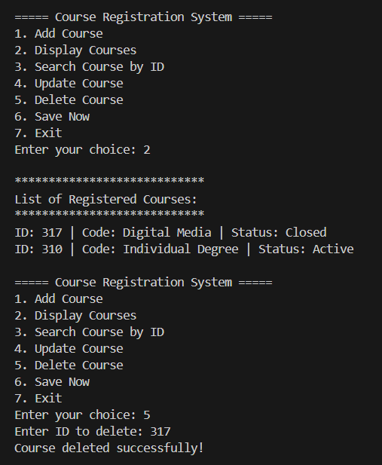

Figure 150: Output Task_7_70-100.4

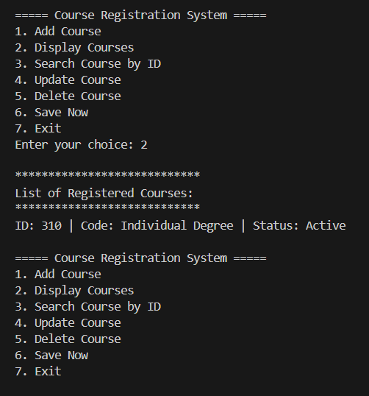

Figure 151: Output Task_7_70-100.5

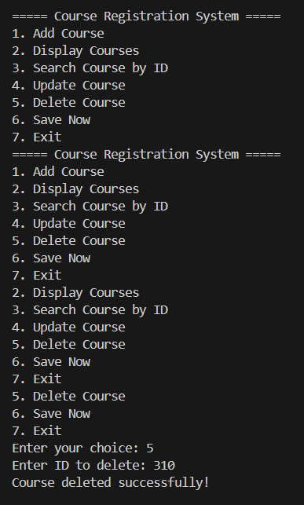

Figure 152: Output Task_7_70-100.6

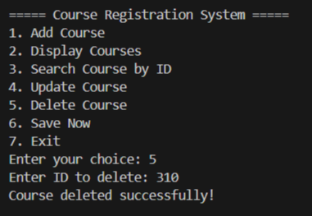

Figure 153: Output Task_7_70-100.7

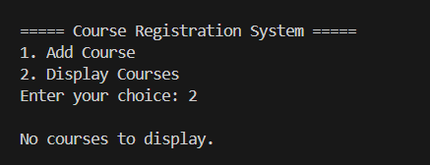

Figure 154: Output Task_7_70-100.8

The figure below shows the empty file after deleted courses on Virtual Code:

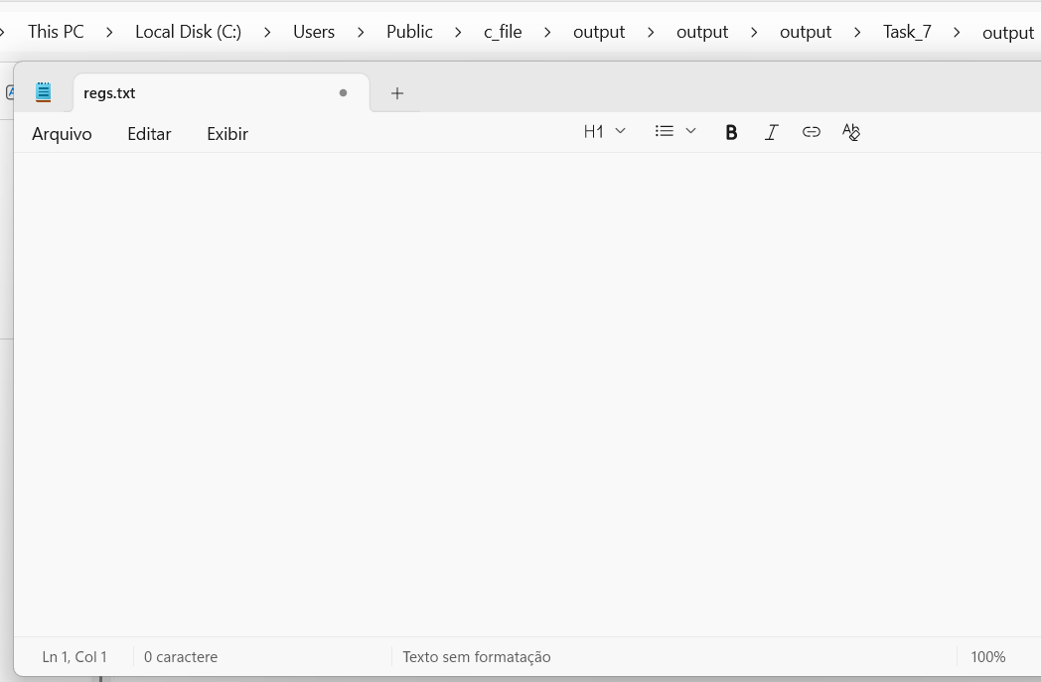

Figure 155: Output Task_7_70-100.9

# Task 8: Personal Learning

This task requires a personal reflection on the overall experience within the module. The focus includes the development of skills, recognition of strengths and weaknesses, areas for improvement, monitoring of progress, approaches to time management, and consideration of possible changes to previous assessments.

## Reflective Report

Personal Reflection:Throughout this module, I have experienced significant growth both in my technical abilities and in the way I approach problem solving more generally. At the beginning, programming in C felt overwhelming, and I struggled to visualise its practical application. However, through sustained practice, class attendance, discussions with colleagues, and independent study, I developed an understanding not only of programming concepts but also of myself as a learner.

Skills Developed: The most valuable skill I have gained is the ability to analyse problems critically and systematically. Whereas earlier I would see a system, such as a food ordering app, a website, or software and simply use it, I now find myself considering the underlying logic, structure, and algorithms that make it function. This curiosity connects directly to the concepts introduced in this module. I have also strengthened my ability to break problems down into smaller steps, test different approaches, and persist until I reach a working solution. Beyond programming, I developed patience, attention to detail, and resilience when faced with trial and error.

Strengths and Weaknesses: One of my main weaknesses at the start was anxiety. I wanted to understand everything quickly, and when this was not possible, I became frustrated. I also initially found it difficult to see the purpose of the code I was writing. Over time, I realised that without mastering the foundations, it would be impossible to progress. Accepting this helped me to focus on building my knowledge gradually.

My main strengths are determination and dedication. Even when tasks seemed overwhelming, I persisted, whether by drawing scenarios on paper to clarify logic, creating tables to visualise the structure of code, practising additional exercises, or seeking help when required. Recognising these strengths and weaknesses has been key to developing my learning style and improving my confidence.

Areas for Improvement: I recognise that I still need to apply critical thinking more consistently. While I now understand the syntax and structures of C, I must become more comfortable in simulating real-world scenarios and applying functions to solve them. To achieve this, I plan to set clearer stages, goals, and milestones for future study, which will help me measure progress and reduce anxiety. Structured practice and reflection after each attempt will also be essential for improvement.

Monitoring Progress: My progress is evident when comparing the first task with the later ones. Initially, simple exercises took a long time and caused confusion. By the end of the module, however, tasks that once seemed unattainable became manageable. Mistakes made during execution were no longer failures but opportunities to identify areas for improvement.

One specific example of overcoming difficulties in higher-scoring tasks was through seeking additional resources beyond the classroom. Platforms such as W3Schools and professional content shared on LinkedIn provided explanations and examples that supported understanding (W3Schools 2025; LinkedIn Learning 2025). Using these tools, along with visual aids such as hand-drawn diagrams and structured tables, clarified complex programming logic. These strategies transformed confusion into clarity and contributed to achieving consistency in later assessments.

Time Management and Balancing Tasks: Time management was one of the greatest challenges. I aimed to complete each task as soon as it was released, but the time required for learning sometimes meant working on multiple assignments simultaneously. Balancing this with other coursework, group projects, and personal responsibilities such as family and work was demanding.

There were moments when deadlines overlapped and required negotiation. In group assignments, I collaborated with colleagues to agree on priorities and set internal dates that suited everyone. This experience highlighted the importance of flexibility and communication. Although I could not always complete one task before another was released, I remained organised and delivered my work on time.

Collaborative and Independent Learning: Another important aspect of my journey was learning through collaboration. Conversations with classmates provided new perspectives and often clarified concepts I had misunderstood. At times, a single question from a colleague became the key to unlocking my own understanding.

At the same time, I relied on independent learning, watching videos, consulting external resources, and experimenting with code outside the classroom. This combination of collaborative and independent approaches helped me to build confidence and autonomy in my learning. It also reinforced the idea that programming is not solely a solitary activity but also one of shared knowledge and collective growth.

What I Would Change: If I could revisit one of the assessments, I would choose the Temperature Logger task. This task involved collecting, storing, and calculating data, and I found it particularly engaging because I enjoy working with numbers and interpreting results. With more time, I would extend it to include graphical representations of the data, or perhaps exporting results into external files such as spreadsheets for further analysis. I believe this would make the data more meaningful and allow clearer insights, aligning with my personal interest in using programming to facilitate data-driven decision making.

Future Relevance: Learning C during my foundation year has been valuable. As a base language, it provided me with an understanding of what programming is and what underpins the systems we use every day. This perspective is motivating, because it connects abstract code to practical systems and applications. The logical mindset I have developed will also support me in future modules and potentially in my career, where critical thinking and structured problem solving are essential. Although challenging at times, gaining knowledge of C offers long-term benefits, as its principles underpin many modern languages and systems, making the effort to understand it a worthwhile investment for the future.

Conclusion: Overall, this module has transformed how I view problem solving and programming. I no longer see code as isolated commands but as a language for structuring thought and building solutions. I have learnt the importance of patience, persistence, and gradual improvement, as well as the need to balance personal strengths and weaknesses.

I also understand better how I learn: by breaking problems down, using visual aids such as tables and diagrams, and combining collaborative input with independent exploration. Looking forward, I intend to apply these lessons not only in future programming modules but also in other areas of study and professional life. This reflective journey has demonstrated that with determination, structure, and practice, even the most difficult tasks can become achievable.

# Appendix

Link to codes .c:

<https://drive.google.com/file/d/1_y_4uajiG0A4Gk9gltI0arTM8PPetPXW/view?usp=drive_link>



Functions and Control Structures Used: The following table provides an overview of the main C functions and language constructs applied across the tasks. Each entry includes a short description and usage notes, highlighting their relevance to the programs implemented in this report.



# References

freeCodeCamp. 2020. *Pointers in C are not as difficult as you think*. [online]. Available at: <https://www.freecodecamp.org/news/pointers-in-c-are-not-as-difficult-as-you-think> [Accessed 23 August 2025].

GeeksforGeeks. 2025. *Selection Sort VS Bubble Sort*. [online]. Available at: <https://www.geeksforgeeks.org/dsa/selection-sort-vs-bubble-sort/> [Accessed 14 September 2025].

GeeksforGeeks. 2025. *C Pointers*. [online]. Available at: <https://www.geeksforgeeks.org/c/c-pointers> [Accessed 23 August 2025].

LinkedIn Learning. n.d. *Complete guide to C programming foundations: Diving into C*. [online]. Available at: <https://www.linkedin.com/learning/complete-guide-to-c-programming-foundations/diving-into-c?u=56747793> [Accessed 23 August 2025].

Testbook. 2025. *Difference between Bubble Sort and Selection Sort*. [online]. Available at: <https://testbook.com/key-differences/difference-between-bubble-sort-and-selection-sort> [Accessed 14 September 2025].

W3Schools. n.d. *C Pointers*. [online]. Available at: <https://www.w3schools.com/c/c_pointers.php> [Accessed 23 August 2025].

Wikipedia (2025) *Errno.h*. Available at: [https://en.wikipedia.org/wiki/Errno.h](https://en.wikipedia.org/wiki/Errno.h?utm_source=chatgpt.com) (Accessed: 22 September 2025).

Wikipedia. 2025. *Pointer (computer programming)*. [online]. Available at: <https://en.wikipedia.org/wiki/Pointer_(computer_programming)> [Accessed 23 August 2025].

Ziggit.dev. 2023. *Understanding sentinels, slices, arrays, pointers*. [online]. Available at: <https://ziggit.dev/t/understanding-sentinels-slices-arrays-pointers/2600> [Accessed 23 August 2025].